Markhael Jordan: Setting Big Goals with ABLE

Markhael Jordan, age 21, has big goals in life. He wants to get his driver’s license. He wants to go to college. He wants to be a barber. And he wants to get married. His grandmother, Marjorie Jordan, wants all that and more for him. “He’s very self-sufficient,” she says. “He keeps his bedroom and bathroom clean; he takes out the trash, he does laundry and he can cook. Markhael can make a mean cheesecake!” He learned how to make it in high school. “Now I have the recipe,” he says.
Despite his abilities, Markhael has challenges that make some things in life difficult. “Markhael was born prematurely,” says Marjorie. “He was three pounds and 14 ounces. We thought all was normal, but by the age of two we started noticing a few things were off. It was nothing monumental, but by two and a half he didn’t talk. He was also very hyper, and he would cry almost all night long. A nurse practitioner mentioned the word ‘autism’ to my daughter. I had to ask her what it was, so we Googled it. I recognized 14 or 15 of the characteristics listed.”
Markhael’s mother, Marla, returned to school, and Marjorie took Markhael in, becoming not only his caregiver, but his devoted advocate. “I joined a support group with other parents of children with autism so I could learn all I could about the condition.”
Marjorie began to notice little things, such as Markhael’s insatiable appetite for milk. “He drank a lot of milk!” Once, while away from home, he didn’t get the milk he normally drank, and Marjorie noticed he acted better. She mentioned it in the support group and learned that others had the same experience with their children. As Markhael got older, Marjorie had to put latches high up on the doors because he was up so much during the night. “He would go in the kitchen and eat everything he saw, and he drank milk like crazy.”
Finding the right doctor helped get Markhael on the right track. Marjorie took him to see Dr. Jacob Skiwski at the Children’s Health Center in Columbus. “He was already treating several children with autism. He told me to do all I could to keep Markhael awake all day so that he would be tired and sleep during the night. We also got with a therapist at University Medical Center in Jackson.”
Instead of sending Markhael to a special school, Marjorie made the decision to send him to public school. “He started pre-school at age three and he went all the way through, graduating with his class at Louisville High School. He did ROTC for two years, and he loved art class – he draws really well.” Markhael received a certificate of completion instead of a high school diploma, so he is unable to get into college. “There is a special program at Mississippi State,” says Marjorie. “We are trying very hard to get him admitted because we feel it would be the ideal program for Markhael.”
After high school, Marjorie tried to find a suitable place for Markhael. What was available just didn’t fit his needs. “They played a lot of bingo and did puzzles. Markhael is too advanced for that. He needs interaction with people.” In looking for alternatives, Marjorie found Vocational Rehab with the Mississippi Department of Rehabilitation Services. It was a game-changer for both Markhael and Marjorie. “He is now working at Pizza Hut one day a week and he loves it.” Markhael says that he washes dishes and does other tasks at the restaurant. “I like working at Pizza Hut. I wish I could work even more.” When he’s not working, Markhael is home alone.
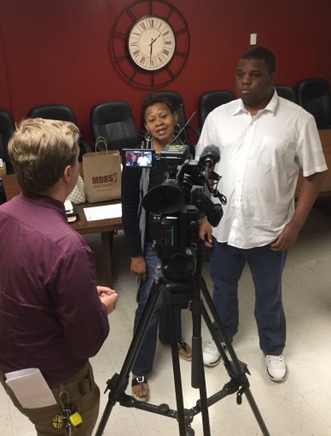
Marjorie is hoping Markhael can get more hours at Pizza Hut, or work at another job. “The biggest concern at first was the income he earns could affect his SSI and Medicaid. That’s so vitally important to us, so we were concerned.” When Marjorie heard about the Achieving a Better Life Experience Act (ABLE) program through MDRS, she signed Markhael up right away. Through ABLE, there is no limit to what individuals with disabilities can do. That now includes savings. “I am able to give Markhael his own money, and he even has a debit card. But the rest goes into a tax-deferred savings account that we can use for many daily, disability-related expenses. It also gives me peace of mind.”
Marjorie explains that a big concern with disabled children is what happens to them when their caregiver passes away. “If Markhael inherits money, it could knock out his benefits. Now it can go into his ABLE account.” Marjorie’s son is a financial advisor. “His company sent him to training to learn about the ABLE program so that when it went live, he could offer it to his clients. I think it’s a fantastic program,” says Marjorie. “So many people who have children with disabilities are afraid for them to work, which is unfortunate because it can improve their overall quality of life. The ABLE program now makes it possible for people like Markhael to work and be a productive citizen.”
Markhael is getting closer to reaching some of his goals. He has learned to drive but needs to pass the written test. He is actively trying to get into the ACCESS program at Mississippi State University. He cuts his own hair. And Markhael has a girlfriend. “He’s very sensitive, and very family oriented,” says Marjorie. “Markhael is my pride. He has a great support group with me, his grandfather, his mother and his extended family. We all want Markhael to be the best he can be.”

