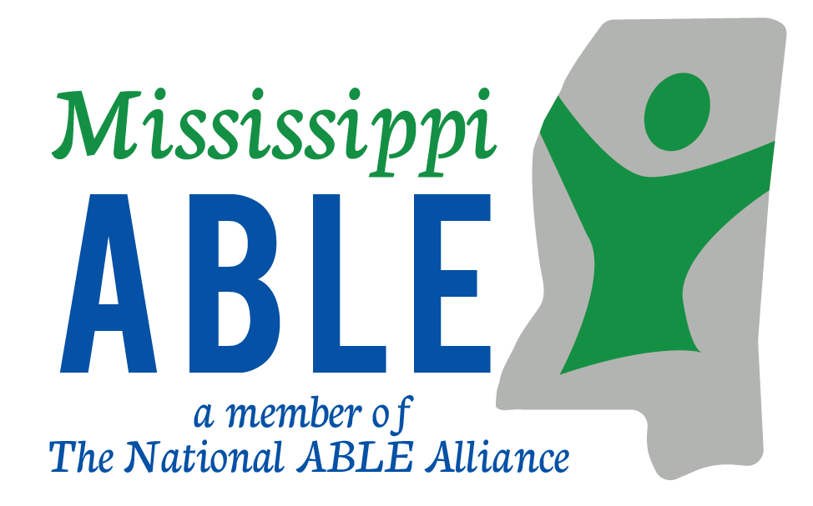
Frequently Asked Questions about COVID-19 Stimulus Payments and ABLE Accounts

What is the stimulus payment I am receiving?
The government is giving people a stimulus payment of $1,200 and some will get $500 more if they have a child they support. They can spend it any way they want. The stimulus payment is meant to help our country’s struggling businesses and communities during the COVID-19 pandemic. If you are already getting monthly Social Security benefits you will get the stimulus payment the same way. The stimulus payment MUST be spent within 12 months. Otherwise, it will count as an asset and could reduce your benefits. Many people have already received their stimulus payments.
Beware of scams! The IRS will not call or email you about the stimulus payment. Do not share your personal information on the phone or over email.
Can I deposit the stimulus payment into an ABLE Account?
Yes! You can put all or part of your stimulus payment into an ABLE account. That way, you don’t have to worry about spending the money right away if you don’t need to. Putting the payment in an ABLE account can give you flexibility. Plus, it will have the same benefits protection that the other money in your ABLE account has.
Why should I consider putting some, or all, of this payment into an ABLE account?
An ABLE account can help you save for things that are not covered by benefits. If you don’t need to use the stimulus payment for things right now, you could use it to start saving. You can save for whatever you need to be independent and participate in your community. That includes adaptive equipment, a vehicle, a home, assistive technology, personal support services, and many other expenses. You can also use an ABLE account to save for emergencies.
Do I have to use the stimulus payment the same way that I use my SSI benefit money?
No. The stimulus payment is NOT a payment from Social Security. You do not have to follow Social Security rules when you spend it. Your stimulus payment can be used in any way you choose. You could use your payment now. You could spend it within 12 months. You could save it in an ABLE account to give your more time to spend it while preserving your benefits.

Will the stimulus payment disqualify me from the benefits I need?
Not for 12 months. After a year, whatever is left will count toward your $2,000 SSI asset limit if you leave it in a regular account. If you save it in an ABLE account, it won’t count toward your $2,000 asset limit.
How does an ABLE account help me keep from exceeding my $2,000 asset limit?
Funds in your ABLE account are not counted toward your $2,000 asset limit. You will not lose your benefits or lose eligibility for federal benefits (like SSI, SSDI, Medicaid and HUD) by owning an ABLE account. You can save up to $100,000 in your ABLE account and still receive your monthly SSI benefits.
Can other people help me decide how to spend the money or set up an ABLE account?
Yes. However, it is your decision how to spend the stimulus payment. Making financial decisions is hard for many people. People you trust can help you decide what to do with your money. This includes family, caregivers and others. They might also be able to help you set up an ABLE account.
What should my family, rep payee, service provider, and other trusted supporters do to help me decide what to do with the stimulus payment?
People who help you with your money need to be sure they do not put their needs or wishes ahead of yours. That includes when they help you with decisions about the stimulus payment. They should talk with you about your options, your needs and your wishes. Some people and their supporters might choose to use something called ‘supported financial decision-making practices’. This may help then when talking about the stimulus payments and the 12-month spending timeline. Some people may choose to save some of the money for later. An ABLE account is a way to save and still protect your benefits. A good place to start is to contact your state’s ABLE plan administrator.
Are there any other payments related to COVID-19 that I should be aware of?
If you were working and lost your job, you may be able to receive unemployment benefits. The federal government is giving people who receive unemployment an extra $600 a week because of COVID-19.
Unemployment benefits are counted as unearned income for SSI. You must tell Social Security if you are receiving unemployment. This could affect your SSI or SSDI benefits.
You can save your unemployment benefits in an ABLE account so that they will not count as an asset in the future. Unemployment will still count as income when you receive it.
Where can I get more information about Stimulus payments?
IRS. “Economic Impact Payments.” https://www.irs.gov/coronavirus/economic-impact-payments.
Where can I find more information about ABLE Accounts?
For Mississippi ABLE visit www.mississippiable.com or call 1-888-609-3469.
Mississippi is a member of the National ABLE Alliance. For more information concerning a member state visit www.savewithable.com.
A resource for a nationwide overview of ABLE can be found at www.ablenrc.org.

Consumer Financial Protection Bureau, “Your Money, Your Goals: Focus on People with Disabilities”
https://files.consumerfinance.gov/f/documents/cfpb_ymyg_focus-on-people-with-disabilities.pdf
National Disability Institute – Financial Resilience
https://www.nationaldisabilityinstitute.org/financial-resilience-center/

