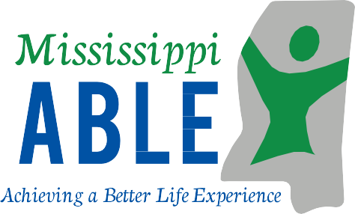
Allowing individuals with
disabilities to save without losing public benefits.
www.MississippiAble.com
(888) 609-3469
A Member of the National ABLE Alliance
Administered by the Mississippi Department of Rehabilitation Services

To learn more about ABLE or sign up: www.MississippiAble.com
The Mississippi ABLE Act is
codified in Miss. Code Ann.
§43-28-1 et seq. The legislation
established an ABLE Board
which works with the
Mississippi Department of
Rehabilitation Services to
administer the program.
Mississippi is a member of The
National ABLE Alliance.

The Achieving a Better Life
Experience Act (ABLE) of
2014 allows individuals with
disabilities to save money
in a tax-advantaged account
that may be used for qualified
disability related expenses
while keeping eligibility for
federal public benefits.

Order brochures or schedule a presentation: MSABLEINFO@mdrs.ms.gov

Contact customer service: 888-609-3469

*Disclaimer: The information provided in this flyer is general background information only, is given in summary form, and does not purport to be complete. If you are considering opening an
ABLE account, you should seek competent advice concerning the effect of opening and contributing to an ABLE account on the eligibility or continued eligibility for federal and state government benefits.
Funds remaining in an ABLE account may be subject to Medicaid recovery upon the death of the account owner. You should also seek the advice of a professional concerning any financial, tax, or legal implications related to opening and maintaining an ABLE account. Participating
in Mississippi’s ABLE Program may involve investment risk including the possible loss of
principal.

Plan Highlights

Savings accounts for individuals with disabilities
Who is eligible?

You can open an account for yourself, or an authorized individual can open on your behalf if:

- You acquired your disability before the age of 26

- Meet disability qualifications as determined by SSA or have a similarly severe disability and a written diagnosis from a licensed physician

- Save up to $16,000 per year
- If an account owner is working, he/she can contribute an additional amount based on what the IRS allows
- The maximum balance allowed is
$235,000

Will not affect public benefits

- Eligibility for federal programs not affected by account balance
Qualified Disability Living Expenses Include but are not limited to:
- Education
- Health and wellness
- Housing
- Transportation
- Legal fees
- Financial management
- Employment training and support
- Assistive technology
- Funeral and burial expenses
- Personal support services
- Basic living expenses
- Balances under $100,000 excluded from SSI resource limit

Can be used for daily transactions and/or long-term savings

- Debit card and checking options
- Low-risk to high-risk investment options

May provide tax advantages
- Earnings on investments are tax- free
- Deposits may qualify for state tax deduction
User Friendly

- Open an account with as little as $25
- Access your account by phone or online 24/7
- Checking option allows easy access to funds via a debit card
- Ugift feature allows anyone to contribute to your account
Low Fees

- Fee-free ATM access at over 340 ATMs located throughout Mississippi
- Flat quarterly fee, regardless of account balance
- No transaction fees

