**2021 SRC ANNUAL REPORT**

**STATE REHABILITATION COUNCIL**

**FFY 2021: 10/1/20 – 9/30/21**

***In Partnership with***



**Office of Vocational Rehabilitation**

**Office of Vocational Rehabilitation for the Blind**

**TABLE OF CONTENTS**

DESIGNATED STATE AGENCY

**MISSISSISSIPPI DEPARTMENT OF REHABILITATION SERVICES**

WELCOME – MDRS EXECUTIVE DIRECTOR3

**STATE REHABILITATION COUNCIL (SRC)**

WELCOME – CHAIRMAN, SRC4

SRC COUNCIL MEMBERSHIP5

SRC ACTIVITIES (INCLUDES COMMENTS)6-19

CONSUMER SATISFACTION SURVEY (OVR/OVRB)20

DESIGNATED STATE UNIT

**OFFICE OF VOCATIONAL REHABILITATION (OVR)**

WELCOME – DIRECTOR, OVR21

PERFORMANCE INDICATORS, OVR22

ADDITIONAL VR PROGRAM SERVICES AND HIGHLIGHTS, OVR23-25

DISTRICTS SERVED – MAP, OVR26

**MEASURES OF SUCCESS (OVR)**

EMPLOYMENT OUTCOMES – OVERVIEW AND STATISTICS, OVR27

DEMOGRAPHICS, OVR28-29

SUCCESS STORIES, OVR30-31

**OFFICE OF VOCATIONAL REHABILITATION FOR THE BLIND (OVRB)**

WELCOME – DIRECTOR, OVRB32

OVERVIEW, OVRB33

HIGHLIGHTS, OVRB34-37

REGIONAL MAP, OVRB38

**MEASURES OF SUCCESS (OVRB)**

EMPLOYMENT OUTCOMES - OVRB..39

DEMOGRAPHICS, OVRB..40

OVERVIEW, ADDIE MCBRYDE REHABILITATION CENTER.……….……………. 41-43

OVERVIEW, BUSINESS ENTERPRISE PROGRAM (BEP)44

INDEPENDENT LIVING SERVICES FOR THE BLIND, OVRB 45-46

MS PARTNERS FOR INFORMED CHOICE, OVRB47

SUCCESS STORIES, ILB / WIPA48



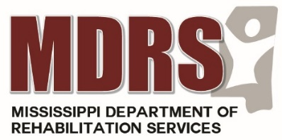

***Welcome from the Executive Director,***

***Chris Howard***

***Dear Governor Reeves, Members of the Mississippi Legislature and Fellow Mississippians:***

On behalf of the Mississippi Department of Rehabilitation Services’ Office of Workforce Development, I thank you for the opportunity to share highlights of our Offices of Vocational Rehabilitation (VR) and Vocational Rehabilitation for the Blind (VRB)  through our partnership with the State Rehabilitation Council during **Federal Fiscal 2021**.

The work of our Vocational Rehabilitation teams and the SRC is vital to carrying out our mission of assisting Mississippians with disabilities to gain/retain employment and to provide appropriate and comprehensive services in a timely and effective manner.    We are proud to report that in this FFY, and despite great challenges presented by the pandemic, we served over **15,000** individuals, helped more than 2,600 become successfully employed, provided Pre-employment Transition Services (Pre-ETS) to over **7,100** students, developed **12** new partnerships with Community Rehab Partners to provide Pre-ETS training, held a job fair in which over **130** businesses participated, developed or maintained **12** Project SEARCH sties, partnered with corporate giants such as Sephora and Fastenal, expanded our internship programs and assisted in the growth of Mississippi State’s ACCESS program.  The pages ahead will outline our work in these areas more specifically.

Our success is to be credited to our outstanding statewide staff here at MDRS.  They work hard every day to make a difference in the lives of those we serve, and regularly consult with the members of the State Rehabilitation Council as a matter of duty and due diligence.

I thank you for your continued support of our mission and look forward to another year of successful outcomes and life-changing work.

Sincerely,

Chris M. Howard

Executive Director

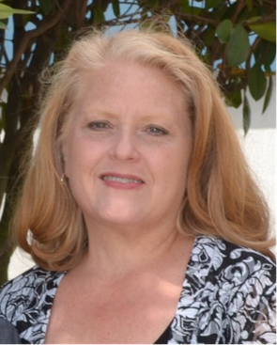 **MISSISSIPPI**

**STATE REHABILITATION COUNCIL CHAIR LETTER**

***Dear Governor Reeves and Members of the Mississippi Legislature:***

*On behalf of the State Rehabilitation Council (SRC), I am happy to share the annual report of the Mississippi Department of Rehabilitation Services’ Office of Vocational Rehabilitation and Office of Vocational Rehabilitation for the Blind (OVR/OVRB).*

The State Rehabilitation Council is a body mandated by The Rehabilitation Act and its resulting regulations at CFR 361. Members, described in these regulations, represent a broad range of individuals with disabilities across the state. We are pleased in 2021 to have received timely appointments which have enabled the SRC to be a fully functioning body.

Our mandated functions include:

• Reviewing, analyzing, and advising OVR/OVRB on the performance of their responsibilities related to eligibility and order of selection; the extent, scope, and effectiveness of vocational rehabilitation services; and functions that affect the ability of individuals with disabilities in achieving employment outcomes

• Partnering with OVR/OVRB in developing goals and priorities; and evaluating the effectiveness in obtaining these goals

• Advising OVR/OVRB in the vocational rehabilitation portion of the Unified State Plan

• Conducting a review and analysis of consumer satisfaction

• Submitting this report and making it available to the public

• Coordinating activities with other named Councils within the state, to include the Statewide Independent Living Council

• Performing other relevant functions the SRC determines appropriate consistent with the purpose of OVR/OVRB

The Mississippi Department of Rehabilitation Services’ OVR/ OVRB have continued effective Vocational Rehabilitation Services to Mississippi’s citizens who experience disability. Employment outcomes secured after the receipt of Vocational Rehabilitation Services have assisted in Mississippi’s recovery after suffering from the Covid 19 pandemic. “Recovery, Powered By Inclusion”, a phrase used during the VR and VRB Disability Employment Awareness Month, has been exercised year-long in programs and services that not only benefitted the citizens who experience disability and received services, but our entire state of Mississippi as well, in recovery.

We hope you will consider strong funding of this agency for the 20% required state match to federal funds so that it will have the funding levels to remain an essential Mississippi resource to help restore both the State’s economy as well as the strong spirit of Mississippi Citizens through their own self-supporting employment. The State Rehabilitation Council is happy to continue to advise the agency in regards to the individual stakeholder groups who we represent.

Sincerely,



Mary Lundy Meruvia, Chairperson

State Rehabilitation Council

**STATE REHABILITATION COUNCIL MEMBERSHIP**

**July 1, 2020 - June 30, 2021**

**Mary Lundy Meruvia, Chairperson**

**Chris Howard, Ex Officio**

**Chris Howard, Ex Officio**

|  |  |
| --- | --- |
| * Brad Bounds (Philadelphia) * Josh Bower (Clinton) * Donald Brown (Vicksburg) * Lee Cole (Jackson) * Sharon Strong Coon (Jackson) * Jin Joo Crosby (Jackson) * Pam Dollar (Mize) * Shannon Hillman (Brandon) | * John McGinn (Jackson) * Presley Posey (Flora) * Ed Roberson (Madison) * Cassandra Singleton (Philadelphia) * Augusta Smith (Jackson) * Rebecca Treadway (Tupelo) * Jean Walley (Laurel) |

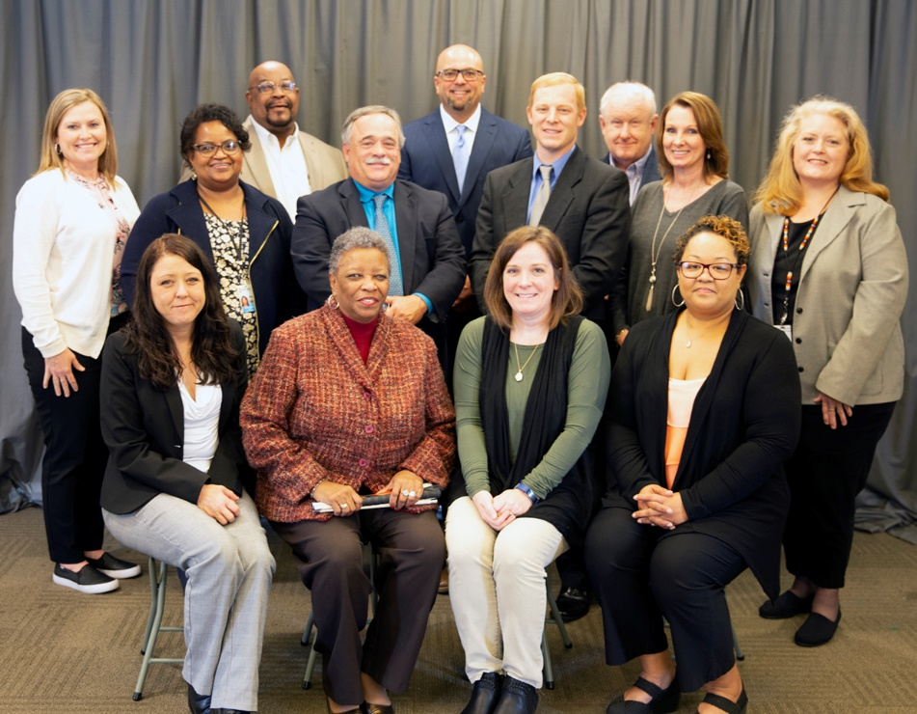

**L to R:1st row – Cassandra Singleton; Lee Cole; Rebecca Treadway; Jin Joo Crosby  
2nd row – Shannon Hillman; Ed Roberson; Josh Bower; Jean Walley; Mary Lundy Meruvia  
3rd row – Donald Brown; Brad Bounds; Presley Posey  
Not Pictured: Sharon Strong Coon; Pam Dollar; Chris Howard; John McGinn; Augusta Smith**

*The public is always invited to attend the quarterly State Rehabilitation Council Meetings. Meeting locations, dates and times and are posted at* [*www.mdrs.ms.gov*](http://www.mdrs.ms.gov/) *and the NFB Newsline. If you would like to attend a meeting, contact Betsy Simoneaux at* [*bsimoneaux@mdrs.ms.gov*](mailto:bsimoneaux@mdrs.ms.gov) *or call at 601-853-5336 for further information.*

**2021 MISSISSIPPI**

**STATE REHABILITATION COUNCIL ACTIVITIES**

**FFY 2021 Mississippi State Rehabilitation Council Activity Report**

The Mississippi State Rehabilitation Council (SRC) held four (4) quarterly meetings for the Federal Fiscal Year **October 1, 2020 – September 30, 2021**. Utilizing TEAMS and teleconferencing, the members were able to attend our quarterly meetings during the continued pandemic era. During each meeting, everyone is welcomed, introductions are made and guests are recognized. Agenda topics are centered around the SRC Functions and provided by the Offices of Vocational Rehabilitation (OVR), Vocational Rehabilitation for the Blind (OVRB) and Business Development Services (BDS). The State Rehabilitation Council reviewed and provided input at each meeting on selected topics related to:

* Reviewing, analyzing, and advising OVR/OVRB/BDS on the performance of their responsibilities related to eligibility and order of selection; the extent, scope, and effectiveness of vocational rehabilitation services; and functions that affect the ability of individuals with disabilities in achieving employment outcomes
* Partnering with OVR/OVRB in developing goals and priorities and evaluating the effectiveness in obtaining these goals
* Advising OVR/OVRB/BDS in the vocational rehabilitation portion of the Unified State Plan
* Conducting a review and analysis of consumer satisfaction, including a quarterly report from the Client Assistance Program (CAP) as well as a report of Due Process Hearings
* Submitting the SRC Annual Report and making it available to the public
* Coordinating activities with other named Councils within the state, with a specific agenda item quarterly for a report from the Statewide Independent Living Council (SILC)
* Performing other relevant functions, the SRC determines appropriate consistency with the purpose of OVR/OVRB/BDS

**DECEMBER 2020 MEETING**

The **2020 State Rehabilitation Council Annual Report** was reviewed and discussed at the December 2020 meeting. LaVonda Hart, Director of Vocational Rehabilitation, explained the information contained in the SRC Annual Report. Draft copies were provided as some information was still being compiled. The SRC Annual Report is required by the Rehabilitation Services Administration (RSA) and must be submitted before the end of the calendar year. This report includes data in relation to the Offices of Vocational Rehabilitation (including Pre-ETS) and Vocational Rehabilitation for the Blind.

Ms. Hart also reviewed the **State Plan** that is submitted to the MDRS Workforce Core Partners for WIOA. This report is then submitted to the MS. Department of Employment Services which is the lead partner in organizing the combined report.

*Continued,* 2021 Mississippi – State Rehabilitation Council Activities

The **RSA 911 Report**, a quarterly report, is submitted to RSA four times during the Program Year. The Program Year ‘21 begins July 1, 2020 and ends June 30, 2021. It was noted that the SRC still operates on the federal fiscal year.

More information was provided on the **Structured Discovery Center** and the requirements that will need to be met for approval. Dr. Edward Bell, referred by the RSA, will be assisting the agency to ensure the requirements are met.

Further discussions included the **Comprehensive Services Needs Assessment**, which is compiled to reflect future needs of VR/VRB. The **Public Consulting Group** has been contracted to compile detailed reporting.

# Formal SRC Input: *Responses to SRC Questionnaire - December 4, 2020 Meeting*

1. **After attending the quarterly SRC meeting, what further input do you have for VR/VRB regarding the eligibility (including Order of Selection- OOS), the extent, scope and effectiveness of services provided; and functions performed by the Designated State Unit (DSU) that affect or potentially affect the ability of individuals with disabilities in achieving employment outcomes?**

* *2020 has been a difficult year. I appreciate everyone who has done out-of-the-box thinking to get services to clients and helped keep spirits high amongst clients who are feeling down or frustrated at the closeness of service due to Covid-19.*
* *None*
* *I think they are doing a wonderful job. Keep up the great work.*
* *Was a great meeting. Staff always provides extensive details.*
* *The VRB Training Needs Survey should be disseminated to all current VRB referrals, applicants, clients, state partners, including SRC members, School for the Blind, DD Council; IL Providers, among others and all VRB staff for dissemination and for sharing with Mississippians who experience blindness. The results will help VRB to plan the Structured Discovery Service provision that is being proposed to best meet the needs of Mississippians who need this service.*
* *I am looking forward to learning more about the goal to establish the Structured Discovery Learning program in Mississippi. This sounds like a great opportunity to keep Mississippians who need this service.*

1. **Having heard this quarters report on the results of the consumer satisfaction surveys, do you have any comments or recommendations for input into the service delivery process?**

* *It’s always nice to see the positive comments. It is important to constantly check up on the negative comments, trying to see if service delivery could be better.*
* *None*

*Continued,* 2021 Mississippi – State Rehabilitation Council Activities

* *The ratings were very good. The comments that were not positive were being addressed. I feel good about that.*
* *None*
* *The satisfaction continues to be high indicating that people’s needs are being met through services.*
* *No, it was a thorough report.*

1. **After attending this quarterly SRC meeting, what further input do you have for the State Plan goals and Priorities? What further comment(s) do you have in regards to evaluating the effectiveness of the VR/VRB Program in meeting the goals and priorities?**

* *I am excited about the idea of having Structured Discovery for our OVRB clients. I had no idea that some clients had to leave the state for an extended period of time to receive Structured Discovery. This will be a great benefit for our OVRB community.*
* *None*
* *I think VR/VRB are working really hard toward meeting their goals. The make Mississippi proud.*
* *None*
* *I look forward to reviewing the Policy Manual changes and provide input where flexibility occurs.*
* *No Additional input.*

1. **Do you have any comments or recommendations concerning the presentation on the Office of Business Development?**

* *None at this time*
* *None*
* *A great report. I like how you move a few things around. Great job.*
* *None*
* *I look forward to reviewing the final draft after VR and VRB have completed the program report for the annual report.*

|  |
| --- |
| ***Additional State Rehabilitation Council Member Activities during***  ***FFY 2021 (December 2020 Quarterly Meeting)*** |

**Chairperson Election** – *Selection of the SRC Chairman* for the 2021 Year was discussed. Pursuant to the SRC Federal Regulations, a Council Chairperson must be selected. The bylaws state the role and duties of the SRC Chairperson. A survey will be sent via Survey Monkey asking for nominations for the Council Chairman for the upcoming year. Once nominations are received, they will be voted on.

**Nomination Committee** – The *nomination form* was updated and available for all Council members to review. Changes were made that followed specific wording from the Federal

*Continued,* 2021 Mississippi – State Rehabilitation Council Activities

Regulations in regards to positions on the council and information needed about the applicant.

The six members rolling off the Council as of June 30, 2021 due to having served the maximum of two term limits will be: Pam Dollar; Jean Walley; Shannon Hillman; Lee Cole; Presley Posey and Cassandra Singleton.

**Budget Committee** – According to Article 4 of the SRC Bylaws, the Council is charged with developing a *Resource Plan*. There is a data element in the Innovation and Expansion Report that asks for a dollar figure for the SRC. Even though expenses are consistent, the SRC has not had any input into the Resource Plan. A review of expenses based on the last five years was used to determine future costs. A *proposed budget* has been established.

**MARCH 2021 MEETING**

**Pre-Employment Transition Services** (Pre-ETS) were discussed. **Virtual Transition Camps** will be held on a daily basis offering three and five day camps to our VR students with disabilities. This will be provided by **Employ U** which is a fee for services Pre-ETS Provider. These camps will be held during Christmas and Spring Break.

**MPIC/HOPE Alliance**,a contracted Pre-ETS third-party provider, will be serving incarcerated youth with disabilities. Participants housed at various facilities around the state will be participating with this program.

A report was provided on the startup process of the **Comprehensive Statewide Needs Assessment**. Three surveys were sent: 1) Community Partners, 2) OVR/OVRB Consumers, and 3) OVR/OVRB/BDS Staff.

The new policies of the **Alcohol and Drug Program** from the **Department of Mental Health** were reported. Mr. Don Brown explained that the new process will be geared toward the person, not the program. Funding is now called *Fee for Services* (FFS).

The **American Society of Addiction Medicine (ASAM)** has developed an assessment tool which will be used to determine the level of care needed for an individual addicted to types

of drug substances and/or abuse. Ranging from outpatient to inpatient hospitalization, the levels are based on the type and severity of the substance use/abuse.

* **Formal SRC Input: *Responses to SRC Questionnaire – March 5, 2021 Meeting***

1. **After attending the quarterly SRC meeting, what further input do you have for VR/VRB regarding the eligibility (including Order of Selection- OOS), the extent, scope and effectiveness of services provided; and functions performed by the Designated State**

*Continued,* 2021 Mississippi – State Rehabilitation Council Activities

**Unit (DSU) that affect or potentially affect the ability of individuals with disabilities in achieving employment outcomes?**

* *None*
* *NA*
* *None at this time*

1. **Having heard this quarter’s report on the results of the consumer satisfaction surveys, do you have any comments or recommendations for input into the service delivery process?**

* *None*
* *NA*
* *Positive comments are awesome and we need to encourage staff to keep checking to help resolve client complaints.*

1. **After attending this quarterly SRC meeting, what further input do you have for the State Plan Goals and Priorities? What further comment(s) do you have in regards to evaluating the effectiveness of the VR/VRB Program in meeting the goals and priorities?**

* *None*
* *NA*
* *None at this time*

1. **Do you have any comments or recommendations concerning the presentation on Pre-ETS?**

* *None*
* *NA*
* *It will be exciting to see the information from the Florida vendors and how it can be implemented in Mississippi. It is great to share resources.*

1. **Do you have any comments or recommendations concerning the presentation on the new Alcohol and Drug Procedures?**

* *None*
* *NA*
* *None at this time*

|  |
| --- |
| ***Additional State Rehabilitation Council Member Activities during***  ***FFY 2021 (March 2021 Quarterly Meeting)*** |

**NCSRC –** The Mississippi SRC is a member of the *National Coalition of the State Rehabilitation Council*. This coalition strives to ensure members are receiving the networking, support and guidance they need. During the past year, bi-monthly trainings have been held covering various topics to keep all SRCs updated and informed.

*Continued,* 2021 Mississippi – State Rehabilitation Council Activities

**Chairperson Election –** It was reported by the SRC Liaison that Mary Meruvia had been selected to serve as the *2021 SRC Chairman*. A report detailing the nomination, election and outcome process was included in the SRC meeting packet.

**Nomination Committee** –the Nomination Committee Chairman reminded the Council that s*ix positions would be expiring* plus others that decline. All council members were *encouraged to seek nominations* for the expiring positions.

Copies of the *SRC Fact Sheet and Nomination forms* were included in the SRC Packets distributed and mailed to all members. The chairman noted that at least 50% of the Council members need to be an individual with a disability.

**JUNE 2021 MEETING**

Due to the Covid-19 pandemic, the June 2021 meeting officially marked the first year of virtual meetings. While the pandemic slowed many activities, the SRC was able to continue business as normal. Due to technology, the SRC conducted the four quarterly meetings.

The **Order of Selection** (OOS) was explained to the SRC. It is common practice of MDRS to provide comprehensive VR services to all eligible clients. However, when resources are not sufficient to serve all clients, an Order of Selection may be implemented. MDRS has been fortunate that all categories have been opened since 2009. When an OOS is executed, it establishes a system of categorization for prioritizing individuals with the most significant disabilities providing individuals priority to receive services. Applications can still be taken during an OOS, but services will not be provided.

The **Autism Program** was highlighted by VR Program Coordinator, Jennifer Jackson. Ms. Jackson discussed various trainings that have been provided to counselors and staff that work with clients that have Autism. Continual monthly virtual trainings are being provided to assist counselors with learning from examples of past cases.

The **VRB Career Reboot** was presented to the Council. It is managed by Perkins School for the Blind. It is a young adult transition program available for anyone between 18-35 years of age, has a high school diploma and wants to achieve Competitive Integrated Employment. Two paths are offered for clients that participate in the program.

* **Formal SRC Input: *Responses to SRC Questionnaire – June 4, 2021 Meeting***

1. **After attending the quarterly SRC meeting, what further input do you have for VR/VRB regarding the eligibility (including Order of Selection- OOS), the extent, scope and effectiveness of services provided; and functions performed by the Designated State Unit (DSU) that affect or potentially affect the ability of individuals with disabilities in achieving employment outcomes?**

*Continued,* 2021 Mississippi – State Rehabilitation Council Activities

* *None*
* *If the order of selection is ever initiated, please make sure consumers are aware of the process.*
* *I think the staff is doing a wonderful job. The reports were very impressive. Thank you.*
* *No further input.*
* *No additional input. The information was well presented.*
* *This was a great meeting full of interesting reports and information. The summer job programs are very exciting. Hopefully every employer will have a successful experience and see the benefit of employing our customers.*
* *The policy appears to follow all law and regulation. It is outstanding to think that no categories have been closed since 2009. This is impressive. This signifies to me that staff are utilizing resources very efficiently.*

1. **Having heard this quarter’s report on the results of the consumer satisfaction surveys, do you have any comments or recommendations for input into the service delivery process?**

* *None*
* *None*
* *During this Covid year the work has continued to go on. It is amazing that it has at the rate it has. Great Job.*
* *No comments or recommendations*
* *Job well done*
* *Consumer appears satisfied. I wish the instrument would be standardized and use the same instrument mid service delivery and at the end of the service delivery for better comparison.*
* *Please hire more counselors and give them a raise. They are doing a mountain of work.*

1. **After attending this quarterly SRC meeting, what further input do you have for the State Plan Goals and Priorities? What further comment(s) do you have in regards to evaluating the effectiveness of the VR/VRB Program in meeting the goals and priorities?**

* *None*
* *The directors of both programs are doing a wonderful job.*
* *I don’t have any suggestions*
* *No Comments*
* *I’m impressed with the work the MDRS team is beginning to put in place. People in internships, establish careers opportunities and outreach to the business community.*
* *VR & VRB have continual new approach that bring about good outcomes for people with disabilities. I was impressed to hear about the way that all high quality services are available, even if out of state.*

*Continued,* 2021 Mississippi – State Rehabilitation Council Activities

* *Great work. Keep striving to get our numbers back up to pre-Covid levels. It’s been a tough year and we are all thankful for the hard work to get us to the other side of the*

*crisis.*

1. **Do you have any comments or recommendations concerning the presentation on Autism?**
   1. *None*
   2. *None*
   3. *Very good report. I love that this area is getting the needed attention.*
   4. *No Comments*
   5. *No additional recommendations*
   6. *The resources for staff prepared by your new coordinator are excellent. Resources for employers could be helpful. Training to the public could assist as well.*
   7. *Great Report Jennifer. I am so glad that MDRS is focusing on the success of individuals with Autism. I love that you are collaborating on every case for individuals with Autism. That is awesome.*

**5A. Do you have any comments or recommendations concerning the presentation on**

**Order of Selection (OOS)?**

* *NA*
* *None at this time*
* *No. It seems to be a well thought out process.*
* *No comments*
* *No additional recommendations*
* *Thanks for sharing the policy.*
* *This is a great report. It really helped me understand what OOS means. I am glad that all categories are currently able to receive services and that there is an appeal procedure just in case it is needed.*

**5B. Do you have any comments or recommendations concerning the VRB Career Reboot Presentation?**

* + - *None*
    - *None*
    - *No Good presentation. I love the work being done. Thanks.*
    - *No comments*
    - *The VRB Career Reboot sounds like a great program.*
    - *Thank you for inviting Deana Criess to present to the SRC about the program. I also appreciated Betsy Simoneaux following up by email with informative materials to the group after Deana’s presentation on the VRB Career Reboot Program.*
    - *I am happy to learn more about this resource and to learn that it is being utilized with people in our state.*

*Continued,* 2021 Mississippi – State Rehabilitation Council Activities

* + - *Super excited for the summer job opportunities for our customers. I am thankful for your efforts in writing for the funds to reimburse business owners who lost merchandise during Covid.*

|  |
| --- |
| ***Additional State Rehabilitation Council Member Activities during***  ***FFY 2021 (June 2021 Quarterly Meeting)*** |

**NCSRC** – Additional *NCSRC information* was provided to the Council. A zoom training session will be held for all SRC members regarding the purpose, regulations and functions of the SRC.

**Nomination Committee –** *Nominations* for upcoming vacancies were received by the Council. The Business, Industry and Labor position is still vacant with no nominations; therefore, the search will continue for this position and all other positions will move forward for approval. All Council Members were sent copies of the nominations. The motion was made and passed to submit the current nominations for the upcoming term of the SRC to the MDRS Executive Director. Once the Executive Director has approved, the nomination letters will be sent to the Governor for confirmation.

**Budget Committee -** The current *financial information* was provided to the committee and the *Resource Plan* will be updated. The *SRC 3rd Quarterly Meeting* will be held in conjunction with the *Rehabilitation Association of Mississippi (RAM) Annual Conference* in Bay St. Louis, Mississippi. This meeting will be offered virtually as well.

**OCTOBER 2021 MEETING**

The October 2021 meeting was the first *in-person* meeting since the beginning of Covid-19 and was held in conjunction with the Rehabilitation Association of Mississippi (RAM) Annual Conference. This meeting was also offered virtually. The newly appointed State Rehabilitation Council members were welcomed and the current members were appointed to serve their second term. MDRS staff introductions were shared with the Council members with explanations of their agency positions.

Chairman Mary Meruvia reviewed the Mississippi SRC Bylaws, the Rehab Act of 1973, and the Federal Register Sections 361.16 and 361.17 with the Council members. These document reviews detailed the guidelines for the State Rehabilitation Councils.

Executive Director Chris Howard welcomed the newly appointed members of the Council and thanked them for accepting their position on the SRC. Mr. Howard is looking forward to working with them in the future. Mr. Howard explained MDRS’ programs, expounded the many successes of MDRS, and highlighted MDRS’ missions and goals.

Mr. Don Brown, Nomination Committee Chairman, thanked the new members for accepting the nominations, introduced each member and thanked the members who rolled off in June 2021.

*Continued,* 2021 Mississippi – State Rehabilitation Council Activities

LaVonda Hart, Dorothy Young, and Josh Woodward, Directors of the Office of Vocational Rehabilitation, Vocational Rehabilitation for the Blind, and Business Development, respectively, introduced themselves and discussed their individual programs.

Ms. Hart provided a Powerpoint presentation titled “*WIOA Mandates a VR/SRC Partnership*” which provides the framework for the SRC role and a basic overview of the SRC partnership with VR. The presentation explained the duties and functions of the SRC Council, the requirements and rules of the RSA for the Council and reviewed the representatives required to serve on the council.

* **Formal SRC Input: *Responses to SRC Questionnaire – October 13, 2021 Meeting***

1. **After attending the quarterly SRC meeting, what further input do you have for VR/VRB regarding the eligibility (including Order of Selection- OOS), the extent, scope and effectiveness of services provided; and functions performed by the Designated State Unit (DSU) that affect or potentially affect the ability of individuals with disabilities in achieving employment outcomes?**

* *Combining WIPA with the Independent Living for the Blind doesn’t seem to fit. It seems to overwhelm staff, which can cause delays in WIPA Services and WIPA Services being less intense than needed when a benefits recipient is making choices about work and benefits.*
* *Well run meeting under the virtual use of technology. Chairperson kept the meeting on track. DSU totally adheres to the SRC's role as established in the Rehab Act. As of now, Mississippi is serving all OOS - Until MS cuts back to OOS 1, 2, or 3.*
* *I believe all is going well.*
* *I am glad that this was the first meeting as a member of the council and I have a lot to learn. I can't add anything until I understand more about VR/VRB.*
* *None*
* *None at this time - will likely address at a later time.*
* *No input at this time.*
* *This was my first meeting which I attended by phone. I do not have any input at this point regarding eligibility, extent, scope and effectiveness of services provided.*
* *None at this time*
* *I think they are doing a great job - especially Ms. Charity Cornelius. I appreciate her willingness to go beyond during this PHE.*
* *None at this time.*
* *None*

*Continued,* 2021 Mississippi – State Rehabilitation Council Activities

1. **Having heard this quarter’s report on the results of the consumer satisfaction surveys, do you have any comments or recommendations for input into the service delivery process?**

* *The satisfaction surveys indicate overall satisfaction. It seems that both surveys should ask the same questions and use the same scale for best use. I believe that staff take the customer satisfaction seriously and review the results frequently with changes made when needed to bring about better satisfaction.*
* *Spend time next meeting reviewing satisfaction information. How do you keep the "Bias" out of people doing surveys? Planning survey questions, administering survey, interpreting responses. Should a neutral party be contracted to develop and administer survey?*
* *I like how it is a 1-4 scale. That way there aren’t mostly 3s of a 1-5 scale.*
* *None*
* *No comment.*
* *Who makes the survey calls? Is it done in-house or by a third party?*
* *None*
* *I think that the service delivery to MDRS employees needing accommodations can stand some improvements.*
* *No comment.*
* *It appears that the service delivery process works well.*
* *Not at this time.*
* *Everything sounds reasonable.*
* *None*
* *Consumers seem very happy with services.*

1. **After attending this quarterly SRC meeting, what further input do you have for the State Plan Goals and Priorities? What further comment(s) do you have in regards to evaluating the effectiveness of the VR/VRB Program in meeting the goals and priorities?**

* *Josh Woodward’s Department has their finder on the needs of the employers. Are these needs communicated to all staff? For Example, Vocational Evaluator and Rehabilitation Counselors - when they assist consumers to set employment outcome goals. I would like to hear more about the connection between employer needs and expectations and training supported at the VR Counselor level. Does the training that*

*a consumer gets match the Labor Market? The virtual employer tours that were started are most excellent.*

* *May consider expanding the time for quarterly meetings.*
* *None*
* *No additional comments.*
* *From what I understand, VR/VRB seems to be a great program that does great work. I would like to know more about the services.*

*Continued,* 2021 Mississippi – State Rehabilitation Council Activities

* *None at this time.*
* *No comment.*
* *The effectiveness of the Program in meeting the goals and priorities seems to be working well.*
* *None at this time. Doing a great job. No suggestions.*
* *None*

1. **Do you have any comments or recommendations concerning the presentation on:**
2. **The VR Presentation – “WIOA mandates a VR/SRC Partnership and provides the framework for the SRC Voice: Working Together Works”?**

* *The idea to do the brief SRC orientation was excellent. It would be super to have an extended session.*
* *May be good for someone from NCSRC to come to Mississippi and share SRC roles,*

*responsibilities and other state practices as an orientation for new members, current members and other parties.*

* *Communication needs to be better.*
* *None*
* *Great Presentation. It is nice to have new members on the SRC.*
* *Not at this time.*
* *Not at this time.*
* *No comment.*
* *I attended the meeting via phone.*
* *Not at this time.*
* *No. This should be effective.*
* *None*
* *Very well put together and informative.*
* *None*

1. **On the presentation “Establishment of Community Rehabilitation Program; Comprehensive Statewide Needs Assessment”?**

* *This agenda item was tabled due to insufficient time. The SRC agenda needs to be expanded in length of time as not to rush the presenters and as not to discourage discussion from SRC members.*
* *How will Needs Assessment be utilized? May want to have a neutral party analyze and evaluate needs assessment and how to improve and increase services as expressed in the October 13, 2021 meeting.*
* *I like how the assessments are done on open ongoing and at the end of closed cases.*
* *No comment.*
* *Not at this time.*
* *None*
* *Not at this time.*

*Continued,* 2021 Mississippi – State Rehabilitation Council Activities

* *No comment.*
* *At this time, I do not have any recommendations.*
* *Not at this time. No recommendations. Keep up the great work.*
* *None*
* *None at this time.*
* *None*

|  |
| --- |
| ***Additional State Rehabilitation Council Member Activities during***  ***FFY 2021 (October 2021 Quarterly Meeting)*** |

The SRC Chairman *welcomed all members* of the Council to the October Meeting and the members introduced themselves. All *SRC nominations have been confirmed by Governor Tate Reeves* and certificates will be distributed at the December Meeting.

**Nomination Committee –** The chairman welcomed new members to the Council. The chairman recognized newly appointed members, current members and thanked members whose term expired June 30, 2021 for their services to the Council and Mississippians with disabilities.

**Budget Committee**- There has been no update as of yet as no expenses have been incurred to date.

|  |
| --- |
| ***Additional State Rehabilitation Council Member Activities in Partnership with the***  ***Offices of Vocational Rehabilitation and Vocational Rehabilitation for the Blind*** |

**Offices of Vocational Rehabilitation (OVR) and Vocational Rehabilitation for the Blind OVRB):**

OVR and OVRB are advocates of the State Rehabilitation Council’s mission and assist the SRC with its responsibilities. The offices of OVR and OVRB provide liaison support as well as administrative, technical assistance, and coordination in support of the SRC’s responsibilities. OVR and OVRB provide a VR Program Specialist as a liaison to coordinate activities between MDRS and the SRC. The VR Program Specialist and Program Officers provide administrative support, when necessary, to facilitate the work of the SRC. A Program Specialist is assigned, as requested, to assist the SRC members with specific mandated duties.

**Administrative, technical, and liaison support offer the following:**

* In-person meetings – coordinate dates, times, location, distribute communications and handouts to SRC Council members and attendees
* Virtual Meetings – provide virtual meeting communications and reference handouts to SRC Council Members and attendees
* Meals/Refreshments – coordination of meal selection, deliveries, and location

*Continued,* 2021 Mississippi – State Rehabilitation Council Activities

* Communications/Bulletins – communications are distributed to members regarding quarterly meetings, special meetings, agendas, and follow up agenda items
* Minutes – meeting recordings, preparation of the official legal record of the council meetings, and coordinate amendments to previous minutes
* Technical Support – technical assistance is provided during meetings for presentations, etc. and coordination of technical equipment availability
* Website – preparation and coordination through MDRS personnel for SRC communication uploads to the MDRS website
* SRC Annual Report – prepare the SRC Annual Report and coordinate upload to the MDRS website

**Office of Vocational Rehabilitation and**

**Office of Vocational Rehabilitation for the Blind**

**CONSUMER SATISFACTION SURVEY**

*Annual 2020 – 2021 Results for the Closed Ended Questions*

The ratings for the various services consumers received are presented below using the average (mean) score given to each item by all respondents interviewed. If an item did not apply to a particular respondent or if the consumer did not know or refused to rate an item, the consumer’s response is not included in calculating the average score for that item. The seven items rated are in Table 1 (for verbiage, reference questionnaire.) Chart 1 is included for an easy visual comparison. The respondents were asked to rate the items (Questions Q1 to Q4 and questions Q7 to Q9) on a scale of 1 to 5, with ‘1’ being *very poo*r and ‘5’ being *very good*. Thus, a high score indicates that the service was *very good* and a low score indicates a rating of *very poor*.

**Table 1 - Service Ratings by Consumer**

*Rate the following items on a scale of ‘1 to 5’, with ‘1’ being very poor and ‘5’ being very good.*

|  |  |  |
| --- | --- | --- |
|  | **# of Consumers** | **Average**  **Rating**  **Mean** |
| Q1 The help the OVR staff provided at the time you applied for VR services | 998 | 4.79 |
| Q2 The help from the OVR staff during the planning of your services | 993 | 4.80 |
| Q3 The help from the OVR staff when you were receiving your VR Services | 991 | 4.81 |
| Q4 The help you received from other agencies or service providers | 176 | 4.54 |
| Q7 Your employment outcome | 776 | 4.61 |
| Q8 Employment benefits provided by your new employer | 394 | 4.13 |
| Q9 Overall, how do you rate the services you received? | 992 | 4.80 |

***Note: The items in Table 1 and Chart 1 are labeled Q1 to Q4 and Q7 to Q9. These are the names of the questions in the above questionnaire.***

**Average Rating**

**Q1 Q2 Q3 Q4 Q7 Q8 Q9**

**Chart 1 - Average Consumer Ratings**



***LaVonda Hart***

***Director, Office of Vocational Rehabilitation***

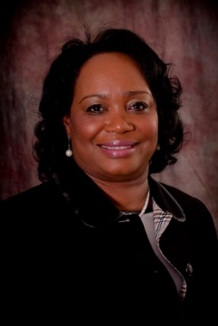

The Office of Vocational Rehabilitation (OVR) managed over **13,500** consumer cases during the **Federal Program Year 2021.** OVR’s overall mission is to provide successful competitive integrated employment outcomes for individuals with disabilities. Competitive integrated employment emphasizes employment within work settings, competitive wages and benefits, and advancement opportunities equivalent to jobs held by individuals without disabilities. Employment in the community and economic self-sufficiency can be achieved with appropriate vocational rehabilitation services and supports.

OVR continued to implement and offer extensive training to staff to provide, collect and document regulations as required by the Workforce Innovation and Opportunity Act (WIOA). OVR training is a continuous process and we will continue to ensure that the OVR staff, specifically VR Counselors who provide direct services, possess a 21st century knowledge of the labor market. With the utilization of performance development strategies, VR can effectively measure the services provided to individuals with disabilities. VR’s approach is to engage with the consumer to assist them with skill development and to obtain credentials to compete for employment opportunities in today’s competitive labor market.

In-depth focus of public awareness through outreach activities presents positive opportunities of VR service offerings to individuals with disabilities. Connecting with this population will develop the VR program to effectively serve these individuals with career path options thereby increasing their ability to achieve self-sufficiency.

OVR’s concentration on serving students with disabilities has developed into progressive relationships with schools and providers throughout Mississippi. These partnerships have aligned our services with the Workforce Innovation and Opportunity Act (WIOA) requirements. These working relationships have helped the educational community gain an understanding of the Pre-Employment Transition Services (Pre-ETS) Program. The Pre-ETS Program is designed to assist Mississippi students with disabilities to understand their career paths, make career decisions, and explore opportunities. After the provisions of these services, students are then ready to make an informed decision regarding post-secondary training and employment opportunities.

We are pleased to have the Mississippi State Rehabilitation Council as an important partner in the success of the OVR program and the consumers we serve. We appreciate the continued support of our MDRS Executive Director as we continue our mission to provide exceptional vocational rehabilitation services. We look forward to the continued partnership and support as we provide Mississippi job seekers with disabilities with the highest quality employment and training services.

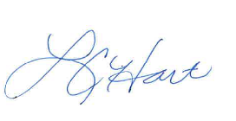

LaVonda C. Hart, MS, CRC

Director, Office of Vocational Rehabilitation

Mississippi Department of Rehabilitation Services

**Office of Vocational Rehabilitation**

**2021 PERFORMANCE INDICATORS**

The OVR Program was able to provide services to over **13,500** Mississippians with disabilities to receive training and skills for meaningful employment during the past year. **2,575** Mississippians with disabilities became employed after receiving OVR services.

OVR services are provided through the federal grant (78.7 percent) through Rehabilitation Services Administration (RSA), our federal partner, which is state matched with appropriation (21.3 percent) from the Mississippi Legislature. Without these funds, over **13,500** Mississippians with disabilities in need of services would not have had access to VR services. Under Section 116(b)(2)(A) of WIOA, there are six Primary Indicators of Performance.

OVR will continue to submit quarterly 911 data in order to establish baseline information for our common performance measures. OVR received data on the WIOA new performance indicators from the quarterly data dashboard report from the RSA Dashboard. The RSA Dashboard, 1st quarter through 4th quarter data for **PY 2021**  (**July 1, 2020 through June 30, 2021**) indicated the following:

* **Employment Rate - 2nd Quarter After Exit: 52.9% -** The percentage of participants who are in unsubsidized employment during the second quarter after exit from the program (for Title I Youth, the indicator is the percentage of participants in education or training activities, or in unsubsidized employment during the second quarter after exit);
* **Employment Rate – 4th Quarter After Exit: 51.3% -**  The percentage of participants who are in unsubsidized employment during the fourth quarter after exit from the program (for Title I Youth, the indicator is the percentage of participants in education or training activities, or in unsubsidized employment during the fourth quarter after exit);
* **Credential Attainment: 21.1% -** The percentage of those participants enrolled in an education or training program (excluding those in on-the-job training (OJT) and customized training) who attain a recognized postsecondary credential or a secondary school diploma, or its recognized equivalent, during participation in or within one year after exit from the program;
* **Measurable Skill Gains: 69.7% -** The percentage of program participants who, during a program year, are in an education or training program that leads to a recognized postsecondary credential or employment and who are achieving measurable skill gains, defined as documented academic, technical, occupational, or other forms of progress, towards such a credential or employment.
* **Effectiveness in Serving Employers:** WIOA Sec. 116(b)(2)(A)(i)(VI) requires the Departments to establish a primary indicator of performance for effectiveness in serving employers. The departments are piloting three approaches designed to gauge three critical workforce needs of the business community. (*Data is not available yet)*

|  |
| --- |
| **Office Of Vocational Rehabilitation**  **ADDITIONAL VR PROGRAM SERVICES AND HIGHLIGHTS** |

* **3,016 individuals** who are **Deaf, Hard of Hearing, Deafblind or Late Deafened** received services resulting in **1,195** being **successfully employed**.
* **800 plus hours** of interpreting services were provided by the **Office of Deaf and Hard of Hearing (including for the office of Governor Tate Reeves)**.

* **AbilityWorks served 1,216** clients this year through the provision of Vocational Evaluation and Work Adjustment Services.
* **15** Community Rehabilitation Programs (CRPs) known as AbilityWorks are operated by MDRS.
* **583** Mississippians received Section 511- **Career Counseling Information and Referral** (CCIR)

|  |
| --- |
| **OVR: SERVING MISSISSIPPI STUDENTS AND**  **YOUTH WITH DISABILITIES** |

**Pre-Employment Transition Services:**

Students with disabilities, ages 14-21, receive the Pre-Employment Transition Services (Pre-ETS) listed below (as needed) to help prepare for post-secondary education such as college, vocational schools, etc.

* Counseling on opportunities for post-secondary education such as college, vocational schools, etc.;
* Work-Based Learning Experiences, including internships and On-the-Job Training;
* Training in self-advocacy and social skills; and/or
* Peer Mentoring Programs at MSU, USM and NEMCC, and EMCC.

**Supported Employment:**

Many clients require more extensive support services in order to adjust to or remain on the job.  Supported employment can provide a vocational training instructor or job coach to provide training on the job at the jobsite.

* **548** **Mississippian**s were served by **Supported Employment Program**
* **55** obtained and retained **employment**
* **99** Closed Non-Rehabilitated in **Supported Employment**
* **40** New **Support Contracts** Signed
* Success of **Referrals** received for Clients: **ID/IDD-29; 1915i-31; SMI-92**

***Continued,* OVR: ADDITIONAL VR PROGRAM SERVICES AND HIGHLIGHTS**



**Project SEARCH Mississippi is administered by the Mississippi Department of Rehabilitation Services and is a joint partnership between MDRS, a business and a school district.**



**Current Sites/Participating Schools**

**University Medical Center-Jackson**

**Rankin County Schools**

**Baptist Hospital-Jackson**

**Clinton Public School District**

**Forrest General-Hattiesburg**

**Hattiesburg, Petal and Lamar County School District**

**North Mississippi Medical Center-Tupelo**

**Tupelo School District**

**South Central Regional Medical Center-Laurel**

**Jones County School District**

**Merit Health River Region-Vicksburg**

**Vicksburg-Warren School District**

**Baptist Medical Center-**

**Attala-Kosciusko/Kosciusko-Attala School District**

**Viking/Alluvian-Greenwood**

**J Z George School District**

**King Daughters Hospital-Brookhaven**

**Brookhaven School District**

**Singing River Hospital-Ocean Springs**

**Ocean Springs School District**

**Neshoba General Hospital-Philadelphia**

**Neshoba County School District**

**Baptist Memorial Hospital-North Mississippi**

**Lafayette High School/Oxford School District**

**Baptist Memorial Hospital-DeSoto**

**DeSoto County School District**

**www.mdrs.ms.gov**

**What is Project Search?**

The Project SEARCH Program is a unique, business-led, nine-month employment preparation program that takes place entirely at the workplace. Up to 12 students with disabilities experience total workplace immersion, classroom instruction, career exploration, and hands-on training through three different worksite rotations. The goal for each participant is competitive employment. To reach that goal, the program provides real-life work experience combined with training in employability and independent-living skills to help young people with significant disabilities make successful transitions to productive adult life.

**Project Search Mississippi Success**

* Nearly **100** individuals with disabilities have graduated from Project SEARCH Mississippi since Project SEARCH UMMC launched in August 2018.
* **57** of those individuals have gained employment.
* **5** individuals are currently participating in a 320-hours paid internship which will result in gainful employment.
* The job search continues for graduates. Project SEARCH 2021-2022 kicks off in August with **13** sites across the state.

***Continued,* OVR: ADDITIONAL VR PROGRAM SERVICES AND HIGHLIGHTS**

|  |
| --- |
| **OVR/OVRB Provided** |

* **1,632** **Potentially Eligible Students** (VR/VRB) with disabilities ages 14-21 were provided **Pre-Employment Transition services (Pre-ETS)**.
* **1,200 transition students/youth** with disabilities were provided career and training services.
* **63 students** with disabilities obtained competitive integrated employment upon transitioning from high school.
* OVR/OVRB Transition and Potentially Eligible Students served numbers dropped substantially this year (statewide) due to the Covid-19 restrictions in the school districts.

**Office of Vocational Rehabilitation**

**DISTRICTS SERVED**

**District I**

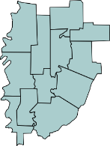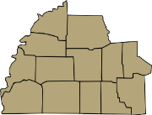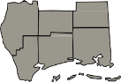

District I

District II

District III

District IV

District V District VI District VII

District VIII

District IX

District X

**Kenisha Black, District Manager**

*(Calhoun, Coahoma, Desoto, Lafayette, Marshall, Panola, Tate, Tunica, Quitman, Yalobusha)*

51 County Road 166

Oxford, MS 38655

(662) 234-3171

**District II**

**Keely Green, District Manager**

*(Alcorn, Benton, Itawamba, Lee, Pontotoc, Prentiss, Tippah, Tishomingo, Union)*

2620 Traceland Drive

Tupelo, MS 38801

(662) 842-1010

**District III**

**Kristin Brock, District Manager**

*(Bolivar, Carroll, Grenada, Holmes, Humphreys, Issaquena, Leflore, Sharkey, Sunflower, Tallahatchie, Washington, Yazoo)*

104 Professional Plaza

Greenwood, MS 38930

|  |  |
| --- | --- |
| (662) 453-6172  **District IV**  **(Vacant), District Manager**  *(Clay, Chickasaw, Choctaw, Lowndes, Monroe, Montgomery, Oktibbeha, Webster)*  207 Industrial Park Road  Starkville, MS 39759  (662) 323-9594  **District V**  **Janet Darden, District Manager**  *(Hinds, Warren)*  3895 Beasley Road  Jackson, MS 39213  (601) 898-7004  **District VI**  **Mary Habig, District Manager**  *(Attala, Leake, Madison, Rankin, Scott, Simpson, Smith)*  1032 Center Pointe Blvd.  Pearl, MS 39208  (601) 706-5600  **District VII**  **Sandra Sanders, District Manager**  *(Clarke, Jasper, Kemper, Lauderdale, Neshoba,*  *Newton, Noxubee, Winston)*  1003 College Drive  Meridian, MS 39304  (601) 483-3881 | **District VIII**  **Jeanette Yates, District Manager**  *(Adams, Amite, Claiborne, Copiah, Franklin, Jefferson, Jefferson Davis, Lincoln, Lawrence, Marion, Pike, Walthall, Wilkinson)*  1221 Parklane Road, NE McComb, MS 39648  (601) 249-2498  **District IX**  **Jean Walley, District Manager**  *(Covington, Forrest, Greene, Jones, Lamar, Perry, Wayne)*  17 J.M. Tatum Industrial Drive, Suite 130 Hattiesburg, MS 39401  (601) 545-5619  **District X**  **Kathy Woodard, District Manager**  *(George, Hancock, Harrison, Jackson, Pearl River, Stone)*  13486 Fastway Lane  Gulfport, MS 39503  (228) 575-3789 |

**Office of Vocational Rehabilitation**

**EMPLOYMENT OUTCOMES – VR CONSUMERS 2021**

**TOP 10 OCCUPATIONS – INTEGRATED SETTING**

Below is a chart showing the Top 10 Occupations of VR Consumers and the number of clients that were employed in these occupations.

|  |  |
| --- | --- |
| **OCCUPATION** | **NUMBER OF CLIENTS** |
| Office and Administrative Support | 260 |
| Management | 198 |
| Transportation and Material Moving | 174 |
| Sales and Related | 140 |
| Skilled Craft | 137 |
| Healthcare Practitioners and Technical | 119 |
| Production | 112 |
| Personal Care and Service | 103 |
| Food Preparation and Serving Related | 100 |
| Construction and Extraction | 94 |

**Top 10 Occupations - VR**

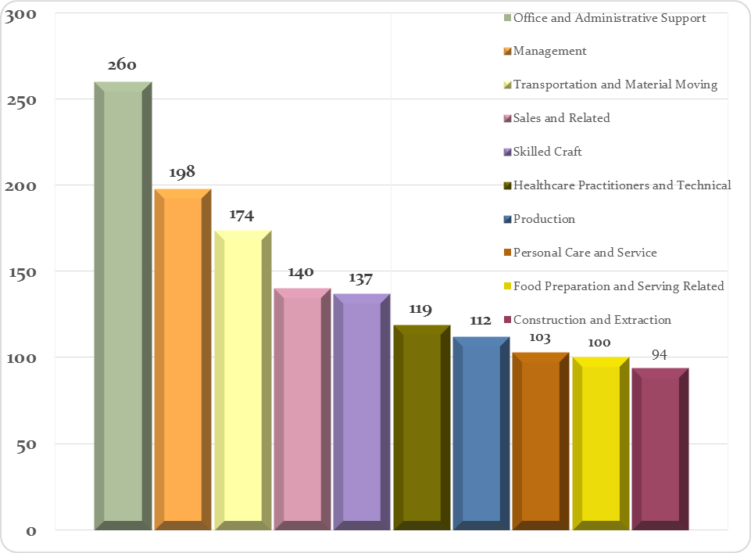

**Office of Vocational Rehabilitation**

**DEMOGRAPHICS OF CLIENTS SERVED 2021**

**ETHNICITY / RACE - VR**

|  |  |  |
| --- | --- | --- |
| **Ethnicity / Race** | **Clients** | **%** |
| White | 7754 | 55.98% |
| Black or African American | 5634 | 40.67% |
| Hispanic or Latino | 202 | 1.46% |
| American Indian or Alaskan Native | 131 | 0.95% |
| Asian | 70 | 0.51% |
| Does not wish to Self-Identify | 24 | 0.17% |
| Native Hawaiian or Pacific Islander | 20 | 0.14% |
| Not completed | 17 | 0.12% |

***(Clients can choose more than one race)***

***VR-Ethnicity/Race Statistics includes Potentially Eligible***

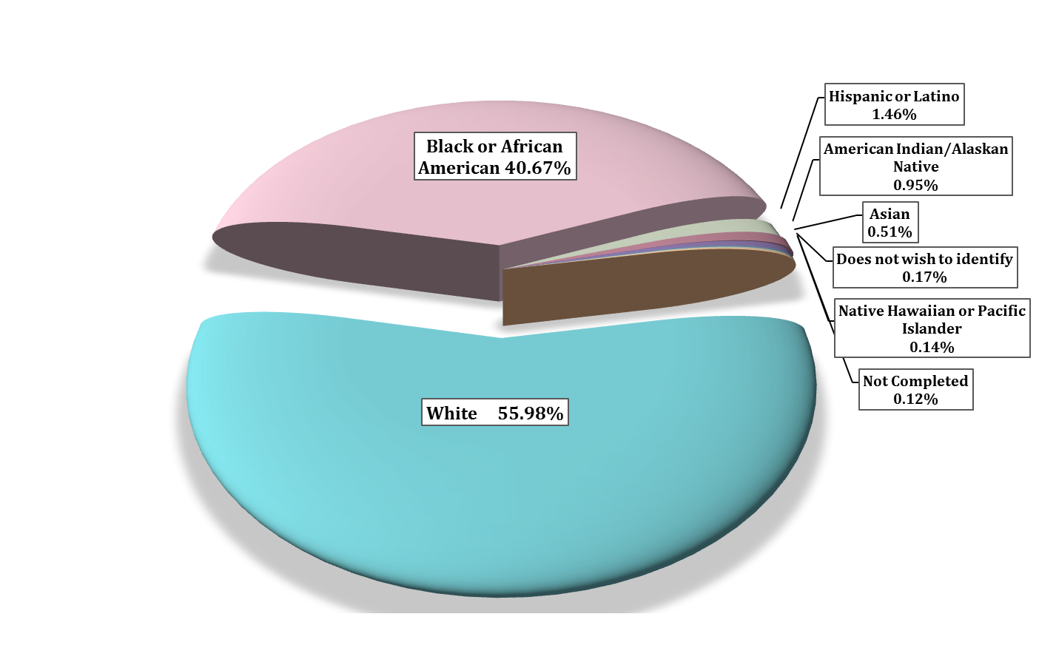**VR – Ethnicity/Race Demographics**

**10/1/20 - 9/30/21**

**Office of Vocational Rehabilitation**

**DEMOGRAPHICS OF CLIENTS SERVED 2021**

**AGE RANGE – VR**

|  |  |  |
| --- | --- | --- |
| **Age Range** | **Clients** | **%** |
| 21 & Under | 4507 | 33.38% |
| 22-30 | 1890 | 14.00% |
| 31-40 | 1536 | 11.38% |
| 41-50 | 1666 | 12.34% |
| 51-60 | 1956 | 14.49% |
| 61-70 | 1336 | 9.90% |
| 71-80 | 520 | 3.85% |
| 81-100 | 90 | 0.67% |
| **TOTAL** | **13,501** | |

***VR-Age Range Statistics includes Potentially Eligible***

**VR - Age Range Demographics**

**10/1/20 - 9/30/21**

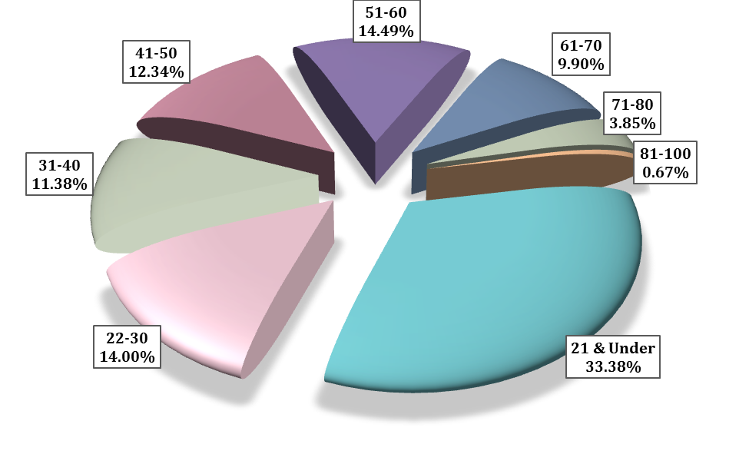

**OVR SUCCESS STORIES – *Client Spotlight***

***LaDarrius Harrell’s Work Ethic Sets Him Apart***

By J. E. Gates

Twenty-year-old LaDarrius Harrell of Liberty can be counted on to show up for work on time and work hard on the job.

LaDarrius has attention-deficit/hyperactivity disorder, commonly known as ADD/ADHD, but that hasn’t stopped him from winning accolades for his work ethic on his first full-time job.

After LaDarrius’ internship with Greentree Lumber Company of Liberty, the company hired him in November 2020 as a manual lumber stacker, citing his work ethic. “We have enjoyed having LaDarrius as part of the Teal Jones team in Liberty,” Leigh Allen, a vice president with Greentree, said in an email. “He has an excellent attendance record and good performance reviews.” LaDarrius has received two performance-based raises in the year he has been on the job. And he received an additional raise when Greentree Lumber was purchased in July by the Teal Jones Group.

LaDarrius was diagnosed with ADD/ADHD at age 5. The National Institute of Health defines ADHD as an ongoing pattern of inattention and/or hyperactivity-impulsivity that interferes with functioning or development.

In LaDarrius’ case, he said he doesn’t like to be touched and sometimes doesn’t like distractions. Despite having to deal with those who didn’t understand a person living with ADHD, LaDarrius was able to complete high school.

When asked his advice for others with a disability, LaDarrius replied: “Don’t let a disability affect what you do. Keep doing what you like.”

LaDarrius credits the Mississippi Department of Rehabilitation Services, which has worked with him since age 17, for helping him with his success.

He came to MDRS’ Vocational Rehabilitation services for Transition and Youth Career Services in 2018. LaDarrius received pre-employment transition services, counseling and guidance, job placement, job search/prep, and finally ended up in an internship program with Greentree Lumber.

Mississippi Department of Rehabilitation Services counselor Mickey Abston said he is appreciative of LaDarrius Harrell. “He is a prime example that our program does help benefit people with a disability and it is possible for people with a disability to become employed and remain gainfully employed,” Abston said of LaDarrius. “That is what we put in the work for.” Abston said LaDarrius is a very nice man when you talk to him. He said LaDarrius is prompt and returns your calls. “He handles his responsibilities like a young man should,” Abston said. “He is just a joy to work with.”

MDRS Business Relations Specialist Theresa Taylor says LaDarrius is a good worker with a great spirit who was able to successfully complete training and employment. She said teamwork is essential for success to enhance the lives of individuals with disabilities.

And for LaDarrius’ future, the Amite County High School graduate says he has no plans to leave his job anytime soon. When not working, LaDarrius loves playing basketball and video games. He has two other brothers, and they live in Liberty.

***For services with MDRS Office of Vocational Rehabilitation and to locate an office closest to you,***

***visit*** [***www.mdrs.ms.gov***](http://www.mdrs.ms.gov/) ***and click on the “location finder” link.***

**OVR SUCCESS STORIES – *Client Spotlight***

**Brookhaven 911 Dispatcher: *You Can Move Forward with a Disability***

By J.E. Gates

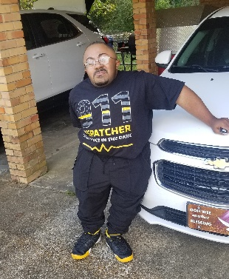At age 12, Alan “Trey” Henderson dreamed of becoming an emergency dispatcher. Eleven years later at age 23, Trey is living his dream as a 911 dispatcher with the Brookhaven Police Department. He works three days a week as a part-time emergency dispatcher. He is also in training to obtain his certification to become a fulltime dispatcher.

However, the Brookhaven native isn’t your typical 911 dispatcher. Trey lives with a disability that has resulted in at least 74 broken bones and three surgeries since birth. He suffers from Osteogenesis Imperfecta, commonly referred to as brittle bone disease. He stopped counting at 74 broken bones but said he has suffered about 30 additional breaks.

Trey, who stands 4’6” tall, uses a rolling walker and a motorized wheelchair to help him get around. Despite his disability, Trey has never let that stop him from achieving his goals in life. He obtained his Associate Degree from Copiah-Lincoln Community College in December 2018. Trey then went to the University of Southern Mississippi where he obtained his Bachelor’s Degree in Liberal Studies with a minor in Communication in December 2020. While at USM, Trey participated in the Peer Mentoring Program. He was also a production staff volunteer for the campus radio station until his on-campus experience was cut short because of the Coronavirus pandemic. He completed his USM studies virtually due to the pandemic.

MDRS, through its Vocational Rehabilitation Program, assisted Trey with his college expenses to obtain his associate and bachelor’s degrees. MDRS also provided Trey with a covered trailer to haul his motorized wheelchair and helped him with his career pathway and search for employment. MDRS helps individuals with disabilities gain independence through employment. MDRS Vocational Rehabilitation services can include educational assistance, job training, vocational evaluation, counseling and guidance as well as providing assistive technology services such as wheelchairs, walkers, and prosthetic devices.

Karen Brooks, a Deputy District Manager for the Mississippi Department of Rehabilitation Services, said it has been a pleasure working with Trey because he is such a polite, friendly, and outgoing young man who never meets a stranger.

In July, Trey began working on his job as a 911 dispatcher for the Brookhaven Police Department after Chief Kenneth Collins told encouraged him to apply for the job. Trey works Friday, Saturday, and Sunday as a dispatcher. He said every day is different and that is one of the reasons he loves his job.

Collins said all Trey needed was for someone to open the door for him to pursue his dream. “He has a disability but that doesn’t mean he can’t work and do the job. He is a very knowledgeable young man. He isn’t looking for a handout,” Collins said. “Trey wants to learn and be the best dispatcher he can be…He was just looking for a door to open and when I opened the door, he took it upon himself to be the best. He is motivated and has a beautiful attitude.” Trey said despite his disability, he has never felt sorry for himself. He credits his parents with his positive outlook on life. “You can move forward with your disability,” Trey said of his advice to others with a disability.

Trey said his parents always told him he can do anything in life through God if he puts his mind to it. I’m very proud of Trey,” said his mother, Victoria Henderson. “His mind has been sharp since day one. I always told Trey you will have to learn to be nice to other people, be respectable to people, and thank God every day of your life. I said if you put God first, you can do anything. Don’t let nobody tell you what you can and cannot do. You are your own person. You set your destiny for you.”

Trey and his family are very thankful for the assistance that MDRS has given him through the Office of Vocational Rehabilitation and the opportunity he was provided. Trey would encourage anyone who has a disability and is seeking employment, to contact their local Vocational Rehabilitation Office.

***For services with MDRS Office of Vocational Rehabilitation and to locate an office closest to you,***

***visit*** [***www.mdrs.ms.gov***](http://www.mdrs.ms.gov/) ***and click on the “location finder” link.***





**Office of Vocational Rehabilitation for the Blind**

***“Alone we can do so little****;* ***together we can do so******much.”- Helen Keller***

Dear Friends and Colleagues,

I am proud to present the Office of Vocational Rehabilitation for the Blind (OVRB) Annual Report for Fiscal Year 2021 (FFY). In the pages that follow, we hope you are inspired to hear the success of our staff and our fellow Mississippians who have accomplished success in their employment, independence and freedom to live just like other Mississippians who are not blind, deafblind, and or visually impaired after receiving services from OVRB.

COVID – 19 is still around and this positions our vocational rehabilitation counselors, instructors, managers, administrative assistants, maintenance team, business consultants and each team member to deliver services differently. Our work involves close contact, working one on one and touching. Social distancing does not exist when you are training clients how to use their white cane, how to make their beds, iron and learn the braille alphabets and new technology. These are activities most individuals may take for granted. For a person that has lost their vision, services provided are the doors to independence. I have only named a few of the services your state employees provide daily throughout our great state. Keep in mind, in spite of COVID, we made the decision to roll up our sleeves, mask up, purchase sanitizers and deliver services to our fellow Mississippians.

In Fiscal year 2021, OVRB served over **1,800** Mississippians with visual disabilities. Moreover, **234** of those individuals closed successfully in Competitive Integrated Employment. Our division offered and provided information on skills and credential attainment to every consumer who has reached out to OVRB. This will help our Mississippians with deciding whether to increase their skills in our state.

Mississippi please be proud of your state employees who have proven that working together and for others gives our state the best return of productive citizens working daily in communities of their choice. Our program served more clients and partnered with our elected officials, county supervisors and county administrators to open more businesses for our Randolph Sheppard Program which provided our Mississippians with employment opportunities across the state. We say thank you to Executive Director Chris Howard, who traveled with us in presenting our program to county and elected officials. Our Committee of Blind Vendors worked with us in making sure we presented our program in unity and proved that blindness does not mean you cannot work.

OVRB is committed to providing quality services to assist eligible Mississippians who are blind, deafblind, or visual impaired in achieving their maximum level of employment, education and personal independence through our 93 employees who are employed throughout our state. This report will highlight improvements and change for every Mississippian who received services from the employees in OVRB. Your report will have an update from the following areas:

* Northern / Southern Region
* Business Enterprise Program (BEP)
* Addie McBryde Center for the Blind
* Mississippi Partners for Informed Choice (M-PIC)

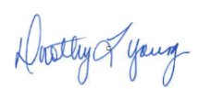Respectfully submitted,

Dorothy L.  Young, M.S., C.V.S.

Director, Office of Vocational Rehabilitation for the Blind

**Office of Vocational Rehabilitation for the Blind**

**OVERVIEW**

The Office of Vocational Rehabilitation for the Blind is divided into two regions located in the North and South. Each region is staffed with qualified professionals who provide vocational rehabilitation counseling, education, independent living skills, orientation and mobility training, low vision rehabilitation technology and Deafblind services for eligible Mississippians. Each client works with their OVRB Counselor to develop their Individualized Plan of Services (IPE) to mirror their strengths, abilities, and capabilities for successful employment outcomes.

In preparation for the 2021 SRC Annual Report, the Regional Office Managers summarized key programs activities and accomplishments in addressing employment and independence.

**The Northern and Southern Region key program highlights are presented in the following sections for period beginning October 1, 2020 through September 30, 2021.**

**Office of Vocational Rehabilitation for the Blind**

**OVRB REGIONS – SERVED: HIGHLIGHTS**

|  |
| --- |
| **OVRB SOUTHERN REGIONAL OFFICE** |

**OVRB SOUTHERN – VOCATIONAL PROGRAM SUMMARY:**

* **356** New Applications
* **291** New employment plans developed
* **132** Closed successfully in Competitive Integrated Employment
* **953** Total Served in the Southern Region

**OVRB SOUTHERN - HIGHLIGHTS:**

* **15** students were provided with Pre-ETS
* **6** graduated high school and entered college or a training program
* **52** clients received Post-Secondary Training services (youth and adult)
* **11** students participated in the NFB Peer Mentoring Program
* **74** outreach activities were completed by VRB South to various community partners

##### ACCOMPLISHMENTS THIS YEAR:

Due to the COVID19 restrictions and CDC Guidelines, the OVRB Southern Region has persevered in keeping their clients safe, as well as, themselves by following the recommended safety protocols. Despite challenges, the staff provides quality services in a timely manner. Then Southern Region staff continues to be committed and dedicated in placing their clients “first” in their daily job duties.

##### INNOVATIVE PRACTICES WITH POSITIVE IMPACTS ON STAFF OR CLIENTS:

To efficiently provide services in a timely manner, the Southern Region staff submits Activity Due Reports monthly. Southern Region management runs a *60 day No Contact* List monthly and sends to the staff. These practices assist staff to effectively manage their caseloads. The staff remains informed of the latest information through scheduled conference calls, Zoom calls and continuous email updates, which has provided them with the information needed to better serve their clients.

*Continued,* OVRB REGIONS – SERVED: HIGHLIGHTS

**OVRB Southern – Client Spotlight**

|  |  |
| --- | --- |
| In 2017, a woman with Usher Syndrome applied for VR services. She was employed at two different locations, but her primary employment was as a front desk clerk at an animal shelter. Her vocational goal was to maintain that employment, because she loved her work. Usher Syndrome is a combination of sensorineural hearing loss and vision loss from retinitis pigmentosa. The client's initial IPE included personal adjustment training and orientation and mobility training at the Addie McBryde Rehabilitation Center for the Blind, a low vision assessment, hearing aids, and counseling and guidance services.  Through her training at the Addie McBryde Center, the client gained more confidence in her ability to live independently. She gained some valuable skills and relationships through her time in training. On one occasion, the counselor visited the MS State Fair with the client, during a client outing through the Addie McBryde Center. The counselor observed the client's orientation and mobility skills and noted how well the client was traveling independently with her cane - she had never used a cane before. The client informed the counselor that she felt so much more confident and had even gone to restaurants with friends, which she had not done in several years due to fear of not being able to see anything. | The client said that she was glad to have experienced the training at the Addie McBryde Center. As the case progressed, the counselor purchased low vision aids and an assistive technology device that connected her office phone to her hearing aids, in order to help her to help her to maintain her employment.  Through these services and counseling and guidance, the client was able to better understand the nature of Usher Syndrome, to accept her level of ability and the possibility of its decline. She also gained confidence and an understanding of how to use simple household items to label or mark important things in her home. She learned how to declutter and modify her home environment to best suit her visual needs. Close to the end of her case, her daughter moved out of the house, and the client lived alone. Through counseling and guidance, along with information and referral services, the client was able to adapt to the change and live independently. She was able to successfully maintain her employment and was successfully closed in 2020. She has been referred to independent living for the blind for any additional in-home service needs. |

*Continued,* OVRB REGIONS – SERVED: HIGHLIGHTS

|  |
| --- |
| **OVRB NORTHERN REGIONAL OFFICE** |

**OVRB NORTHERN – VOCATIONAL PROGRAM SUMMARY:**

* **341** New applications
* **244** New employment plans developed
* **128** Closed successfully in Competitive Integrated Employment
* **916** Total served in the Northern Region

**OVRB NORTHERN - HIGHLIGHTS:**

* **15** students were provided with Pre-ETS.
* **3** graduated high school and both entered college or a training program.
* **9** students participated in an MDRS Internship Program.
* **5** of these students participated in the NFB Peer Mentoring Program.
* **28** clients received Post-Secondary Training services (adult and youth).
* **12** outreach activities were completed by VRB North to various community partners.

##### INNOVATIVE PRACTICES WITH POSITIVE IMPACTS ON STAFF OR CLIENTS:

Due to Covid-19 restrictions and guidelines, the reporting period was impacted which required the staff to find innovative ways of providing services to clients. Staff adapted to a distance model of service delivery and client services have returned to pre-pandemic levels based on numbers of new cases and new programs.

Not only did OVRB North learn to navigate through the pandemic but also managed several vacancies. During this time period 6 employees were hired to fill vacancies. Training for these new employees is ongoing. At preset OVRB North is fully staffed.

*Continued,* OVRB REGIONS - SERVED: HIGHLIGHTS

**OVRB Northern – Client Spotlight**

|  |  |
| --- | --- |
| Andrew Clark, an area high school senior with optic atrophy, arrived to complete his OVRB application with staff counselor. He presented himself as a very nice and pleasant individual and answered all questions without difficulty. Although Mr. Clark’s diagnosis was progressive and there is no treatment available to improve Mr. Clark's vision, he would initially rely on Low Vision Aids and Assistive Technology to improve his visual acuity. With determination and the support of his mother and the Mississippi Department of Rehabilitation Services, Mr. Clark felt he could reach his goals in obtaining a Mississippi State University (MSU) Bachelor’s degree and gainful employment for a better quality of life.  Following the determination of his eligibility, Mr. Clark, his mother and his then counselor, met to devise his Individualized Plan for Employment (IPE). They discussed varying initial employment goals such as management, zoologist, and customer service representative among several others. He had many different interests and his numerous choices were positions that were not entry level; Mr. Clark realized he would need to "work his way up". At such time, together with those involved, they chose the goal customer service representative, because of his personality and ability to problem solve. Mr. Clark also understood he could change his employment goal at any time.  The VRB brochure was studied and discussed for possible services. Mr. Clark initially requested assistance with bioptic lenses, as well as training with the lenses with the MSU T.K. Martin Center. After doctor evaluation, Mr. Clark was recommended as a candidate to utilize the bioptic lenses for bioptic driving. As an additional service, Mr. Clark also requested assistance with Counseling and Guidance (C & G) to assist him through the training process of driving with bioptics, as well as the adjustment to using bioptics. At that time, Mr. Clark did not use Low Vision Aids, in the classroom, but felt once he entered the larger college classroom, they (low vision aids) may be necessary for him to be successful; therefore, he may need assistance with adjusting to the fact of his disability becoming more visible to his peers. | Furthermore, he anticipated high school graduation that spring and believed he would also benefit from  C & G through the transition into college, throughout the pursuit of his education, and upon entering the employment world. Ultimately, Mr. Clark was able to obtain his driver license.  Mr. Clark was able to utilize the Addie McBryde Center for Vocational and Low Vision Evaluation, to which he reported a pleasant and enjoyable experience. Low Vision Aids recommendations were provided through evaluation. Counselor discussed the recommendations with Mr. Clark and, through informed choice, he made his selections; these selections were those that best fit him and were authorized for, by counselor, to render assistance with a better educational journey. Yet, a definite employment goal was still unclear.  Mr. Clark finally reached his decision to major in Marketing at Mississippi State University with plans to become a Marketing Agent thereafter. With this employment goal and high school transcripts indicating a 4.04 GPA at high school graduation, Mr. Clark’s request for OVRB sponsorship in his post-secondary education was considered.  After graduation, Mr. Clark was able to meet with MDRS Career Counselor to receive tips for his anticipation of employment. Shortly after the consultation, Mr. Clark was offered an entry-level position with the parks commission in Ohio, his hometown, as a community engagement specialist and recreation specialist, a position which could possibly lead to advancement in the company. Completing paperwork and background checks with the company solidified the deal, along with accepting the offer; as of August 2021, he is now one of the company’s newest employees.  Mr. Clark has been an inspiration to all who have worked with him on his journey. He has defeated odds pertaining to his visual impairment by, but not limited to, taking advantage of opportunities rendered by Mississippi Department of Rehabilitation Service/Office of Vocational Rehabilitation for the Blind. Mr. Clark has also defied the odds as an energetic, passionate about life, purpose-driven young man who just so happens to have been diagnosed with a progressive eye condition. |

**Office of Vocational Rehabilitation for the Blind**

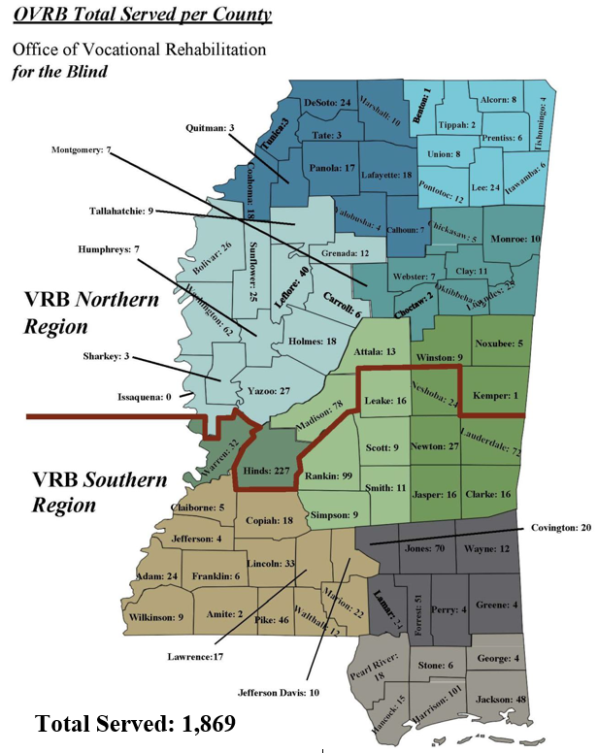**REGIONAL MAP**

**Office of Vocational Rehabilitation for the Blind**

**EMPLOYMENT OUTCOMES – VRB CONSUMERS**

**TOP 10 OCCUPATIONS – INTEGRATED SETTING - 2021**

The Job Table below shows the ‘Top 10 Occupations’ obtained by the OVRB **Consumers who successfully achieved** their employment goal in **Program Year 2021**.

|  |  |
| --- | --- |
| **OCCUPATION** | **NUMBER OF CLIENTS** |
| Office and Administrative Support Occupations | 27 |
| Management Occupations | 24 |
| Skilled Craft | 22 |
| Sales and Related Occupations | 17 |
| Transportation and Material Moving Occupations | 17 |
| Personal Care and Service Occupations | 17 |
| Building and Grounds Cleaning & Maintenance | 11 |
| Education, Training and Library Occupations | 11 |
| Construction and Extraction Occupations | 10 |
| Protective Services Occupations | 10 |

**Office of Vocational Rehabilitation for the Blind**

**EMPLOYMENT OUTCOMES – VRB CONSUMERS - 2021**

The success of an OVRB Program is the job seekers with disabilities who leave the program having achieved their employment goal. The employment categories below use the term found in the federal reporting on outcomes.

|  |  |
| --- | --- |
| **Self – Employment (includes BEP – Randolph Sheppard)** | **2** |
| **Employment with support in Competitive Integrated Employment** | **234** |
| **Self – Employment (except BEP)** | **24** |

**Office of Vocational Rehabilitation for the Blind**

**DEMOGRAPHICS OF CLIENTS SERVED - 2021**

**ETHNICITY / RACE - VRB**

|  |  |  |
| --- | --- | --- |
| **Ethnicity / Race** | **Clients** | **%** |
| Black / African American | 1,025 | 53.50% |
| White | 822 | 42.90% |
| Multi-Racial | 35 | 1.83% |
| Asian | 16 | 0.84% |
| American Indian/Alaskan Native | 11 | 0.57% |
| Does not wish to self – identify | 3 | 0.16% |
| Native Hawaiian/Pacific Islander | 3 | 0.16% |
| Not completed | 1 | 0.05% |

**Office of Vocational Rehabilitation for the Blind**

**DEMOGRAPHICS OF CLIENTS SERVED – 2021**

**AGE RANGE - VRB**

|  |  |  |
| --- | --- | --- |
| **Age Range** | **Clients** | **%** |
| 20 & Under | 89 | 4.76% |
| 21 – 30 | 207 | 11.08% |
| 31 – 40 | 240 | 12.84% |
| 41 – 50 | 323 | 17.28% |
| 51 – 60 | 581 | 31.09% |
| 61 – 70 | 402 | 21.51% |
| 71 – 80 | 25 | 1.34% |
| 81 – 90 | 2 | 0.11% |
| **TOTAL** | **1,869** | |

**Office of Vocational Rehabilitation for the Blind**

***SERVING MISSISSIPPI***

**OVRB by Numbers**

***Serving Mississippi Blind and Visually Impaired Job Seekers***

* **1,869** Mississippians who are Blind and Visually Impaired were served.
* **697** New applications submitted.
* **535** Individuals who are Blind and Visually Impaired started a new Individualized Plan for Employment (IPE) designed to reach a competitive employment outcome for the first time.
* **260** Individuals who are Blind, Visually Impaired, and Deafblind reached their career goal and entered the Mississippi Workforce.

|  |
| --- |
| **Addie McBryde Rehabilitation Center for the Blind**  **Serving Mississippians with Limitation**  **with Orientation / Mobility and Everyday Living** |

Mrs. Adeline Wiseman McBryde was born in October 1883 in Cotton Plant, Mississippi. She received her education in the Tippah public school system. In 1938, when the Division of the Blind was created to the Department of Public Welfare, Mrs. McBryde was selected as the Director. After her death in October 1958, Senate Bill Number 1644, ‘The Adjustment Center for the Blind Act of 1968’, was approved and passed in the Mississippi State Senate. This paved the way for the Addie McBryde Memorial Rehabilitation Center for the Blind.

Established in May 1972, the Addie McBryde Rehabilitation Center for the Blind is located in Jackson, Mississippi on the campus of the University of Mississippi Medical Center (UMMC). The Addie McBryde Center provides traditional intensive evaluation, training, and adjustment services on the campus. In 2021, the Addie McBryde Center provided training to 84 consumers.

The facility has a dormitory capacity for 28 clients, a gymnasium, a client library and classrooms equipped with specialized technology for the Blind and Visually Impaired. Certified Instructors provide individualized training to meet the clients’ needs during the class day from 8:00 AM to 3:00 PM. Clients participate in additional activities in the ‘*Job Readiness’* class focusing on adjustment to vision loss, confidence building, resume writing, interviewing and utilizing resources in the community.

*Continued,* OVRB: Serving Mississippi

**SNAPSHOT OF SERVICES:**

* O&M **27**
* Braille **15**
* Blindness Adjustment **57**
* Job Readiness **5**
* Adult Coaching **3**
* Vocational Evaluation **33**
* Mobile Technology Class **15**
* Low Vision Assessment **16**

*\*No Summer Program due to Covid 19*

|  |
| --- |
| * M |

**Classes offered include:**

* **Orientation and Mobility** - training in use of the long white mobility cane, residential and business travel, use of public transportation, sighted guide and protective techniques
* **Communication/Advanced Communication** - training in braille, adaptive equipment, handwriting, keyboarding, use of the personal computer utilizing both magnification and screen readers
* **Personal Management** - meal planning and preparation, nutrition, shopping, storing and labeling, including organization and safety in the kitchen
* **Techniques of Daily Living** – laundry, housekeeping, grooming, and hand sewing
* **Recreation and Leisure Education** - physical conditioning, arts and crafts, community activities

*Continued,* OVRB: Serving Mississippi

**Addie McBryde Rehabilitation Center – Client Spotlight**

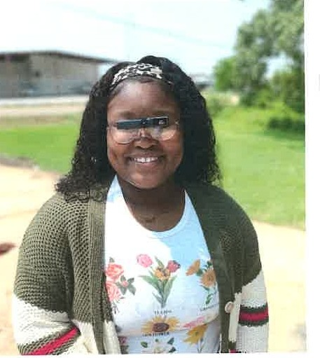

Wow, I really am at a loss of words right now. To have the privilege of writing my success story while at Addie McBryde is truly amazing. Perhaps there is nothing more disorienting than losing your vision. My world was turned upside down. The independence once taken for granted was shattered and fell to the floor. One's previous existence seems as distant as another life. Falling into a deep depression along with severe anxiety, I felt as if my opportunities were very much so limited. Over 10 million Americans are coping with blindness, either totally or through some extent of visual impairment, according to the American Foundation for the Blind. It is nearly impossible to understand the scope of the problem unless one has personal experience in coping with blindness, or is helping someone else cope.

At first, all I had that had helped me through the never-ending days was my faith. With the help of family, friends, church members, and Addie McBryde Rehabilitation Center, I had begun to believe there was a purpose for me. Addie McBryde provided more of an individualized therapy and looked at the individual as a whole and not just as a textbook diagnosis. They did not move on until they felt the client was ready for it and I appreciated that. I was finally able to relax mentally, physically, and emotionally while concentrating on healing so I could focus on getting my life back on track after years of turmoil. Psalms 145 in its entirety kept me sane through the transition of completely losing something I tried so dearly to hold on to. Verse 17 of Psalms 145 enriches my mind and soul the more I read along with prayer for better days ahead.

Even though I did not think so at the time, everything God does is right - the trademark on all His works is love. I know not everyone is religious but everyone needs something to motivate them. For me, it's being reminded in His everlasting word that God loves unconditionally and hears every prayer. Every staff member, from the receptionist to the director, at Addie McBryde, were professional and kept me very informed of not only my progress but how they believed in me and oh how proud of me they still are. While there, I decided to complete my teaching certificate and start my Master's in Biological Sciences/Human Physiology.

Relearning how to live in this world again teaches patience, perseverance, determination and so much more. Taking everything that I have been through this past year and using it as a learning lesson is something that will be beneficial to developing a more positive lifestyle. Being blind or visually impaired is a spectrum in which the uniqueness flows throughout each person in such a positive energy that embraces, respects, and promotes self-confidence, peer motivation, and daily learning along with a love for one another. Together with the help of everyone who has impacted my transition and plenty of determination, I learned the coping skills needed to navigate the world with blindness. I have grown to love my new normal and I thank the Addie McBryde Rehabilitation Center.

**Office of Vocational Rehabilitation for the Blind**

**THE BUSINESS ENTERPRISE PROGRAM (BEP)**

The **Business Enterprise Program (BEP)** provides support for self-employment opportunities in the food service industry for Mississippians who are legally Blind. These BEP entrepreneurs operate a variety of businesses including vending machine routes, snack bars, and military base cafeterias.

**In 2021, 35 Blind Entrepreneurs** operated successful businesses as BEP vendors:

* **235** individuals employed supported by BEP operators
* **215** sites in 33 cities across the state

***Contributing to Mississippi Economy***



**$13,077,595.65**

**Total Sales**



**$55,365.00**

**Sales Tax Paid**



**$8,616,190**

**Wages Paid**

**Business Enterprise Program (BEP) – Spotlight**

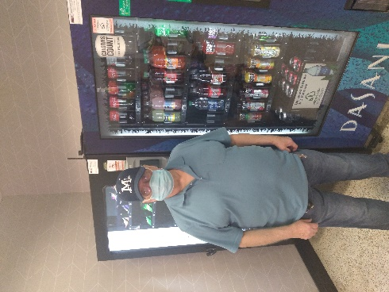Joe Bishop, a Business Enterprise of Mississippi Entrepreneur, is the Manager and Operator of McBryde Snack Bar. Mr. Bishop was diagnosed with optic atrophy which affects the optic nerves. Mr. Bishop’s motto for his business is, “Don’t Charge ‘Em What Your’re not Willing to Pay Yourself.” He has been with the program for over 40 years and is an active member of the COBV (Committee of Blind Vendors).

Joe currently manages five (5) vending machines at Addie McBryde in Jackson, MS with his loving wife, Juanita who he affectionately calls “The Business Manager”. With the help of the Mississippi Department of Rehabilitation Services, Office of Vocational Rehabilitation for the Blind, Mr. Bishop is able to continue to be a vital Mississippi business owner and taxpayer.

**Office of Vocational Rehabilitation for the Blind**

**Independent Living Services for the Blind (ILB)**

The Office of Vocational Rehabilitation for the Blind **- Independent Living for the Blind Program (ILB)** provides services to assist legally Blind individuals adjust to their blindness. The eligibility requirements for the **Older Blind Program** are age 55+ and legal blindness. The Part B eligibility requirements are legal blindness and a significant secondary disability. For both programs, gainful employment may not be feasible but independent living goals are feasible.

The **Itinerant Teacher Program** began in 1994 to provide services to consumers served by VRB who could not attend the Community Rehabilitation Program (Addie McBryde Center) or who did attend and needed follow-up services in the home or on the jobsite. Itinerant Teachers provide services in the consumer’s home, community or work environment. Teachers work closely with the VRB Counselors to coordinate services, evaluate client needs, develop living-needs plans, and provide instructional materials and onsite training.

**Some services include**:

* Low vision assessment: evaluations for magnifiers, portable CCTV’s, and other

optical devices;

* Marking office equipment or home appliances;
* Non–optical adaptive devices: check and signature guides, talking clocks, money identifiers, cooking items, large button phones, etc.;
* Orientation and mobility services or travel training: sighted guide and protective techniques and training in the use of a cane; and/or
* Follow-up training after services has been provided.

**Independent Living Services for the Blind (ILB)** enables eligible consumers to receive peer group counseling, assistive technology evaluation, adjustment services, orientation and mobility training, personal adjustment instruction and training in techniques for daily living. In **2021**, due to Covid-19, the Older Blind Program had a decrease in indirect services (health fairs, vision screening, peer groups, and outreach).

Several staff provided **in-service trainings** to about **60** **participants**. ILB also hosted monthly Peer Support Group meetings utilizing distance technology. A total of **43 peer meetings** were held by conference calls during the year reaching about **132 participants**. ILB provided direct services to **716 consumers** who are legally Blind and either over the age of 55 or have a significant secondary disability by providing a variety of independent living services.

* **76** New Applications submitted
* **76** Seniors started services for the first time
* **118** Carry over from previous year(s)

*Continued,* OVRB: Independent Living Services for the Blind (ILB)

**Providing Services that Promote Independent Living**

* Private Residence  **510**
* Senior Community **1**
* Assisted Living  **5**
* Nursing Home **6**

**Progress Made by the Clients who Received ILB Services**

|  |  |  |  |
| --- | --- | --- | --- |
| **SERVICES** | **TOTAL** | **PROGRESS** | **NO PROGRESS** |
| **Daily Living Skills** | **249** | 61 | 188 |
| **Orientation & Mobility** | **15** | 4 | 11 |
| **Assistive Technology** | **73** | 34 | 39 |

|  |  |  |
| --- | --- | --- |
| **ASSISTIVE TECHNOLOGY FOR OLDER CONSUMERS** | | |
| **Assistive Technology: Devices** | $5,476.09 | 6 Consumers |
| **Home Appliances** | $23.20 | 1 Consumer |
| **Low Vision Aids** | $18,966.64 | 176 Consumers |
| **TOTAL** | **$24,465.93** | **183 Consumers** |

**Office of Vocational Rehabilitation for the Blind**

**Mississippi Partners for Informed Choice**

The **Mississippi Partners for Informed Choice (M-PIC) Program** provides *Work Incentives Planning* and *Assistance (WIPA)* services funded by the Social Security Administration (SSA) under the *Ticket-to-Work* and Work Incentives Improvement Act of 1999.

**Work Incentives Planning and Assistance (WIPA)**

The purpose of *M-PIC/WIPA* is to enable and serve all SSA beneficiaries with disabilities (including Transition-to-Work aged youth) to make informed choices about work and provide *Benefits Planning* and assistance services on request or as resources permit. There are more than 100 WIPA grantees in the United States. The programs employ certified *Community Work Incentive Coordinators (CWICs)* and each serve a specific region of the state.

**Community Work Incentives Coordinators (CWIC)**

If you receive Social Security benefits and you have a job or are looking for a job, there are specially trained professionals known as *Community Work Incentive Coordinators (CWIC)* to help explain the complex employment and benefit-related issues. CWICs provide confidential services to people with disabilities who receive Supplemental Security Income (SSI) and/or Social Security Disability Income (SSDI.) CWICs educate beneficiaries on how employment will affect their public benefits such as SSI, SSDI, Medicare, Medicaid, subsidized housing and food stamps. CWICs provide individual counseling to beneficiaries seeking employment and intensive follow-up services to ensure that they are using the work incentives appropriately.

For **FFY 2021**, **591** individuals with disabilities received *Benefits Counseling* which promotes employment and financial stability of Social Security beneficiaries with disabilities. This serves as an additional Pre-Employment Transition Service (Pre-ETS).

**SNAPSHOT OF SERVICES:**

**- Goal** 500 (July 1, 2020 – June 30, 2021)

* **Information/Referral Services**  591 (July 1, 2020 – June 30, 2021)
* **Eligible for WIPA Services** 487 (July 1, 2020 – June 30, 2021)
* **Referrals** 158 (July 1, 2020 – October 31, 2021)

**ACHIEVEMENTS:**

* **294** Consumers with an employment goal received individualized **WIPA services**
* CWICs provided **WIPA presentations and outreach** information for **8** service entities providing **174** transition age youth information

**OVRB SUCCESS STORIES – ILB AND WIPA**

|  |  |
| --- | --- |
| ***ILB Success***  *Date: November 4, 2021*  *Subject by: Kasey Akins*  Vision lost can be very devastating when you have been able to see all of your life. It makes an impact on your life because you have to adjust to things differently. You have to depend on your other senses more when you lose your vision. Technology may be one of the greatest aids ever created for the blind. Thanks to modern technology, people with vision loss can do numerous things such as write documents, browse the internet, write books and send and receive emails. I have helped a client regain his independence and begin writing his book again. This client is a very assiduous man. He used to be a writer before he lost his vision due to Advanced End-Stage Glaucoma affecting both eyes. He lives with his wife who goes over and beyond to take care of him. They both love when I call or go visit randomly because they know I am here to help and they feel comfortable with me. I try my best to solve every problem they bring to my attention because I know he really needs my help and I need him.  One day he brought it to my attention that he wanted to finish a book but it was hard for him to see what he was writing because he did not have good lighting. So I went about to find him the perfect light and some device that would help him be able to complete his book before he lost his vision completely. Maxi Aids were selling a Naturalight 2X Floor/Table LED Light which I thought would be the perfect aid for him. I authorized for that light and Snow Portable Video Magnifier to see if it would work for him. He was ecstatic once he received the light and video magnifier. The book he was writing was half way done and within having the light and magnifier for a month he was 75% done with the book. Every time we make contact he thanks me for the light and video magnifier because it helped him gain his independence. I have been at a point where I have needed help so I somewhat understand how he feels when times get hard. One quote I go by is by Barack Obama and it states, “If you go out and make some good things happen, you will fill the world with hope, you will fill yourself with hope.” Always remember your climate creates the environment around you! | ***WIPA Success****– WIPA Consumer: Ms. Dooley*  I was referred in August 2020 by the Supported Employment Counselor through the MS    Department of Vocational Rehabilitation Services. She  was referred by her Counselor because she  attends Mississippi State University’s Access Program and was currently working through an internship program. The Fall Internship Program would be  approximately 12 weeks and she would be paid $7.25 per hour. The client and her mother was concerned  about how the paid fall internship would affect the SSI  and Medicaid benefits because she depends on these monthly benefits to help take care of monthly needs such as shelter, food, personal needs, healthcare needs, etc. After verifying the client’s Social Security benefits, a detailed Benefits Analysis Report explaining  how the SSI benefits would be affected. I concluded  that her earnings level would affect her SSI benefits  but because she was a student under the age of 22, she was eligible for the *Student Earned Income Exclusion*, which would not affect the SSI benefits. A letter was typed to explain that the client was currently working a paid internship and would like to utilize the *SEIE*. The client’s mother attached this letter with her first set of pay stubs and was submitted. Now the client’s local S.S. office has this information in her file when new paystubs are submitted throughout her internship program.  The client and her mother both thanked me for thoroughly explaining to them how her internship would affect her SSI and Medicaid (because our clients wanted to be able to complete the paid Internship Program), for informing them of all of the various work incentives available to SSI recipients, and  how to report the client’s earnings from her internship to her local Social Security Office. She was informed to notify the counselor once she obtains another job offer or internship so this information can be updated in her report and advise her based on that specific employment goal. |

***Your perspective is extremely valuable,***

***and we greatly appreciate any and all feedback!***

***(A digital copy of this report is available at*** [***www.mdrs.ms.gov***](http://www.mdrs.ms.gov/)***)***

***Please send direct comments or questions to:***

Mississippi Department of Rehabilitation Services

Attn: Betsy Simoneaux, VR Program Specialist-SRC Liaison

Post Office Box 1698

Jackson, Mississippi 39215-1698

1.800.443.1000

[www.mdrs.ms.gov](http://www.mdrs.ms.gov/)

