tw2o thou0sand 2twenty1one

Mississippi Department of Rehabilitation Services

Mississippi Department of Rehabilitation Services

Annual Report

- Welcome
- AbilityWorks Assistive Technology
Disability Determination Services Special Disability Programs
- Vocational Rehabilitation Deaf Services
Supported Employment Transition Services
- Vocational Rehabilitation for the Blind
Addie McBryde Rehabilitation Center for the Blind Business Enterprise Program
Independent Living Services for the Blind Itinerant Teacher Program
- Office of Business Development Project SEARCH
- VR/VRB Program Funding
- In Depth Look at VR – VRB
- In Depth Look at DDS – OSDP
- Mississippi ABLE
- Districts & Office Locations
Mission Statement

Vision Statement
The Mississippi Department of Rehabilitation Services (MDRS) is the state agency dedicated to helping Mississippians with disabilities to live and work independently. It is the mission
of the Mississippi Department of Rehabilitation Services (MDRS) to provide appropriate and comprehensive services to Mississippians with disabilities in a timely and effective manner. Programs and services assist individuals with
disabilities to gain employment, retain employment and to live more independently.

The Mississippi Department of Rehabilitation Services is committed to being recognized as the premier agency for Mississippians with disabilities by creating a culture of care with compassionate, valued, and knowledgeable staff. We will promote an environment where customers and staff work together to achieve our common goal of empowering and improving the lives of Mississippians with disabilities.

*All numbers are reported by state fiscal year (SFY) July 1, 2020 - June 30, 2021 with the exception of those for Disability Determination Services, which is entirely federally funded. DDS numbers reflect the federal fiscal year (FFY) October 1, 2020 - September 30, 2021

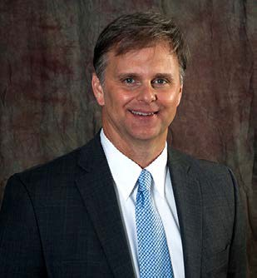On behalf of the Mississippi Department of Rehabilitation Services (MDRS), I am pleased to present our state fiscal year (SFY) 2022 Annual Report. Our entire year has been filled with challenges surrounding the COVID pandemic. We are pleased to note that our agency never once stopped serving Mississippians with disabilities during this challenging time and we have learned that we are as resilient as those we serve. We feel the challenges faced and the lessons learned have only better equipped us to serve our great state. Through our four major programs, we continue to provide important services to 1) assist those we serve in preparing for, obtaining and maintaining employment, 2) as well as helping those with more significant disabilities live at home as opposed to a long-term facility, and 3) to make Social Security determinations to determine eligibility to obtain disability income that will provide for individuals who are unable to work and their families. These great services would not be possible without your continued support.

Chris M. Howard
Executive Director
As we reflect back on this fiscal year, we have seen an increase in the number of Project SEARCH sites across our state. Nationally, the work of many such sites came to a standstill during the pandemic but not in Mississippi. Our state still saw substantial growth and accomplishments in this area. We have seen steady growth in the number of Mississippi ABLE accounts opened—most likely due in part to the growing awareness of our program and stimulus payments as a result of the pandemic. Our Vocational Rehabilitation Programs served nearly 15,000 Mississippians. Our Office of Special Disability Programs served close to 3,000 in our state, and our Disability Determination Services processed over 50,000

claims—that is tens of thousands of people assisted by just this one program within our office.

In addition to the accomplishments noted above, below are additional bullet points of other accomplishments we made over this past year.

Disability Determination Services (DDS) Program
- Despite COVID and social security office closures with limited in-person services, our MS DDS still processed 50,619 claims
- Our MS DDS successfully transitioned to a new claims management system that SSA anticipates will provide greater efficiencies for claims processing
- MS DDS staff yielded a Production Per Work Year (PPWY) of 215
- Even though costs per case increased nationally, MS DDS continues to have one of the lowest Cumulative Cost per Case rates in the region at$477
- COVID restrictions initially only allowed telephone disability hearings for beneficiaries, however, SSA has now approved the use of online video hearings via Microsoft Teams MS DDS
- Mississippi’s Combined Overall Initial Processing Time was 150 days for FY21 which remains below the Region (185 days) and Nation (164.9 days)

Office of Special Disability Programs (OSDP)
- Provided services to over 3,600 individuals across the State providing the opportunity for these individuals to live at home as opposed to a long term care facility
- Provided nearly a $40,000 cost savings per individual per year to the State of Mississippi through the administering of two Home and Community Based Programs
- Provided close to 200 home modifications to individuals across the State to ensure individuals with disabilities are safe and secure in their homes
- In partnership with the Mississippi Highway Patrol developed presentations for high school students regarding the PROM (Please Return on Monday) initiative
- Provided over 11,000 bicycle helmets to elementary schools as a safety prevention activity through the TBI/SCI Trust Fund Program

Office of Vocational Rehabilitation (VR)
Office of Vocational Rehabilitation for the Blind (VRB)
- Assisted over 26,000 individuals with disabilities to successfullyobtain and retain employment
- Collaborated and partnered with local school agencies to provide Pre-Employment Transition Services to over 7,100 students with disabilities while in high school
- Partnered with and developed 12 new partnerships with Community Rehabilitation Partners to provide Pre-Employment Services – Transition camps to students with Disabilities
- Conducted one job fair with ove 130 businesses in attendance held in Jackson

The information contained within this report will provide you with even more information about our service to the state this fiscal year.
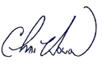

AbilityWorks

AbilityWorks is a network of 15 community rehabilitation programs providing vocational assessment and work adjustment training for individuals with disabilities. This is possible through a wide array of contract and subcontract services provided to local business and industry. During SFY 2021, AbilityWorks served
a total of 1,034 individuals with disabilities. AbilityWorks establishes cooperative agreements with local businesses to provide community based work experience, customized training and on-the-job training.
1,034 clients served

Assistive Technology

Assistive Technology is defined as the application of technology to alleviate barriers that interfere with the lives of individuals with disabilities. It is intended to help the individual maintain or enhance his or her ability to function personally, socially, and/or vocationally. MDRS Rehabilitation Engineers and Rehabilitation Technologists provide consultations on all AT referrals. The Rehabilitation Technologists and Specialists perform initial evaluations and assessments, set up AT equipment, provide follow-up evaluations, design and fabricate original items and provide specifications and final inspections for AT
services. The Assistive Technology division staff evaluates MDRS clients for the most appropriate assistive technology, thus enabling them to return to work and/or live independently. During the SFY 2021, the Assistive Technology division served a total of 1,266 individuals with disabilities.

This information only reports clients who were assigned to the Assistive Technology division during SFY 2021 and does not reflect clients who continue to be served from previous fiscal year(s).

Disability Determination Services

1,266 clients served

We operate in a partnership with the Social Security Administration to determine the medical eligibility of individuals to receive benefits from Social Security Disability Insurance and Supplemental Security Income as directed by federal guidelines from SSA. This office handles disability claims from all 23 SSA

offices in Mississippi.

Special Disability Programs

50,619 claims processed

We specialize in assisting individuals with the most severe physical disabilities to remain active in their homes and communities. Services are provided based on need as determined by functional assessment and are provided through an individualized plan of services and supports. The Office of Special Disability Programs offers services that include, but are not limited to: case management, attendant care, durable medical equipment and specialized medical supplies, home and vehicle modifications, respite care, and transition services. During the State Fiscal Year 2021, the Office of Special Disability Programs provided independent living services for 3,968 individuals with significant (severe) disabilities. OSDP administers the Traumatic Brain Injury/Spinal Cord Injury Trust Fund. A full copy of that report can be found at www.mdrs.ms.gov.
3,968 independent living services provided

Vocational Rehabilitation Services

Total
assisted Mississippians with disabilities:

11,773

We help over 10,000 Mississippians a year overcome limitations imposed by physical or mental disabilities in order for that person to secure or maintain employment. In the State Fiscal Year 2021, the Office of Vocational Rehabilitation Services assisted 11,773 Mississippians with disabilities in receiving services including, but not limited to: counseling and guidance
in adjustment to disability, vocational exploration, physical and mental restoration, job training, assistive technology, and job placement. VR also assisted 1,292 potentially eligible clients that are under the Transition Program. Individuals served by VR have a wide array of disabilities including, but not limited to: hearing loss or deafness, amputations, mental and emotional disorders, epilepsy, developmental disease and disorders,

traumatic brain injuries, orthopedic impairments, residuals from cancer, and speech impairments. The total number of VR consumers employed during SFY 2021 was 2,375.

Deaf Services
2,375 Successful employments

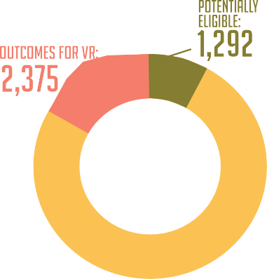
We help people who are deaf, hard of hearing, or late deafened find employment, attend education and training programs, and learn more about their community resources. The MDRS Deaf Services Program continues to promote excellence by striving to assist new RCD’s (Rehabilitation Counselors for the Deaf) to reach the required communications skills level on the Signed Communication Proficiency Interview, an American Sign Language assessment developed by the Rochester Institute of Technology. Adequate
communication skills are a pre-requisite to meaningful counseling and guidance with people who are Deaf and use manual communication. This skill, along with other specialized training, has been a vital factor
in the successful rehabilitation of individuals with deafness or significant hearing loss. In SFY 2021, Deaf Services were provided to 2,879 Mississippians resulting in 1,205 successful rehabilitations.
1,205 Successful Rehabilitations

Supported Employment
We assist individuals with the most significant disabilities who require intensive support services to prepare for, secure, retain, or regain employment. Each MDRS district has a Supported Employment Team consisting of a specialized VR/SE counselor, and a Vocational Training Instructor who oversees the work of Job Trainers working on site with our consumers. During SFY 2021, 633 individuals received Supported Employment services, 57 resulting in successful employment.
57 Successful employments

Transition & Youth Career Services
We work with potentially eligible students with disabilities ages of 14 through 21 to provide pre- employment transition services, as well as our eligible secondary school students with disabilities, their families, and school personel, to assure there is an integrated program of education and vocational training available to begin to build a foundation for a career pathway, and then to help provide a seamless transition from school to work. In SFY 2021, the number of students receiving transition services was 3,897 potentially eligible and 52 Transition Youth students found employment. Services may be provided to students both on and off campus or at one of the 15 AbilityWorks as a part of their school day.
52 Successful employments

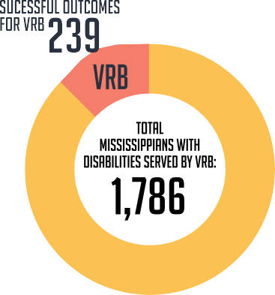Vocational Rehabilitation Services for the Blind

We specialize in working with individuals who are blind or visually impaired to ensure opportunities for inclusion into the workforce, community, and home. Of the 2,614 successful employment outcomes by MDRS, 239 were achieved through Vocational Rehabilitation for the Blind. VRB provided the consumer services such as counseling and guidance in adjustment to disability, vocational exploration, orientation and mobility training, job training, and assistive technology. The total number of Mississippians with disabilities served by VRB during SFY 2021 was 1,786.
239 Successful employment outcomes

Addie Mcbryde Rehabilitation center for the blind
The Addie McBryde Rehabilitation Center for the Blind provides traditional intensive evaluation, training, and adjustment services on the campus of the University of Mississippi Medical Center. In SFY 2021, the Addie McBryde Center provided training to 75 consumers.
Provided Training to 75 Consumers

Business Enterprise Program
The Business Enterprise Program provides support for self-employment opportunities in the food service industry for Mississippians who are legally blind. These BEP entrepreneurs operate a variety of businesses including vending machine routes, snack bars and cafeterias on military bases. In SFY 2021, 34 individuals operated successful businesses as BEP vendors and 2 others are in training to
become vendors. 34 Successful BEP Vendors

Independent living services for the Blind
We serve individuals who are legally blind and either over the age of 55 or have a significant secondary disability by providing a variety of independent living services. In SFY 2021, ILB served over 100 consumers through indirect services such as health fairs, vision screening, peer groups, and outreach. ILB provided direct services to 725 consumers.
Provided Services to 725 Consumers

Itinerant teacher program
Itinerant teachers work closely with VRB counselors to coordinate services, evaluate client needs, develop living-needs plans and instructional materials, and provide on-site training for consumers who are blind or visually impaired. In 2021, the Itinerant Teacher Program provided 9 services for VRB consumers.
Provided Services to 9 Consumers

BUSINESS DEVELOPMENT

The MDRS Office of Business Development (OBD) is committed to being a valuable resource for any business. During FY 2021 MDRS Business Development Representatives (BDR) helped support hundreds of employers across the state in sourcing, hiring and retaining qualified candidates with disabilities. Visit mdrs.ms.gov to find a MDRS Business Development Representative in your area.

  - July – December 2020 Total Referrals – 143
  - January – June 2021 Total Referrals – 214
  - Total Year Referrals – 357

Team Placement Percentage –
  - December 2020 – 79.2%
  - June 2021 – 52.1%

Yearly Costs –
  - Average Cost-per-Call – June 2021 – (January – June 2021) $1.54 per call made
  - Average Cost-per-Placement – June 2021 – (January – June 2021) $38.83 per placement made
  - Team Average Calls-per-Placement – 49 calls per placement made

Yearly Total Placements -
  - January – June 2021 Total Placements – 39
  - July – December 2020 Total Placements – 76
  - Total Placements – 115

PROJECT SEARCH

The Project SEARCH Program is a unique, business-led, nine-month employment preparation program that takes place entirely at the workplace. Up to 12 students with disabilities experience total workplace immersion, classroom instruction, career exploration, and hands-on training through three different worksite rotations. The goal for each participant is competitive employment. To reach that goal, the program provides real-life work experience combined with training in employability and independent- living skills to help young people with significant disabilities make successful transitions to productive adult life.

Nearly 100 individuals with disabilities have graduated from Project SEARCH Mississippi since Project SEARCH UMMC launched in August 2018. Fifty-nine of those individuals have gained employment.
Five (5) individuals are currently participating in a 320-hour paid internship which will result in gainful employment. Sixty-three interns are currently participating in Project SEARCH in thirteen (13) locations across the state.

VR/VRB Program Funding

Title One Section 110 Match Funding
2021
Section 110 Grant $47,309,720 (78.7%)
State Match $12,804,283 (21.3%)
Total Funding $60,114,003 (100.0%)

in-depth look at VR & VRB
Demographics of Persons Served

Gender

45.94%
6,817

54.06%
8,017
Doesn’t wish to self identify: .06%

Age at Application
20 < | 2,780
21-30 | 3,325
31-40 | 1,743
41-50 | 1,907
51-60 | 2,520
61-70 | 1,850
71-80 | 591
81-100 | 123

Education Level of Persons Served
Bachelor’s degree/Masters Degree; Degree above Masters 8.17%

Race

Elementary Education (grade 1-8)
High School graduate or GED 38.17%

No Formal Schooling
1.00%

0.14%
Alaskan Native .91%
Asian .53%
American Indian or
Black or
African American 42.16%
Native Hawaiian or
Other Pacific Islander
Multi-Racial .02%
.12%
White or Caucasian 54.45%
Hispanic/Latino
Does Not Wish to Self Identify
Not Completed
1.45%

.17%
.18%

Post-secondary education, academic/Associates deg. 12.49%

Secondary Education, no HS diploma; Occup
21.87%

Special Education (completion or in attendance) 13.21%

Technical or Occupation Skills Program (not provided by employer)
0.18%

Adult Secondary Education Program (Non-State) 0.16%

Adult Secondary Education Program (State)
Career/ Tech Training Program:
(Leading to a Recognized Post Secondary credential)
.90%

0%

(Not Leading to a Recognized Post Secondary Credential) 3.11%

Employer Training Program
0.60%

Education not listed 0%
IPE has not been developed as of 6/30/19 0%
No Plan Date 0%

in-depth look at VR & VRB
Status of Persons Rehabilitated

Employment Status of Persons Rehabilitated

Employment in Integrated Settings

Self-Employment (excluding BEP) 294

2
Architectures & Engineering | 21
Clerical and Administative Support | 25
RSA SPECIAL OCCUPATIONS | 104
Military Specific Occupations | 63
Life Physical & Social Science | 1
Computer & Mathematical | 76
Legal | 11
Operative | 119
Transportation & Material Moving | 92
Arts, Design, Entertainment, Sports & Media | 28
Farming, Fishing & Forestry | 97
Laborer | 122
Service Worker | 70
Protective Service | 74
Sales | 36
Professional | 14
Business & Financial Operation | 6
Healthcare Support | 245
Installation, Maintenance & Repair | 5
Community & Social Service | 292
Education, Training & Library | 20
Food Perparation & Food | 125
Building/Grounds Cleaning& Maint. | 127
Construction & Extraction | 61
Skilled Craft | 52
Healthcare Practitioners & Technical | 2
Personal Care | 56
Production Occupations | 155
Technical/Paraprofessional | 47
Sales & Related Occupations | 119
Secretarial/Office/Clerical | 150
Management | 21
Office worker, Secretarial, Clerical | 178

TOTAL

Employment in Integrated Setting 2,318
Occupations
2,614

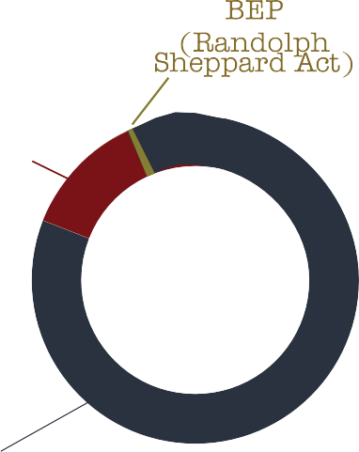

2,614

in-depth look at VR & VRB
Persons served by Primary Disability

5,557

3,482

604

60

209

2,758

1

61

1,657

461

14,850

Clients Served Clients potentially
eligible

Individualized Plans
Clients Served - 2021

1,292

14,850

for Employment
Written

Successfully Employed
4,564

2,614

In-Depth Look at DDS & OSDP

Office of Disability Determination Services
Claims Processed 50,619

Average Cost per Case $477.12

Office of Special Disability Programs

T2 benefits are based on the amount of years a person has worked.

T16 benefits are based on a person’s income and assets.

Average Processing Time T2-152 days/T16-135 days
Accuracy Rate
95.1%
Number Served
TBI/SCI Trust Fund
32

Independent Living Waiver 2,711

TBI/SCI Waiver 904

Proof of Performance

Office of Disability Determination Services
Cost per case
Processing time
Production per Work Year
Year | National Average | Mississippi Average
2015 | 110 Days | 89 Days
2016 | 83/86 Days | 90/85 Days
2017 | 83/85 Days | 81/74 Days
2018 | 86/90 Days | 84/71 Days
2019 | 87/94 Days | 81/73 Days
2020 | 110/120 Days | 105/105 Days
2021 | 122/134 Days | 140/129 Days

Year | National Average | Mississippi Average
2015 | $462 | $316
2016 | $491 | $310
2017 | $498 | $313
2018 | $542 | $378
2019 | $537 | $367
2020 | $599 | $425
2021 | $645 | $477

Year | National Average | Mississippi Average
2015 | 310 | 357
2016 | 313 | 324
2017 | 306 | 329
2018 | 303 | 306
2019 | 302 | 302
2020 | 255 | 268
2021 | 238 | 215

*Prior years reporting is based on Overall Processing time. The reporting for FFY2016 forward is based on claim type (T2 vs T16).

Office of Special Disability Programs
Year | Number of Clients Served | Annual Cost Savings to the Division of Medicaid
2015 | 3,874 | $216,208,403
2016 | 4,043 | $222,365,814
2017 | 3,636 | $207,231,672
2018 | 3,270 | $156,960,081
2019 | 3,717 | $140,175,338
2020 | 3,706 | $148,593,508
2021 | 3,615 | $143,598,487

*As of 6/30/21
*Figures shown above are based on the Division of Medicaid cost reports for the Independent Living Waiver and the Traumatic Brain Injury Waiver. *OSDP numbers are reported from the State Fiscal Year.

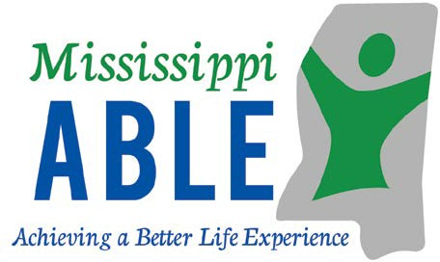

The Mississippi ABLE Program
The Achieving a Better Life Experience Act (ABLE) of 2014 allows individuals with disabilities to save money in a tax-advantaged account that may be used for qualified disability related expenses while keeping eligibility for federal public benefits.

The Mississippi ABLE Act is codified in Miss. Code Ann. 43-28-1 et. seq. The legislation established an ABLE Board which works with the Mississippi Department of Rehabilitation Services to administer the program. The program launched in Mississippi in June of 2021.
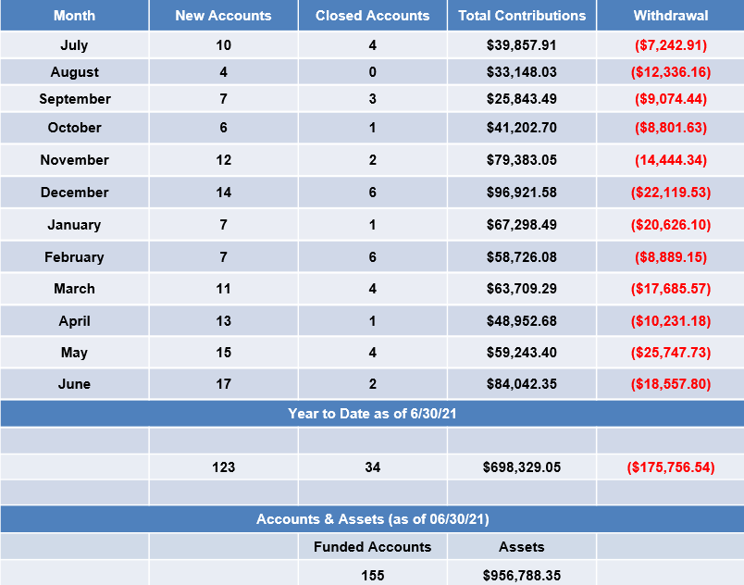
To learn more about able or sign up visit www.MississippiAble.com.
To order brochures or schedule a presentation email MSABLEINFO@mdrs.ms.gov.
To contact customer service call 888-609-3469.

districts & office locations

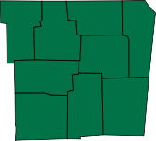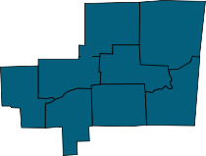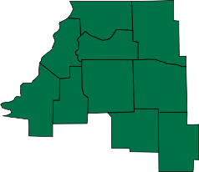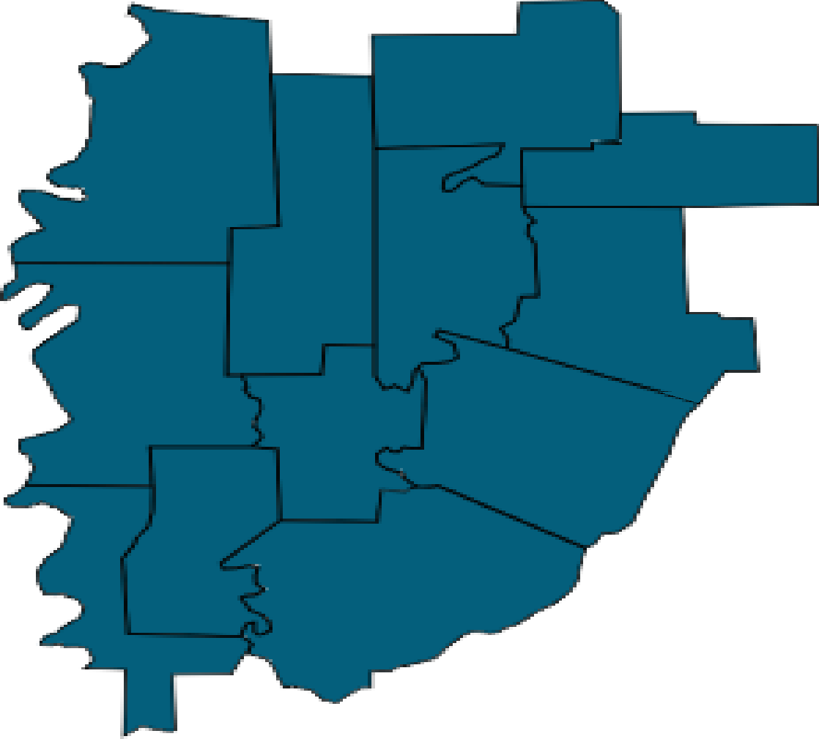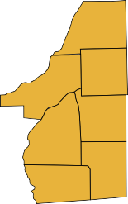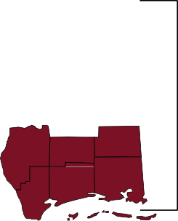Region I
District I
District II
District III
District IV
District VI District VII
District V
District VIII
District IX
District X
Meridian, MS 39307

Region II

Region III

104 Professional Plaza

317 Industrial Park Road Starkville, MS 39759

Columbus, MS 39702

1221 Parklane Road
McComb, MS 39648
Region IV

Additional locations can be found at www.mdrs.ms.gov using the location finder.

2018 Rehabilitation Services
Mississippi Department of
two thousand eighteen

Mississippi Department of Rehabilitation Services
Annual Report

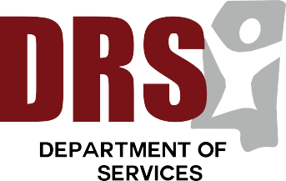
Your perspective is extremely valuable,
and we greatly appreciate any and all feedback!
(A digital copy of this report can be found at www.mdrs.ms.gov)
Please send direct comments or questions to:
Mississippi Department of Rehabilitation Services
Attn: Office of Communications Post Office Box 1698
Jackson, Mississippi 39215-1698
1.800.443.1000
www.mdrs.ms.gov

