2two th0ousand1nin9eteen

Mississippi Department of Rehabilitation Services

Mississippi Department of Rehabilitation Services
Annual Report

Welcome
- AbilityWorks Assistive Technology
Disability Determination Services Special Disability Programs
- Vocational Rehabilitation Deaf Services
Supported Employment Transition Services
- Vocational Rehabilitation for the Blind
Addie McBryde Rehabilitation Center for the Blind Business Enterprise Program
Independent Living Services for the Blind Itinerant Teacher Program
- Offi ce of Business Development Program Funding

- In Depth Look at VR – VRB
- In Depth Look at DDS – OSDP
- Mississippi ABLE
- Districts & Offi ce Locations
Mission Statement

Vision Statement
The Mississippi Department of Rehabilitation Services (MDRS) is the state agency dedicated to helping Mississippians with disabilities to live and work independently. It is the mission
of the Mississippi Department of Rehabilitation Services (MDRS) to provide appropriate and comprehensive services to Mississippians with disabilities in a timely and effective manner. Programs and services assist individuals with
disabilities to gain employment, retain employment and to live more independently.

The Mississippi Department of Rehabilitation Services is committed to being recognized as the premier agency for Mississippians with disabilities by creating a culture of care with compassionate, valued, and knowledgeable staff. We will promote an environment where customers and staff work together to achieve our common goal of empowering and improving the lives of Mississippians with disabilities.

*All numbers are reported by state fiscal year (SFY) July 1, 2018 - June 30, 2019 with the exception of those for Disability Determination Services, which is entirely federally funded. DDS numbers reflect the federal fiscal year (FFY) October 1, 2018 - September 30, 2019

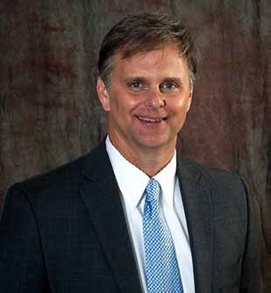On behalf of the Mississippi Department of Rehabilitation Services (MDRS), I am pleased to present our state fiscal year (SFY) 2019 Annual Report. As this is my fourth year as Executive Director to provide to you this report, I am excited to state that MDRS is truly changing the lives of so many people across this great state. Through our four major programs, we have been able to touch approximately 100,000 lives. These programs provide such important services; as: to assist individuals with preparing for and obtaining meaningful employment, to assist individuals with significant disabilities the opportunity to live at home as opposed to a long-term care facility, to provide for a safe place for individuals to live through home modifications, and to make the Social Security determinations to determine eligibility to obtain disability income that will provide for individuals who are unable to work and their families. All of these great services and incredible outcomes would not be possible without your continued support.

Chris M. Howard
Executive Director

As we reflect back on 2019, some of the highlights of our accomplishments include the launch of the Mississippi ABLE Program which our office administers along with the Mississippi ABLE Board, pursuant to state law. In addition, our office launched our first Project SEARCH site in August of 2018 and we continue to grow this program with the expansion of five locations in 2019 and a planned 12 in 2020. Also, we are partnering with beauty retail giant Sephora to assist this great company in training and hiring individuals with disabilities. We expect to hit a goal of 100 such hires in the fall of 2019 and expect 175 in the winter of 2020. Additionally, this partnership with Sephora is assisting us in meeting with other large employers across our state.

In addition to the accomplishments noted above, below are additional bullet points of other accomplishments we made over this past year.

Disability Determination Services (DDS) Program
- Processed 71,115 claims
- Exceeded Budgeted Workload by 1.7%
- Led the Region by being the first State in the Region to rollout our new case processing system (DCPS)
- Provided assistance to other States in the Region by providing over 1,000 medical ratings
- Production Per Worker Year (PPWY) of 302
- Lowest cumulative Cost per Case in the Region ($376)
- Continued to process hearings expeditiously. No Aged Hearings.

Office of Special Disability Programs (OSDP)
- Provided services to over 3,700 individuals across the State providing the opportunity for these individuals to live at home as opposed to a long term care facility
- Provided nearly a $60,000 cost savings per individual per year to the State of Mississippi through the administering of two Home and \ Community Based Programs
- Provided more than 200 home modifications to individuals across the State to ensure individuals with disabilities are safe and secure in their homes
- In partnership with the Mississippi Highway Patrol and Families First of Mississippi, provided outreach to nearly 10,000 high school students regarding the PROM (Please Return on Monday) initiative
- Provided nearly 10,000 bicycle helmets to elementary schools as a safety prevention activity through the TBI/SCI Trust Fund Program

Office of Vocational Rehabilitation (VR)
Office of Vocational Rehabilitation for the Blind (VRB)
- Assisted over 2500 individuals with disabilities to successfully obtain and retain employment
- Collaborated and partnered with local school agencies to provide Pre-Employment Transition Services to over 4200 students with disabilities while in high school
- Partnered with and developed over 20 new partnerships with Community Rehabilitation Partners to provide Pre-Employment Services – Transition camps to students with Disabilities
- The 4th Annual Pre-Employment Transition Camp for Student who are deaf was held at Eagle Ridge
- Completed the 6th VRB and VR Summer Internship Program (SIP) for students– the program allowed students to obtain first-hand work experience in their chosen field
- Conducted three job fairs with over 130 businesses in attendance were held in Southaven, Jackson, and Gulfport.

The information contained within this report will provide you with even more information about our service to the state this fiscal year.

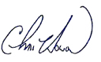
You are a key part to our successes, and we thank you for your support and very much look forward to working with you in the upcoming year. Sincerely,

AbilityWorks
AbilityWorks is a network of 15 community rehabilitation programs providing vocational assessment and work adjustment training for individuals with disabilities. This is possible through a wide array of contract and subcontract services provided to local business and industry. During SFY 2019, AbilityWorks served
a total of 1,830 individuals with disabilities. AbilityWorks establishes cooperative agreements with local businesses to provide community based work experience, customized training and on-the-job training.

1,830 clients served
Assistive Technology
Assistive Technology is defined as the application of technology to alleviate barriers that interfere with the lives of individuals with disabilities, and it is intended to help the individual maintain or enhance his or her ability to function personally, socially, and/or vocationally. MDRS Rehabilitation Engineers and Rehabilitation Technologists provide consultations on all AT referrals. The Rehabilitation Technologists and Specialists perform initial evaluations and assessments, set up AT equipment, provide follow-up evaluations, design and fabricate original items and provide specifications and final inspections for AT
services. The Assistive Technology division staff evaluates MDRS clients for the most appropriate assistive technology, thus enabling them to return to work and/or live independently. During the SFY 2019, the Assistive Technology division served a total of 974 individuals with disabilities.

This information only reports clients who were assigned to the Assistive Technology division during SFY 2019 and does not reflect clients who continue to be served from previous fiscal year(s).

Disability Determination Services

974 clients served

We operate in a partnership with the Social Security Administration to determine the medical eligibility of individuals to receive benefits from Social Security Disability Insurance and Supplemental Security Income as directed by federal guidelines from SSA. This office handles disability claims from all 23 SSA

offices in Mississippi.

Special Disability Programs

78,580 claims processed

We specialize in assisting individuals with the most severe physical disabilities to remain active in their homes and communities. Services are provided based on need as determined by functional assessment and are provided through an individualized plan of services and supports. The Office of Special Disability Programs offers services that include, but are not limited to: case management, attendant care, durable medical equipment and specialized medical supplies, home and vehicle modifications, respite care, and transition services. During the State Fiscal Year 2019, the Office of Special Disability Programs provided independent living services for 3,737 individuals with significant (severe) disabilities. OSDP administers the Traumatic Brain Injury/Spinal Cord Injury Trust Fund. A full copy of that report can be found at www.mdrs.ms.gov.

3,737 independent living services provided

Vocational Rehabilitation Services

Total
assisted Mississippians with disabilities:
12,543
We help over 10,000 Mississippians a year overcome limitations imposed by physical or mental disabilities in order for that person to secure or maintain employment. In the State Fiscal Year 2019, the Office of Vocational Rehabilitation Services assisted 12,543 Mississippians with disabilities in receiving services including, but not limited to: counseling and guidance
in adjustment to disability, vocational exploration, physical and mental restoration, job training, assistive technology, and job placement. VR also assisted 1,925 potentially eligible clients that are under the Transition Program. Individuals served by VR have a wide array of disabilities including, but not limited to: hearing loss or deafness, amputations, mental and emotional disorders, epilepsy, developmental disease and disorders,

traumatic brain injuries, orthopedic impairments, residuals from cancer, and speech impairments. The total number of VR consumers employed during SFY 2019 was 2,379.

Deaf Services

2,379 Successful employments

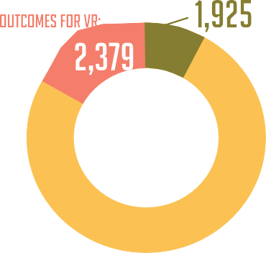We help people who are deaf, hard of hearing, or late deafened find employment, attend education and training programs, and learn more about their community resources. The MDRS Deaf Services Program continues to promote excellence by striving to assist new RCD’s (Rehabilitation Counselors for the Deaf) to reach the required communications skills level on the Signed Communication Proficiency Interview, an American Sign Language assessment developed by the Rochester Institute of Technology. Adequate
communication skills are a pre-requisite to meaningful counseling and guidance with people who are Deaf and use manual communication. This skill, along with other specialized training, has been a vital factor
in the successful rehabilitation of individuals with deafness or significant hearing loss. In SFY 2019, Deaf Services were provided to 2,764 Mississippians resulting in 1,050 successful rehabilitations.

1,050 Successful Rehabilitations
Supported Employment
We assist individuals with the most significant disabilities who require intensive support services to prepare for, secure, retain, or regain employment. Each MDRS district has a Supported Employment Team consisting of a specialized VR/SE counselor, and a Vocational Training Instructor who oversees the work of Job Trainers working on site with our consumers. During SFY 2019, 487 individuals received Supported Employment services, 37 resulting in successful employment.

37 Successful employments
Transition & Youth Career Services
We work with potentially eligible students with disabilities between the ages of 14 through 21 to provide pre-employment transition services, as well as our eligible secondary school students with disabilities, their families, and school personel, to assure there is an integrated program of education and vocational training available to begin to build a foundation for a career pathway, and then to help provide a seamless transition from school to work. In SFY 2019, the number of students receiving transition services was 4,285 and 347 students found employment. Services may be provided to students both on and off campus or at one of the 15 AbilityWorks as a part of their school day.

347 Successful employments

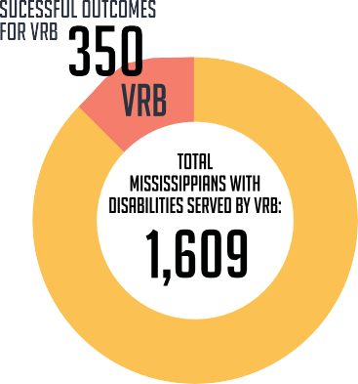Vocational Rehabilitation Services for the Blind

We specialize in working with individuals who are blind or visually impaired to ensure opportunities for inclusion into the workforce, community, and home. Of the 2,729 successful employment outcomes by MDRS, 350 were achieved through Vocational Rehabilitation for the Blind. VRB provided consumers services such as counseling and guidance in adjustment to disability, vocational exploration, orientation and mobility training, job training, and assistive technology. The total number of Mississippians with disabilities served by VRB during SFY 2019 was 1,609.

350 Successful employment outcomes

Addie Mcbryde Rehabilitation center for the blind
The Addie McBryde Rehabilitation Center for the Blind provides traditional intensive evaluation, training, and adjustment services on the campus of the University of Mississippi Medical Center. In SFY 2019, the Addie McBryde Center provided training to 112 consumers.

Provided Training to 112 Consumers

Business Enterprise Program
The Business Enterprise Program provides support for self- employment opportunities in the food service industry for Mississippians who are legally blind. These BEP entrepreneurs operate a variety of businesses including vending machine routes, snack bars and cafeterias on military bases. In SFY 2019, 38 individuals operated successful businesses as BEP vendors.

38 Successful BEP Vendors

Independent living services for the Blind
We serve individuals who are legally blind and either over the age of 55 or have a significant secondary disability by providing a variety of independent living services. In SFY 2019, ILB served over 5,004 consumers through indirect services such as health fairs, vision screening, peer groups, and outreach. ILB provided direct services to 847 consumers.

Provided Services to 847 Consumers

Itinerant teacher program
Itinerant teachers work closely with VRB counselors to coordinate services, evaluate client needs, develop living-needs plans and instructional materials, and provide on-site training for consumers who are blind or visually impaired. In 2019, the Itinerant Teacher Program provided 59 services for VRB consumers.

Provided Services to 59 Consumers

BUSINESS DEVELOPMENT
The MDRS Office of Business Development (OBD) is committed to being a valuable resource for any business. During FY 2019. MDRS Business Development Representatives (BDR) helped support hundreds of employers across the state in sourcing, hiring and retaining qualified candidates with disabilities. Visit mdrs.ms.gov to find a MDRS Business Development Representative in your area.
Total Calls: 11,053.0 Average Calls Per Rep: 789.50
Average Days to Employment: 78.80
Total Number of People Employed: 253
Total Number Job Searching: 416
Total Number Searching for Training / Internship: 306
Placements per Call Percentage (Team): 3.82%
Referral Source:
VR – 73%
VRB – 5.6%
SE – 21.3%
Type of Contact by BDR:
In Person Cold Call: 27%
Phone: 24%
Email: 16%
Employed Sector Breakdown Highlights:
Manufacturing: 14%
Food Service: 11%
Retail: 16%
Transportation and Warehousing: 8%
Medical Facilities: 86.4%

VR/VRB Program Funding

Title One Section 110 Match Funding

 | 2018
Section 110 Grant | $44,680,926 (78.7%)
State Match | $12,092,805 (21.3%)
Total Funding | $56,773,731 (100.0%)

in-depth look at VR & VRB
Demographics of Persons Served

Gender Age at Application

45.33%
7,287

54.64%
8,735
20 <
21-30
4,924
2,106

Doesn’t wish to self identify: .03%
31-40 | 2,100
41-50 | 2,216
51-60 | 2,529
61-70 | 1,623
71-80 | 472
81-100 | 107

Education Level of Persons Served
Race

Bachelor’s degree/Masters Degree; Degree above Masters | 7.15%
Elementary Education (grade 1-8) | 0.98%
High School graduate or GED | 27.76%
No Formal Schooling | 0.25%
Post- secondary education, academic/Associates deg. | 9.65%
Secondary Education, no HS diploma; Occup | 15.18%
Special Education (completion or in attendance) | 3.61%
Technical or Occupation Skills Program (not provided by employer) | 0.20%
Adult Secondary Education Program (Non-State) | 0.25%
Adult Secondary Education Program (State) | 1.33%
Career/ Tech Training Program:
Leading to a Recognized Post Secondary credential) | 1.78%
Not Leading to a Recognized Post Secondary Credential) 0.64%
Employer Training Program | 0.01%
Education not listed | 22.44%
IPE has not been developed as of 6/30/19 | 2.83%
No Plan Date | 6.01%

American Indian or
Alaskan Native .16%
Asian .32% Black or
African American 44.42%

Native Hawaiian or r .06% Other Pacific Islande

Multi-racial 2.42%
White or Caucasian 52.17%
Does not wish to .09%
self identify
Hispanic/Latino .35%

in-depth look at VR & VRB

Status of Persons Rehabilitated

Employment Status of Persons Rehabilitated

Self-Employment (excluding BEP) 299

TOTAL

Employment in Integrated Settings

Employment in Integrated Setting 2,425

Occupations
2,729
Office/Administrative Support | 336
Sales | 225
Transportation & Material Moving | 161
Management | 156
Food Preparation & Food | 132
Production Occupations | 128
Skilled Craft | 122
Building/Grounds Cleaning& Maint. | 119
Personal Care | 119
Service Worker | 104
Healthcare Practitioners & Technical | 100
Education, Training & Library | 99
Construction & Extraction | 85
Installation, Maintenance & Repair | 74
Community & Social Service | 67
Healthcare Support | 65
Protective Service | 55
Professional | 49
Laborer | 48
Business & Financial Operation | 40
Operative | 31
Farming, Fishing & Forestry | 30
Architectures & Engineering | 18
Arts, Design, Entertainment, Sports & Media | 18
Legal | 12
Technical/Paraprofessional | 11
Life Physical & Social Science | 9
Computer & Mathematical | 7
Military Specific Occupations | 5

2,425

in-depth look at VR & VRB
Persons served by Primary Disability

6,222

3,946

668

67

2,675

268

4

76

1,531

602

16,077

Clients Served and Closed for 2018
Clients Served Clients potentially

16,077

eligible

Individualized Plans for Employment
Written

Successfully Employed

1,925

2,729

5,182

In-Depth Look at DDS & OSDP

Office of Disability Determination Services

T2 benefits are based

Claims Processed Average Processing Time Average Cost per Case Accuracy Rate
78,580
T2-81 days/T16-74 days
$313.00
95%
on the amount of years a person has worked.

T16 benefits are based on a person’s income and assets.

Office of Special Disability Programs
Number Served

Independent Living Waiver TBI/SCI Trust Fund TBI/SCI Waiver

Proof of Performance
2,593
82
910

Office of Disability Determination Services

Cost per case
Production per Work Year
Processing time
Year | National Average | Mississippi Average
*2012 | 102 Days | 93 Days
*2013 | 107 Days | 91 Days
*2014 | 104 Days | 89 Days
*2015 | 110 Days | 89 Days
*2016 | 83/86 Days | 90/85 Days
2017 | 83/85 Days | 81/74 Days
2018 | 86/90 Days | 84/71 Days

Year | National Average | Mississippi Average
2012 | $435 | $279
2013 | $455 | $311
2014 | $462 | $316
2015 | $462 | $316
2016 | $491 | $310
2017 | $498 | $313
2018 | $542 | $378

Year | National  Average | Mississippi  Average
2012 | 324 | 370
2013 | 322 | 368
2014 | 310 | 357
2015 | 310 | 357
2016 | 313 | 324
2017 | 306 | 329
2018 | 303 | 306

*Prior years reporting is based on Overall Processing time. The reporting for FFY2016 forward is based on claim type (T2 vs T16).

Office of Special Disability Programs
Year | Number of Clients Served | Annual Cost Savings to the Division of Medicaid
2013 | 3,487 | $206,635,981
2014 | 3,739 | $220,322,128
2015 | 3,874 | $216,208,403
2016 | 4,043 | $222,365,814
2017 | 3,636 | $207,231,672
2018 | 3,270 | $156,960,081
2019 | 3,717 | $140,175,338

*As of 6/30/19
*Figures shown above are based on the Division of Medicaid cost reports for the Independent Living Waiver and the Traumatic Brain Injury Waiver. *OSDP numbers are reported from the State Fiscal Year.

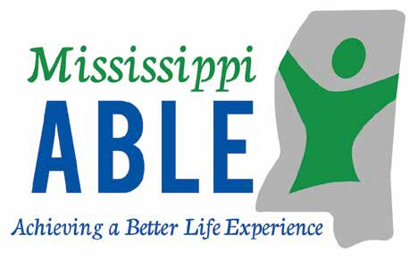

The Mississippi ABLE Program
The Achieving a Better Life Experience Act (ABLE) of 2014 allows individuals with disabilities to save money in a tax- advantaged account that may be used for qualified disability related expenses while keeping eligibility for federal public benefits.

The Mississippi ABLE Act is codified in Miss. Code Ann. 43- 28-1 et. seq. The legislation established an ABLE Board which works with the Mississippi Department of Rehabilitation Services to administer the program. The program launched in Mississippi in June of 2019.

To learn more about able or sign up visit www.MississippiAble.com.

To order brochures or schedule a presentation email MSABLEINFO@mdrs.ms.gov.

To contact customer service call 888-609-3469.

districts & office locations

Region I

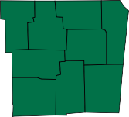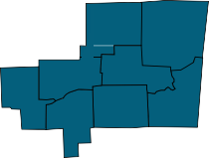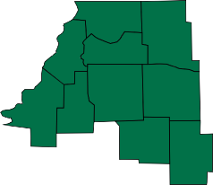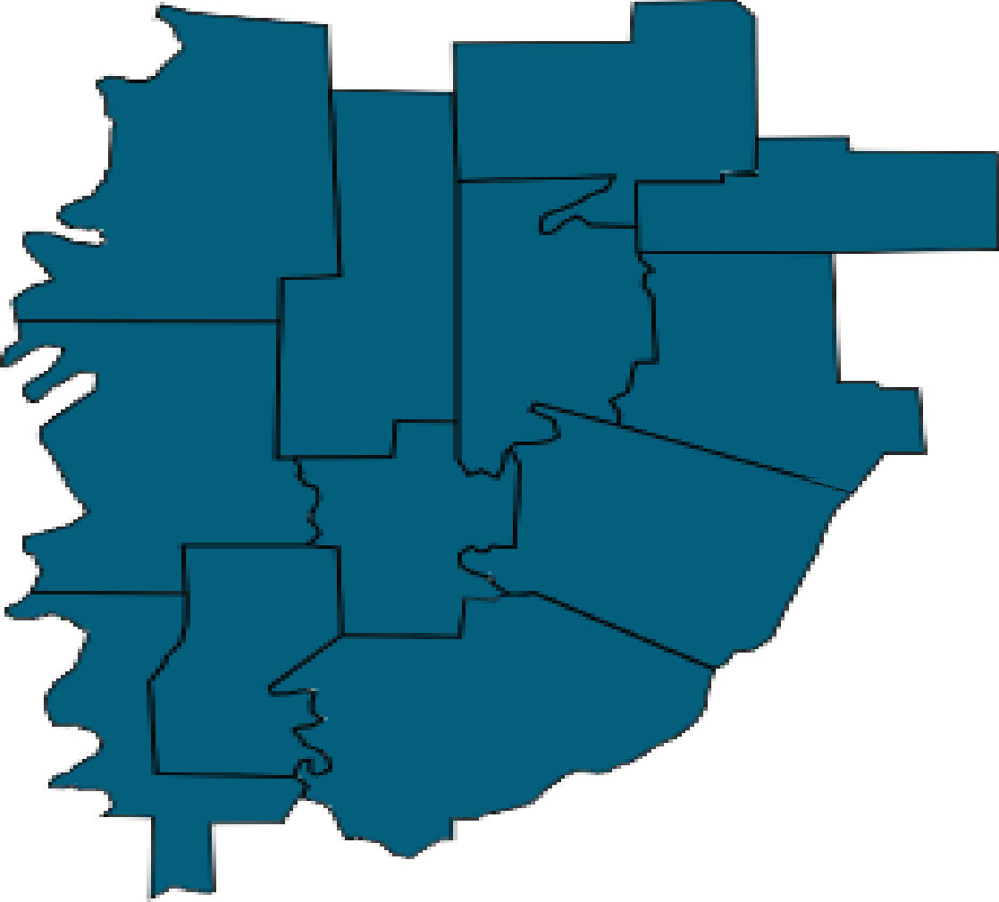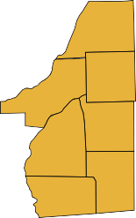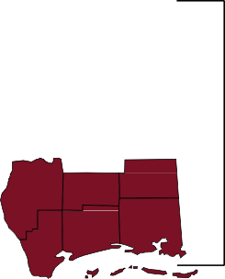Region II
District I
District II
District III
District IV
District VI District VII
District V
District VIII
District IX
District X

Region III

104 Professional Plaza

1221 Parklane Road
Region IV

Additional locations can be found at www.mdrs.ms.gov using the location finder.

2018 Rehabilitation Services
Mississippi Department of
two thousand eighteen

Mississippi Department of Rehabilitation Services
Annual Report

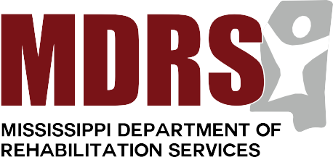
Your perspective is extremely valuable,
and we greatly appreciate any and all feedback!
(A digital copy of this report can be found at www.mdrs.ms.gov)
Please send direct comments or questions to:
Mississippi Department of Rehabilitation Services
Attn: Office of Communications Post Office Box 1698
Jackson, Mississippi 39215-1698
1.800.443.1000
www.mdrs.ms.gov

