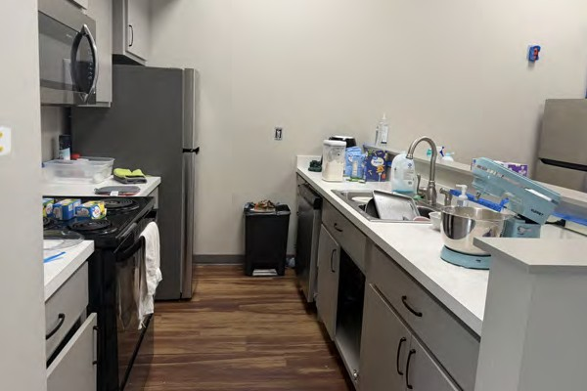
Mississippi EMERGE Center for the Blind
Discover Your Independence
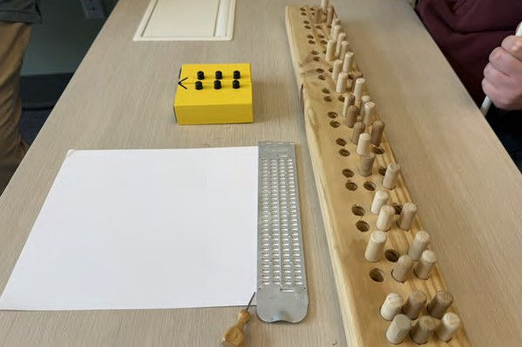
At the Mississippi EMERGE Center for the Blind, we believe blindness does not define potential. With training, support, and opportunity, individuals who are blind or have low vision can build the skills and confidence needed to pursue greater independence in their daily lives, education, and employment goals.

Located in Long Beach, Mississippi, the EMERGE Center uses a unique approach to blindness skills training that goes beyond traditional methods empowering individuals to build true independence and self-sufficiency.

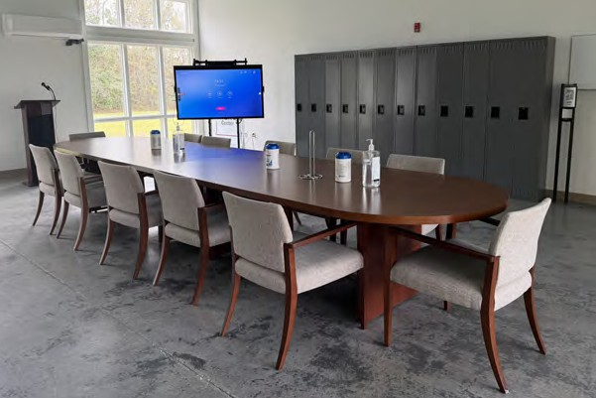
Through the consistent use of Structured Discovery principles, participants learn to challenge and overcome negative perceptions about blindness—gaining the confidence and skills needed to live without limits.

What is Structured Discovery?
Structured Discovery is a hands-on training approach that teaches non-visual skills and problem-solving through real-world experiences. Participants learn to rely on touch, hearing, and other senses to navigate life with confidence.

About Us
Our team is trained in Structured Discovery, having completed immersive instruction themselves. Participants benefit from regular interaction with successful blind professionals and community leaders who model:
- Positive attitudes about blindness
- Strong self-advocacy skills
- Success in competitive integrated employment

Our Program
A full-time, 6–9 month residential training program focused on:
- Independence
- Confidence
- Practical blindness skills
- Employment readiness
- Community integration

Skills You Will Learn
- Cane Travel
- Braille Reading
- Home & Daily Living Skills
- Assistive Technology
- Confidence-Building Activities

Program Expectations
- Full-time participation (6-9 months)
- Use of learning shades during training
- Use of a long white cane
- No sighted guides during instruction
- Active participation in all classes

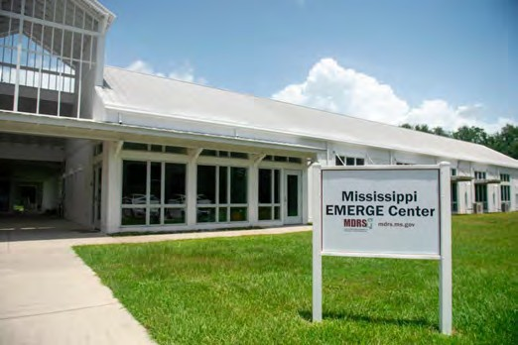
Get real-world experience at the Mississippi EMERGE Center’s residential program. Live in a two-bedroom apartment, possibly with a roommate, and build independent living skills in a true home setting. With a shared kitchen, living space, and in-unit washer and dryer, you’ll build confidence and apply what you learn every day.

This program goes beyond coping—it’s about living confidently and independently without relying on sight. Through a supportive community, you’ll gain the skills, mindset, and confidence to reach your goals and take control of your future.

Whether your goal is to return to work, continue your education, or live more independently, we are here to help you every step of the way.

Discover what is possible. The journey doesn’t end here—it begins here.

Contact us today! 228.241.2239

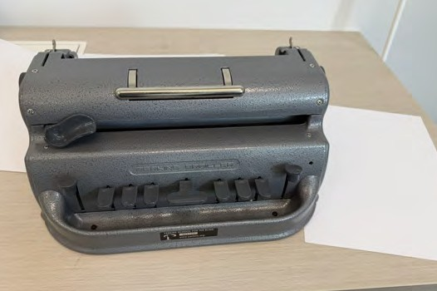
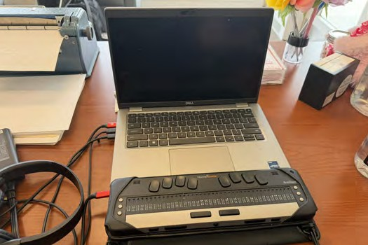
VR/VRB services are federally funded in part by the U.S.
Department of Education, with state-matched contributions. Full funding details are available at www.mdrs.ms.gov

Mississippi EMERGE Center 310 North Cleveland Avenue Long Beach, MS 39560

mdrs.ms.gov
Mississippi Department of Rehabilitation Services 1281 Highway 51 North Madison, MS 39110
1-800-443-1000 • www.mdrs.ms.gov
The Mississippi Department of Rehabilitation Services is an Equal Opportunity Employer.
5/2026
Mississippi

EMERGE
Center
Encouraging Mississippi Employment through Resilient Growth and Empowerment

