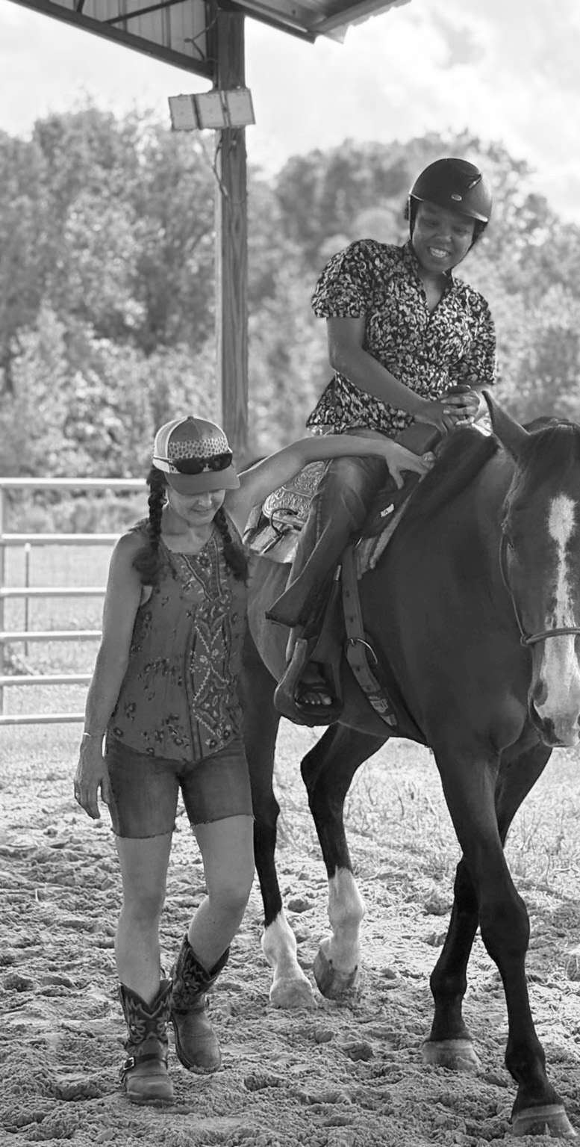
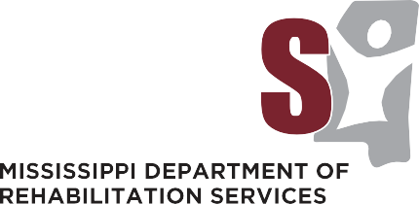
ANNUAL REPORT 2025

Office of

Special Disability Programs
Traumatic Brain Injury & Spinal Cord Injury Trust Fund Program

TABLE OF CONTENTS
3
4
Welcome Eligibility Funding
Program Administration Advisory Council
Advisory Council Members TBI/SCI Waiver
Direct Client Services
8
9
12
5
6
7
13
Expenditures By Service Category Grant Projects
Total Expenditures
Annual Nursing Home Survey Other Activities
Making an Impact: Subgrant Projects in Action

Mission Statement
It is the mission of the Mississippi Department of Rehabilitation Services (MDRS) to provide appropriate and comprehensive services to Mississippians with disabilities in a timely and effective manner. Programs and services assist individuals with disabilities to gain employ-ment, retain employment and to live more independently.

Vision Statement
In an effort to enable Mississippians with spinal cord injury and traumatic brain injury achieve their maximum level of independence, the 1996 Mississippi Legislature established the Traumatic Brain Injury/Traumatic Spinal Cord Injury (TBI/SCI) Trust Fund. The goal of the Trust Fund Program is to assist individuals who are severely disabled by traumatic spinal cord injury or traumatic brain injury to resume activities of daily living and to reintegrate into the community with as much dignity and independence as possible.


Billy Taylor Executive Director

Dear Governor Reeves
and members of the Mississippi Legislature:
As the Executive Director of the Mississippi Department of Rehabilitation Services, I am proud to present the 2025 Traumatic Brain Injury/Traumatic Spinal Cord Injury Trust Fund Annual Report. The Trust Fund Advisory Council Members, along with other individuals interested in expanding services to people with spinal cord and traumatic brain injuries, have generously contributed their time, expertise, and enthusiasm in carrying forward the intent of the original legislation. It is a privilege to report the continued good progress of the Trust Fund and its partners who provide the much-needed resources for Mississippians with traumatic brain and spinal cord injuries.

Every effort has been made by the members of the Trust Fund Advisory Council and the staff of the Mississippi Department of Rehabilitation Services to identify, address and implement the components and objectives of the Trust Fund. Because of the services made possible by the Trust Fund, Mississippians with traumatic brain and spinal cord injuries are better able to strive for and achieve an improved quality of life following injury. The continued administration of the Traumatic Brain Injury/Spinal Cord Injury Home and Community-based Waiver, which utilizes dollars from the Trust Fund to match federal dollars to extend services to more individuals with a traumatic brain injury or spinal cord injury, has been fundamental to the success of effectively serving these individuals. This program allows individuals to live in their own homes surrounded by their families and caregivers instead of a nursing or institutional facility.

During FY 2026, we will continue to pursue all possible funding alternatives and resources to leverage the maximum draw down of available federal funds. We will continue our efforts to encourage inter agency collaboration while working to develop new services for our clients. The staff of the Mississippi Department of Rehabilitation Services continues to work diligently to ensure that the necessary resources for individuals who have sustained a traumatic brain injury or spinal cord injury are available today and in the future.


Sincerely,

Billy Taylor, Executive Director



Eligibility
Any resident of Mississippi, regardless of age, who has a severe disability as a result of a traumatic spinal cord injury or a traumatic brain injury and is medically stable, shall be eligible for services. Medical stability is defined as the absence of (a) an active, life threatening condition (e.g., sepsis, respiratory, or other condition requiring systematic therapeutic measures); (b) IV drip to control or support blood pressure; and (c) intra-cranial pressure or arterial monitoring.

For the purposes of this program, traumatic brain injury is defined as an insult to the skull, brain, or its covering, resulting from external trauma which produces an altered state of consciousness or anatomic, motor, sensory or cognitive/behavioral deficits. Spinal cord injury is defined as an acute traumatic insult to the spinal cord, not of a degenerative or congenital nature, but caused by an external trauma resulting in any degree of motor or sensory deficit.

The Trust Fund Program is the payer of last resort. An individual must seek assistance from all available resources prior to the Trust Fund’s participation in a service.

Funding
Motor vehicle accidents is one of the leading cause of both traumatic spinal cord and traumatic brain injuries in Mississippi. Funding for the TBI/SCI Trust Fund is provided through fees and surcharges on moving traffic violations. Collection of these surcharges began July 1, 1996. A $25.00 surcharge is collected from every violation of the Mississippi Implied Consent (Driving Under the Influence) Law, and $5.45 from all other moving vehicle violations.

Program Administration
The Mississippi Department of Rehabilitation Services (MDRS) was designated by the Legislature to administer the Spinal Cord and Brain Injury Trust Fund Program. The MDRS Office of Special Disability Programs coordinates the direct services to eligible consumers, and a full-time program coordinator oversees the coordination of services. A variety of community-related integration programs are also provided through the Traumatic Brain Injury/Spinal Cord Injury Trust Fund via contracts with community organizations and agencies.

Advisory Council
A seven-member advisory Council provides advice and expertise to the MDRS in the preparation, implementation and periodic review of the TBI/SCI Trust Fund Program. The composition of the Advisory Council was designated by legislation to include a maximum of ten members who are comprised by the following: (1) A physician with expertise in areas related to the care and rehabilitation of individuals with spinal cord injuries or traumatic brain injuries, (2) A professional in a clinical rehabilitation setting, (3) A representative designated by the Brain Injury Association of Mississippi, (4) A representative designated by the Mississippi Paralysis Association, (5) Three individuals with spinal cord injuries or traumatic brain injuries, and (6) Three family members of individuals with traumatic spinal cord or traumatic brain injuries.

Current Advisory Council Members
Dr. Edward Manning, Chairperson, Psychologist (Professional in Clinical Rehabilitation Setting) – Dr. Manning is a faculty member (Professor) in the Department of Neurology at the University of Mississippi Medical Center. He has worked extensively in the assessment and treatment of neurobehavioral aspects of brain injury. He is active in the Brain Injury Association of Mississippi and is past president of the association. He is a active member of a number of national professional associations in the fields of Clinical Psychology and Clinical Neuropsychology.

Dr. Howard Katz, Psychiatrists, Brain Injury Specialist (Designee of the Brain Injury Association of Mississippi) – Dr. Katz has been chairman of the Board of Directors of the Brain Injury Association of Mississippi since its inception in 1989. In addition to his active involvement in organizations that promote services to individuals with brain injuries, he is well known for his individualized patient care. As the medical director of 5 post-acute residential rehabilitation facilities, including the only facility in Mississippi, and running a private practice at Mississippi Baptist Medical Center, Dr. Katz works closely with brain and spinal cord injury survivors and their family to maximize independence and provide long-term medical care management.

Mr. Adrian Benson, (Designee of the Mississippi Paralysis Association) – Mr. Benson has been on the Board of Directors for MS Paralysis Association (MPA) since 2014 and currently serves as President of the Board. He survived a spinal cord injury in November of 2003. He is also a board member for MDRS as well as Paralyzed Veterans of America (PVA).

Ms. Susan Marquez, Family Member – Susan learned about the world of TBI/SCI in 2008 when her daughter, Nicole, fell six stories off the roof of her New York apartment building. A freelance writer and marketing/public relations professional, Susan is an avid advocate for the advancement of Mississippians with disabilities, reaching out to families touched by TBI/SCI to help them navigate the system and encouraging them whenever possible.

Mr. Cameron Stubbs, SCI Survivor - Mr. Stubbs previously worked for the Mississippi Department of Rehabilitation Services as an Outreach Coordinator and returned to MDRS in 2019 as a Business Development Representative for the Office of Business Development and is currently the Special Projects Coordinator. Cameron returned to The University of Mississippi in the fall of 2013 to pursue his Master’s Degree in Higher Education. Upon completion of his Master’s Degree in Higher Education in December of 2015, he was hired by the University of Mississippi School of Pharmacy where he served as an Admission Counselor and instructor of EDHE 105: First Year Experience. A spinal cord injury survivor since 2003, he works with multiple organizations advocating for the advancement of Mississippians with disabilities by being Chairman of the Oxford’s Mayor’s Commission for Disability Issues. As a SCI survivor and advocate, he engages the public with disability awareness presentations and motivational speaking to relay his message and story of living with a spinal cord injury to help support families in similar situations.

Nikosha Anderson, SCI Survivor - Nikosha is a busy mom of two boys who obtained her degree in Psychology from Jackson State University and is pursuing her Master’s in Social Work. She is an SCI survivor as the result of a motor vehicle accident in June 2013, and has spent many hours volunteering at Methodist Rehabilitation Center’s QUEST Program.

Amanda Gatlin, TBI Survivor - Amanda was born and raised in West, MS and currently resides in Jackson with her husband and four bonus children, three girls and one boy. She has a bachelor’s degree in Business Administration. For over eight years she has been working in the medical insurance field as a Collections Special Lead. Amanda’s favorite things include spending quality time with friends and family, baking, decorating, hosting parties and riding four wheelers. By the grace of God, Amanda survived being struck in the head by a stray bullet.

TBI/SCI Waiver

812 Individuals Received Services
MDRS received approval from The Centers for Medicare and Medicaid Services (CMS) in 2002 to implement the TBI/SCI Waiver. In 2023, the TBI/SCI Waiver was renewed for another five years. This home and community-based services program is operated in partnership with the Mississippi Division of Medicaid. The program utilizes matching dollars from the TBI/SCI Trust Fund to draw down federal dollars to extend services to individuals with traumatic brain and spinal cord injuries. Individuals enrolled in the TBI/SCI Waiver may receive attendant care, respite care, Environmental Accessibility Adaptations (EAA), medical equipment, and supplies and transition assistance services. All services are provided pursuant to an individualized plan of services and supports. During Fiscal Year 2025, a total of 812 individuals received services through the TBI/SCI Waiver.

Direct Client Services

Durable Medical Equipment and Supplies

92 Individuals Received Equipment and Supplies
Durable Medical Equipment and Supplies enable individuals to increase their ability to perform the activities of daily living, perceive, control, or communicate with the environment in which they live. Because of these services, their independence is greatly enhanced. An example of such services is specialized wheelchairs. There is a $50,000 lifetime cap for Durable Medical Equipment, Environmental Accessibility Adaptations and Vehicle Modifications combined when provided by the Trust Fund. A total of 92 individuals received Durable Medical Equipment and Supplies.

Environmental Accessibility Adaptations

5 Individuals Environmental Accessibility Adaptations
Many times an individual is restricted in his/her activities due to limited access to their environment. EAAs enable the individual to function more independently in their home by making their home environment accessible. Examples of such services are: widening doorways and installing grab bars. A total of 5 consumers received EAAs.

Vehicle Modifications

7 Individuals Received Vehicle Modifications
Vehicle Modifications are provided to accommodate specialized wheelchairs or other mobility devices. These services are also provided to enable the individuals to transport themselves or be transported in the community. Vehicle Modifications are a service component through the TBI/SCI Trust Fund but not the TBI/SCI Waiver. A total of 7 consumers received vehicle modifications.

Respite Services

41 Individuals Received Respite Services
Respite Services gives short-term, temporary relief to the family caregiver because of the absence or need for relief of the caregiver. Respite helps reduce stress and maintain family relations by providing the caregiver with time to rest, relax and re-create. Payments are made for the following levels of care, based on a physician’s determination of need: (1) Companion, (2) Nurse Aide, (3) Licensed Practical Nurse, and (4) Registered Nurse. A total of 41 consumers received Respite Services.

Direct Client Services

Personal Care Attendants Services

739 Individuals Received Personal Care Attendant Services
Personal Care Attendant Services provide human assistance to individuals that enable them to accomplish tasks they would normally do for themselves if they did not have a disability. Personal Assistance may be in the form of hands-on assistance to assist with eating, bathing, dressing, personal hygiene, and transferring or assistance with cognitive activities such as planning daily schedules, grocery shopping, and banking. Transitional Personal Care Attendant Services are limited to 12 months. During this time, the survivor and family members will be assisted with seeking other attendant care services that can go beyond the 12-month limit such as attendant care services provided under the Waiver. A total of 739 consumers received Personal Care Attendant Services.

Emergency Services

0 Individual Received Emergency Services
Emergency services provide assistance of a short-term, urgent nature that is considered critical for the individual’s survival, general health or welfare, or the maintenance/enhancement of their independent living capacity. Emergency services are capped at $1,000.00 one-time expense per lifetime.

Case Management

865 Individuals Received Case Management Services
Case Management involves assisting individuals in gaining access to needed services. Case Management may be used to locate, coordinate, and monitor necessary and appropriate services. Case Management also serves to provide necessary coordination of multiple services and/or Providers. Case Managers are involved in developing an individualized plan of services and supports with the consumer. At a minimum, the case manager maintains monthly contact and conducts quarterly face to face visits with the individual. A total of 865 individuals received case management services through the TBI/SCI Waiver and TBI/SCI Trust Fund.

Transition Assistance Services

0 Individuals Received Transition Assistance Services
Transition Assistance Services are services provided to a Mississippi Medicaid eligible nursing facility resident to assist in transitioning from the nursing facility into the Traumatic Brain Injury/Spinal Cord Injury Waiver Program. Transition Assistance is one-time initial expense required for setting up a household. The expenses must be included on the plan of services and supports. Transition Assistance Services are capped at $800.00 one-time initial expense per lifetime. Transition Assistance Services are a service component through the TBI/SCI Waiver but are not a service component of the TBI/SCI Trust Fund.

Expenditures By Service Category

TBI/SCI Trust Fund and TBI/SCI Waiver
The following chart is an overview of the number of clients served, the types of services received and funds utilized through the TBI/SCI Trust Fund and the TBI/SCI Waiver for Fiscal Year 2025.

Attendant Care | $13,063,368.25
Equipment | $9,237.40
Home Modifications | $86,934.00
Respite | $80,047.60
Specialized Medical Supplies | $41,715.12
Assistive Technology Services | $127,346.30
Vehicle Modifications | $77,206.95
Total Expenditures | $13,485,855.60

Total Number of Clients Served
865

Grant Projects

Prevention and Education Projects
Mississippi continues to face some of the highest rates of traumatic brain injury (TBI) in the nation. Fortunately, many spinal cord and brain injuries are preventable through consistent use of proven safety practices. Measures such as reducing impaired driving, wearing motorcycle and bicycle helmets, properly using safety belts and child restraints, and adopting fall-prevention strategies significantly decrease the likelihood of TBI and SCI across all age groups.

Through the Innovative Program Grant, the TBI/SCI Trust Fund advances prevention efforts by supporting community-based projects that strengthen public awareness and encourage the adoption of safe behaviors. Funded initiatives may focus on specific risk areas—such as diving safety, seat belt use, helmet education, or impaired-driving prevention—or may provide broader outreach to promote general safety principles statewide.

In addition to prevention campaigns, the Trust Fund invests in projects that expand education and understanding of spinal cord and brain injuries. These initiatives serve diverse audiences, including individuals living with TBI or SCI, their families and caregivers, employers, educators, social service professionals, health care providers, and the public. By enhancing knowledge and equipping communities with practical tools, these projects play a vital role in reducing injuries and improving outcomes for Mississippians.

The following Prevention and Education Projects were funded for FY 2025, beginning July 1, 2024:

Brain Injury Association of Mississippi (BIA) and United Spinal Association, MS Chapter
The mission of the BIA and United Spinal Association, Mississippi Chapter is to enhance the quality of life for brain and spinal cord injury survivors and their families while developing programs that prevent these injuries statewide. During FY 2025, the organizations served more than 250 individuals and families through comprehensive programs, outreach, and support services across Mississippi.

2 B Lazy Farm - Equine Safety Program
2B Lazy Farm champions the importance of equine and rough-stock safety by promoting the use of essential protective equipment—such as helmets and breakaway stirrups—for riders of all ages. The program focuses on education and injury prevention, helping reduce the risk of traumatic brain and spinal cord injuries within Mississippi’s equestrian community.

The initiative is led by owner Angie Barnard, a TBI survivor whose own equestrian accident inspired her commitment to protecting others. Through her prevention efforts during FY2025, Angie provided 90 helmets to riders across the state, expanding access to life-saving safety equipment and raising awareness about responsible riding practices.

Mississippi Safety Services - Ollie Otter and Buckle Bear Program
Mississippi Safety Services delivers early childhood passenger-safety education through two engaging mascot-based programs: Ollie the Otter for kindergarten through 2nd grade and Buckle Bear for preschool children. These programs teach young students how to properly use booster seats and seat belts through interactive demonstrations and age-appropriate safety messages.

During SFY2025, the program reached an average of six elementary schools per month and six to eight preschools per month, providing consistent, statewide education on critical injury-prevention practices.

Programs like Ollie the Otter and Buckle Bear are essential in Mississippi, where early education on proper restraint use can significantly reduce the risk of serious injury or death in motor vehicle crashes—the leading cause of injury for children. By teaching safe habits at a young age, these initiatives build lifelong behaviors that protect children, families, and communities.

Grant Projects

Transitional Living Projects
Transitioning from a medical setting back into the home and community after a traumatic injury can be complex and overwhelming for survivors and their families. Transitional Living Projects provide critical support during this period by helping individuals adapt to new physical, cognitive, and emotional needs while promoting safety, independence, and community reintegration.

The Trust Fund Program traditionally supports initiatives that strengthen daily functioning, cognitive retraining, behavior modification, socialization, recreational engagement, and overall adjustment to disability. These projects are designed to empower survivors and equip families with the tools, accommodations, and strategies needed to successfully navigate life after traumatic brain or spinal cord injury.

The following Transitional Living Projects were funded for FY 2025, beginning July 1, 2024. Methodist Rehabilitation Center - Quest Program
The Quest Program at Methodist Rehabilitation Center is a comprehensive, multidisciplinary outpatient program serving individuals with traumatic brain, spinal cord, and other neurological injuries. It provides transitional living support, community integration services, short-term housing, and mileage reimbursement for patients who might otherwise not receive these services.

The program focuses on helping participants regain the skills needed for successful engagement in home, work, school, and community life. Through innovative, evidence-based approaches, the Quest Program supports individualized recovery, fostering independence and facilitating a smooth return to daily activities.

Last year, Methodist Rehabilitation Center delivered inpatient rehabilitation services to over 1,600 patients and outpatient services to more than 2,100 patients, with the Quest Program concentrating on assisting individuals with SCI/TBI to achieve successful community re-entry.

Mississippi Paralysis Association - New Life Kits
The Mississippi Paralysis Association (MPA) provides New Life Kits, nutrition boxes, and weather radios to newly injured individuals, supporting them during the critical transitional phase after a spinal cord injury. These kits include medical supplies, first aid items, and non-perishable food to help individuals and families until all necessary equipment and services are in place.

MPA works closely with social workers in rehabilitation hospitals and remains available to support the broader community, ensuring that newly injured individuals have essential resources and guidance during their recovery journey.

Recreation Projects
Recreational Projects funded through the TBI/SCI Trust Fund provide inclusive opportunities for individuals with spinal cord and traumatic brain injuries, offering activities that are adapted or modified to meet diverse physical and cognitive needs. Many of these projects feature adaptive sports—such as basketball, tennis, softball, hunting, and fishing, accessible to participants of all ages across Mississippi.

By promoting engagement in recreational activities, these projects support physical wellness, socialization, and community integration, helping survivors lead active, fulfilling lives while fostering inclusion and independence.

The following Prevention and Education Projects were funded for FY 2025, beginning July 1, 2024:

MACE—Metro Area Community Empowerment
MACE provides recreational opportunities through basketball, tennis, and softball for individuals with spinal cord and brain injuries. Its wheelchair softball team, the Deep South Hurricanes, has consistently competed at a high level, attending and placing in their division at the Wheelchair Softball World Series.

The team practices in local spaces, including parking lots, and travels out of state to participate in tournaments, breaking barriers and promoting inclusion. Through these efforts, MACE and the Deep South Hurricanes expand access to adaptive sports, encouraging participation, community engagement, and empowerment for athletes of all abilities.

MS Youth Wheelchair League - MY WHEELS
The Mississippi Youth Wheelchair League (MY WHEELS) provides children with the opportunity to participate in competitive adaptive sports, including wheelchair basketball, at no cost to players or their families. Through the program, young athletes learn teamwork, develop skills, and are introduced to Paralympic sports. Many players on the league’s “Wheel Cats” team have gone on to compete in collegiate wheelchair basketball and have received scholarships, demonstrating the program’s impact on both athletic and personal development.

Faith Hope Love Outdoor Ministry, Inc.
Faith Hope Love Outdoor Ministry, Inc. provides fully accessible hunting and fishing experiences for individuals with spinal cord injuries, traumatic brain injuries, paralysis, limb loss, or intellectual/developmental disabilities. Using specialized adaptive equipment and trained volunteers, participants of all ages and abilities can safely engage in these outdoor adventures at no cost to them or their families.

Participants hunt deer, wild hog, and turkey on private land, and the entire experience is video recorded to share with family during meals, fellowship, and preaching. Accessible shooting houses and adaptive equipment ensure a fully inclusive experience. On special occasions, with the support of donations, the Ministry can mount animals and process the meat for participants, further enhancing the experience and creating lasting memories.

Worth Stables - Rider Lift Program
Since 2017, Worth Stables has provided equine-assisted services for individuals with physical, intellectual, and behavioral differences, including TBI, spinal cord injury, cerebral palsy, ASD, Down syndrome, and PTSD. The Trust Fund’s support allowed Worth Stables to purchase a Sure Hands mechanical rider lift, expanding access to clients who previously could not safely mount horses.

The lift has significantly increased program accessibility, allowing more individuals—including those with ambulatory devices—to participate in therapeutic riding year-round. This innovation enhances physical health, emotional well-being, and social engagement, helping Worth Stables serve a broader population and fulfill its mission of inclusive, life-changing equine therapy.

Total Expenditures

FY 2025 Total Expenditures

97.6%

2.3%

0.1%
 Direct Client Services $13,485,855.60  Grants $375,000.00
 Administrative Costs $51,862.57

Annual Nursing Home Survey
The TBI/SCI Trust Fund legislation requires an annual survey of Mississippi nursing homes to identify all residents under the age of fifty-five who have traumatic spinal cord or brain injuries. Beginning June 2025, the Office of Special Disability Programs mailed out two-hundred and ten (210) nursing home surveys. A total of fifty-seven (57) survey forms were returned. Of those fifty-seven (57) survey forms, thirty-three (33) nursing homes reported they had no individuals with traumatic brain injuries or spinal cord injuries. Based on the other twenty-four (24) forms received, the nursing homes reported twenty-eight (28) individuals with a traumatic brain injury and fifteen (15) individuals with spinal cord injury.

Other Activities

The TBI/SCI Trust Fund supports and collaborates with various organizations that provide beneficial opportunities for people living with spinal cord and/or traumatic brain injuries.

Itawamba Crossroads Ranch (ICR)
ICR is a non-profit organization for high functioning adults living with traumatic brain injuries and spinal cord injuries. The ICR provides a safe environment that nurtures adults, enhancing their abilities, allowing them to be productive citizens of society. The ranch includes a lodge for meals, duplexes for citizens, an education center, a gathering place, a skills depot for work, and a green house to grow their own vegetables.

Living Independence for Everyone (LIFE) of Mississippi, Inc.-Promoting Opportunities for Wellness Entertainment and Recreation (POWER)
LIFE’s POWER project focuses on helping people with spinal cord injuries and brain injuries live an active and healthy
lifestyle through a combination of yoga, cardio training, healthy eating habits, social crafts and self-defense.

Project PAC - People and Canines
Project PAC, a program of the Mississippi Coalition for Citizens with Disabilities, was created to enhance the bond between individuals with disabilities and their companion dogs. The program provides professional training for both dogs and owners, including basic obedience, customized training, and, in select cases, limited-service dog training.

For individuals with traumatic brain or spinal cord injuries, having a well-trained dog can offer numerous benefits, including improved safety, emotional support, increased independence, and enhanced daily functioning. By fostering obedience and reliable behavior in dogs, Project PAC helps participants build confidence, reduce stress, and enjoy a
more rewarding and supportive companion experience. 12

Other Activities

Unmasking Brain Injury Mississippi - MDRS, Office of Special Disability Programs
Unmasking Brain Injury is an international movement and through the coordination of the Office of Special Disability Program’s TBI / SCI Trust Fund, MDRS is the first agency in Mississippi to participate. The purpose of this project is to not only create awareness for brain injury, but to also give the survivors a voice. The project allows individuals with brain injury to create an art mask to tell their story as a means to educate others of what it is like to live with a brain injury. It also gives brain injury survivors an outlet to show others that those living with this disability are like anyone else. By combining therapy, art, and advocacy, this project presents an entirely unique perspective on life with brain injury for survivors, caregivers, and professionals.
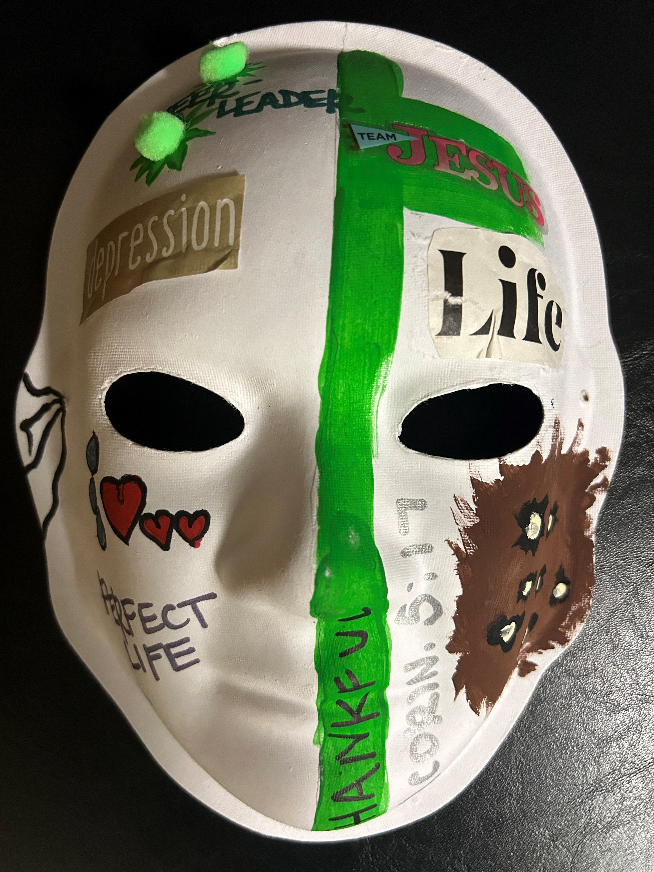
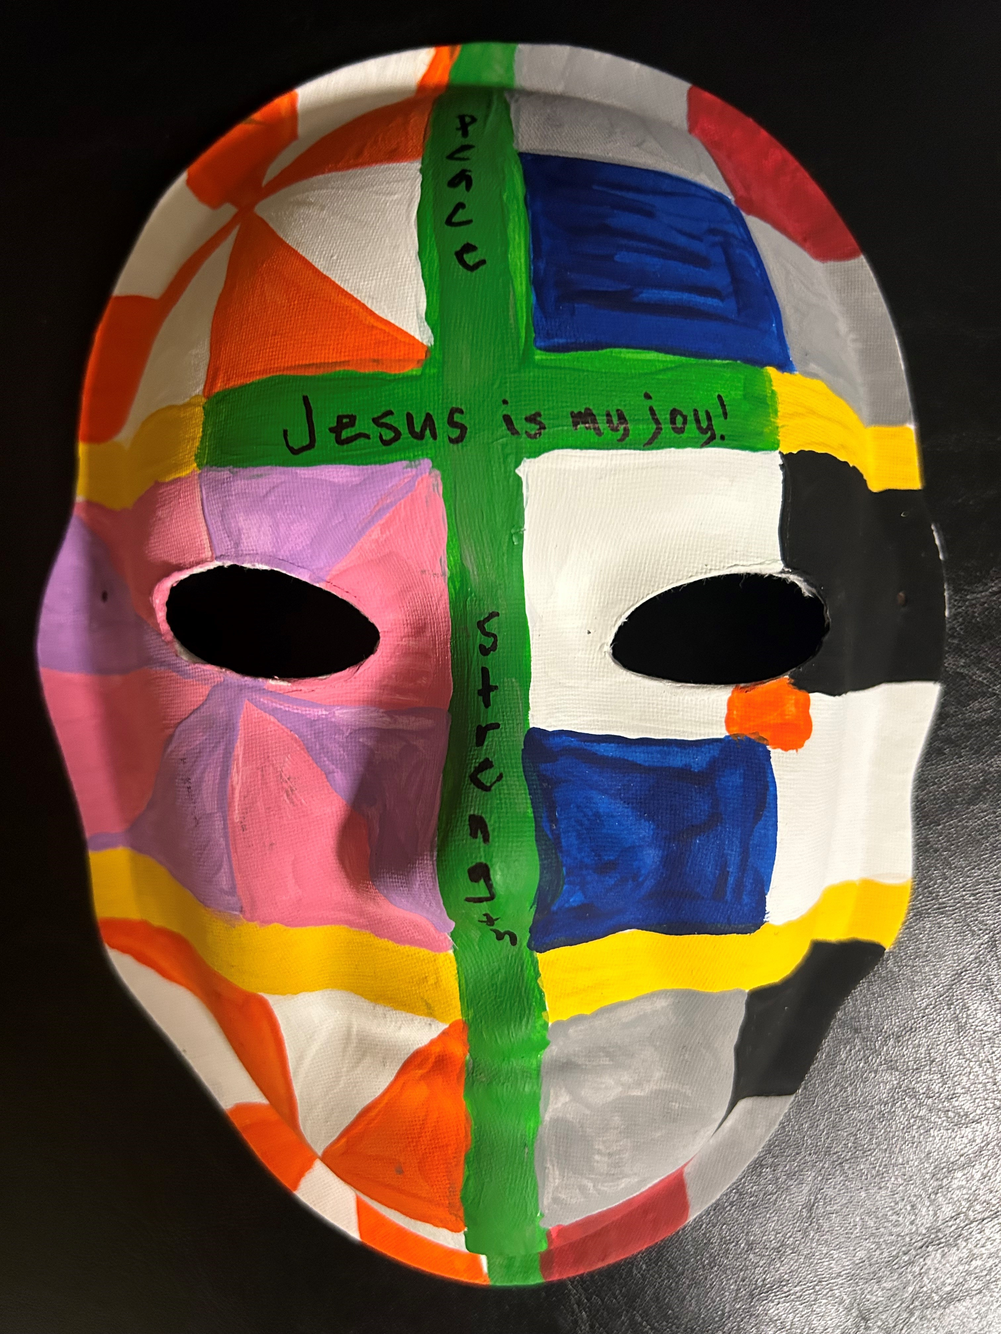
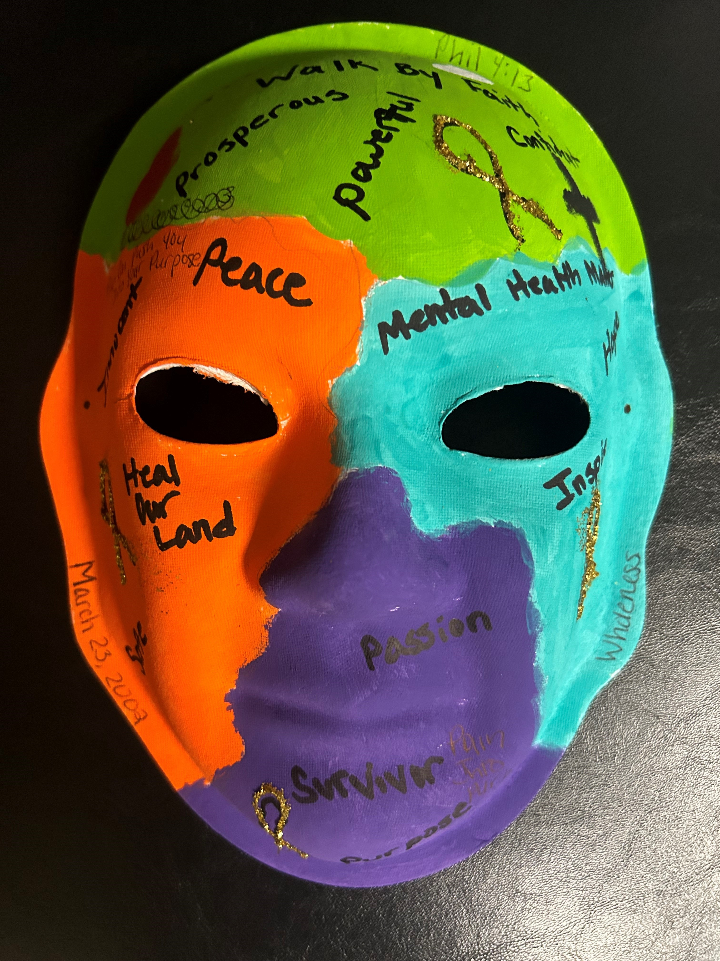
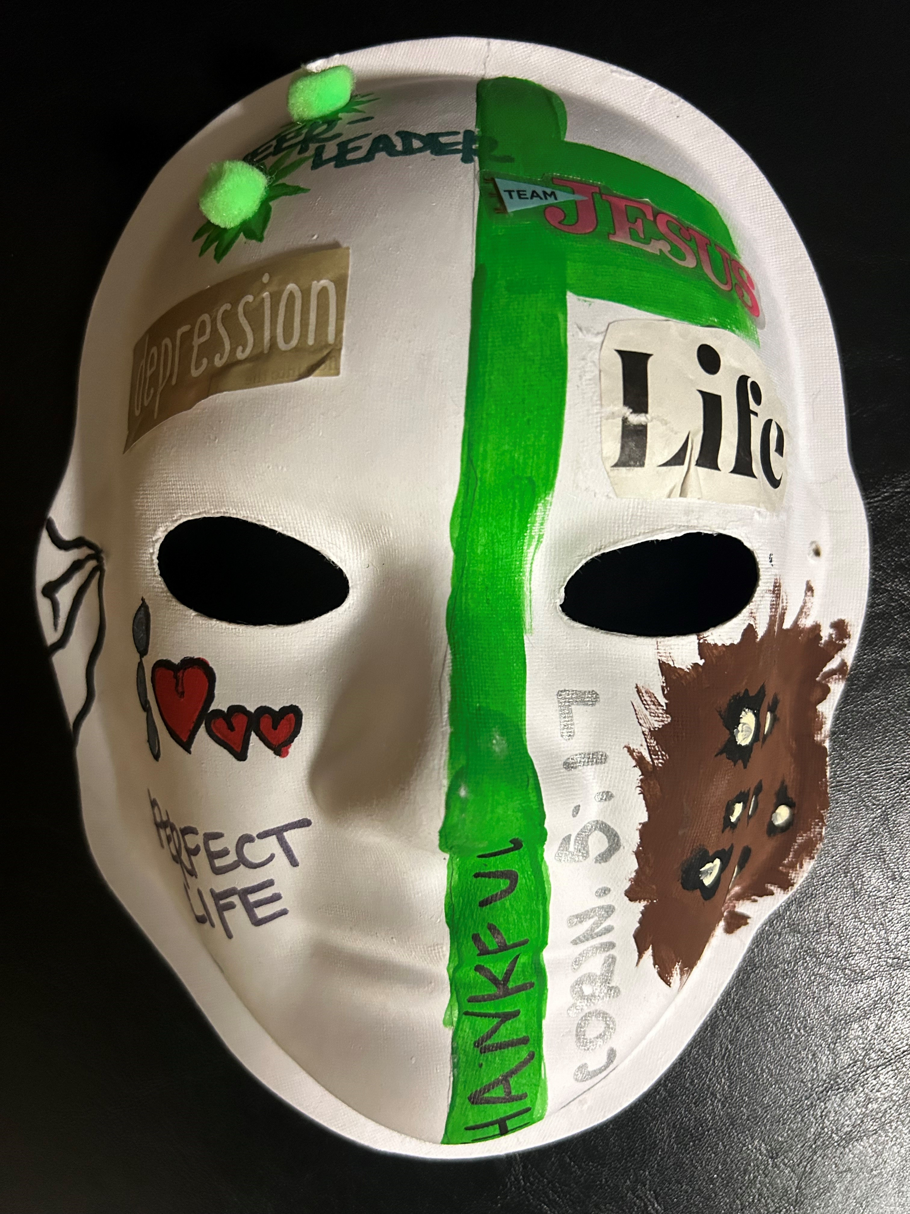

What the 2025 TBI/SCI Trust Fund beneficiaries are saying about the Trust Fund Program:

Making an Impact: Subgrant Projects in Action

Lauderdale County 4-H Horse Club riders—Breann, Hartley, River, McKenna, Fallon, and other students sent beautifully colored horses in appreciation for the donated helmets provided by the TBI/SCI Trust Fund and sub-grant recipient,
Angie Barnard of Too Be Lazy Farm. 13

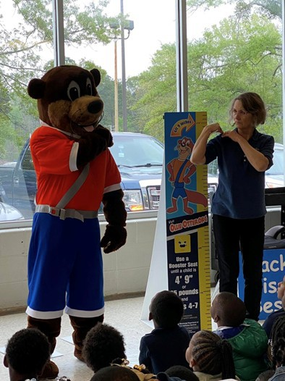

Ollie the Otter and Educator, Gene Everitt of Mississippi Safety Services speak to students about the importance of always wearing a seat belt and riding in a booster seat.
Programs like these are crucial in building lifelong safety habits and keeping our kids safe on the road.

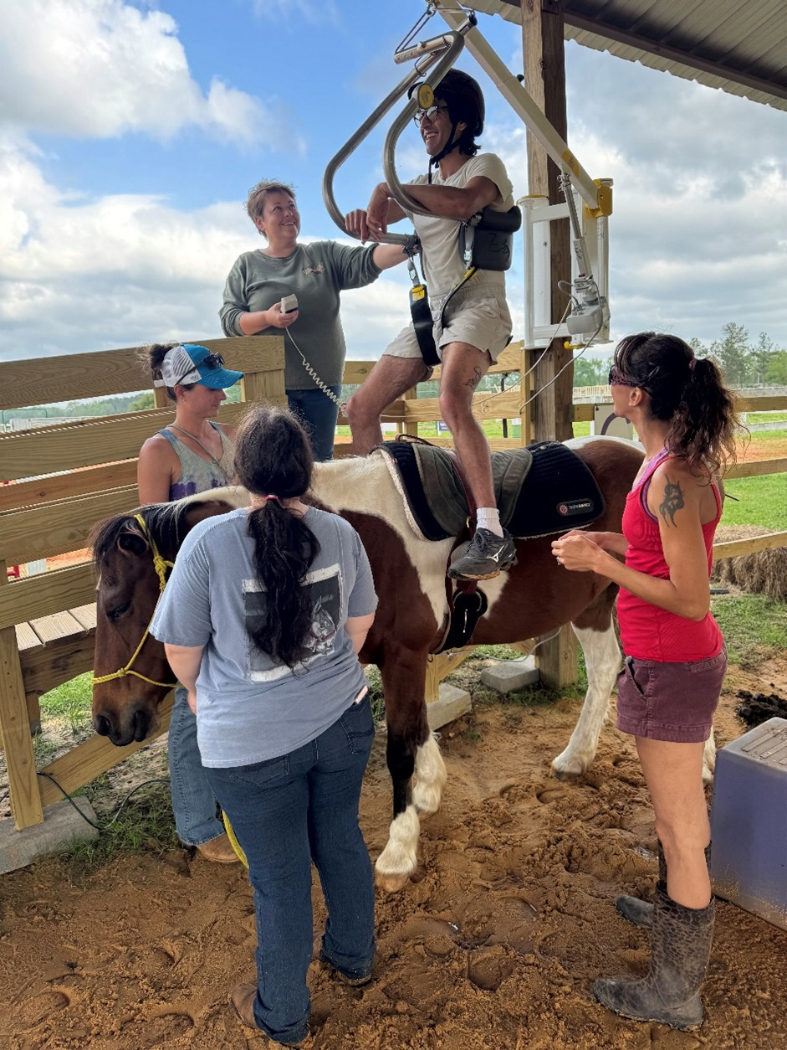

Owner Jessi Mathis demonstrates the Sure Hands mechanical lift during a volunteer and staff training session. This specialized lift enables participants to safely mount a horse
and fully engage in the equine experience.

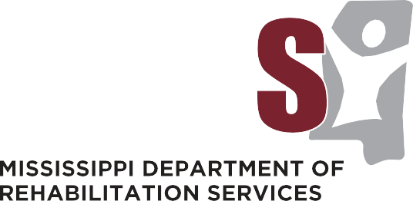


Office of Special Disability Programs
Traumatic Brain Injury/Spinal Cord Injury Trust Fund Program

Your perspective is extremely valuable,
and we greatly appreciate any and all feedback!

Please send any comments or questions to:
Post Office Box 1698 | Jackson, Mississippi 39215-1698 1.800.443.1000 | www.mdrs.ms.gov

The Mississippi Department of Rehabilitation Services is an Equal Opportunity Employer

