Prom Guidelines

What is Prom
PROM is a public awareness campaign created by the Mississippi Department of Rehabilitation Services in 2018 in partnership with the Mississippi Highway Patrol. The campaign encourages prom-bound students to understand the “full-circle” of consequences when choosing to drink and drive, text and drive and/or not buckle up. PROM is a joint partnership with at least two partners, and no more than three.
PROM stands for Please Return on Monday. The full PROM message is: Please Return on Monday -in the same condition you left. YOUR choices today impact YOUR tomorrow.
ANY campaign claiming to be PROM must focus on preventing vehicle accidents caused by choices to drink and drive, text and drive and/or not buckle up. Messaging must make clear that such choices can lead to death (of yourself or someone else) or serious injury that results in a disability (for yourself or someone else). Messaging that includes both the fatality side and the disability side is considered “full-circle.”
The PROM campaign runs during prom season -usually over a two-month period. In Mississippi, prom season is typically the months of March and April.

What Prom is not
PROM is not meant to push ANY message or agenda on prom-bound students other than the one relative to its creation (see first section: What Is Prom). PROM is not just a “motivational pep rally”. PROM is meant to provide students with a realistic presentation related to the consequences of their actions when choosing to drink and drive, text and drive and/or not buckle up.

PROM Strategies
PROM takes a variety of approaches -mostly grassroot- in reaching schools and students: Posters, Presentations, and where possible Peer-to-Peer. In Mississippi, MDRS appoints a PROM coordinator to oversee the campaign, avoid overlap of duties, keep partners organized, and to provide a central point of contact for schools and students.
Posters are placed at high schools throughout the state. In Mississippi, MDRS distributes posters through its transition counselors (counselors working with students with disabilities). MHP Troopers distribute to schools in each of their districts. Any member of the general public may voluntarily distribute posters. Posters must contain the PROM logo, full PROM messaging, and sponsor logos.
Presentations are done in participating high schools. In Mississippi, these presentations are coordinated by the MDRS contact but based on the schedules of the MHP Troopers. Presentations include an MDRS client who acquired his/her disability in an accident that involved drinking and driving, text and driving or not buckling up.
General format of a PROM presentation is: 1) An MHP Trooper speaks about fatality side, 2) An MDRS representative segues, noting the work of the agency and the fact that you may not be killed or kill someone else in such an accident but rather be left living forever with a disability (or leaving someone else in that condition). The MDRS rep introduces the MDRS client. 3) An MDRS client shares their personal story of having to live with a disability as a result of their own choices or someone else’s.
Presentations will vary and generally last 50 minutes to one hour. Given more time, presentations could include other relative aspects such as rollover simulators and motivational speakers. However, at no point should any additional element be added at the expense of any of the main format elements (Fatality Side and Disability Side).
In Mississippi, a video has been produced to be shown in schools where “live” presentations cannot be made.
Peer-to-peer is important to incorporate into PROM, if possible. Students are more likely to listen to other students. Engaging the right students or student groups can increase the conversation students have regarding the PROM campaign both in person and on social media. Participating student groups can be encouraged to start these important conversations.

Partners
The PROM campaign MUST have at least two partners and no more than three. Each Partner is tasked with a unique aspect of the PROM message.
- Partner A: A service oriented/not-for-profit organization; preferably one that works with people with disabilities or whose mission centers on messages against destructive decisions. Particularly: drinking and driving, texting and driving, not wearing a seatbelt.
- Partner B: A law enforcement agency – one which can present the fatality side of the program based on knowledge and experience. (i.e. State Police, Sheriff, Local Police)
- Partner C: A third partner can be permitted if the organization represents a “peer-to-peer” (student), service oriented/not-for-profit organization whose mission centers around messages against destructive decisions. Particularly: drinking and driving, texting and driving, not wearing a seatbelt.

Supports
Examples and supports can be found through the Mississippi PROM campaign. Visit www.mdrs.ms.gov for a link to PROM examples and supports. Questions can be directed to the Office of Communication via oc@mdrs.ms.gov. Each participating agency covers its own expenses and liabilities.

Logo Uses
The PROM logo was created and is owned by the Mississippi Department of Rehabilitation Services and cannot be used except with permission and in accordance with the established messaging guidelines, contained herein.
During PROM presentations, the logo should be displayed as possible (including via a projector, sign, or other appropriate means.)
Logo may be used for fundraising purposes. (see the link for a copy Usage of PROM logo for Fundraising Purposes MOU to be signed before such use.)
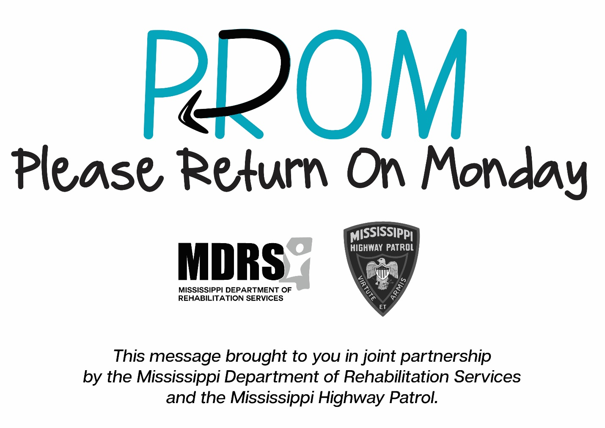

Contact Information
For more information or questions please email the Office of Communication via oc@mdrs.ms.gov or call 1-800-443-1000 and ask for the Office of Communication.

